Teamspirit 222 – January 22
Local groups reduce loneliness and isolation
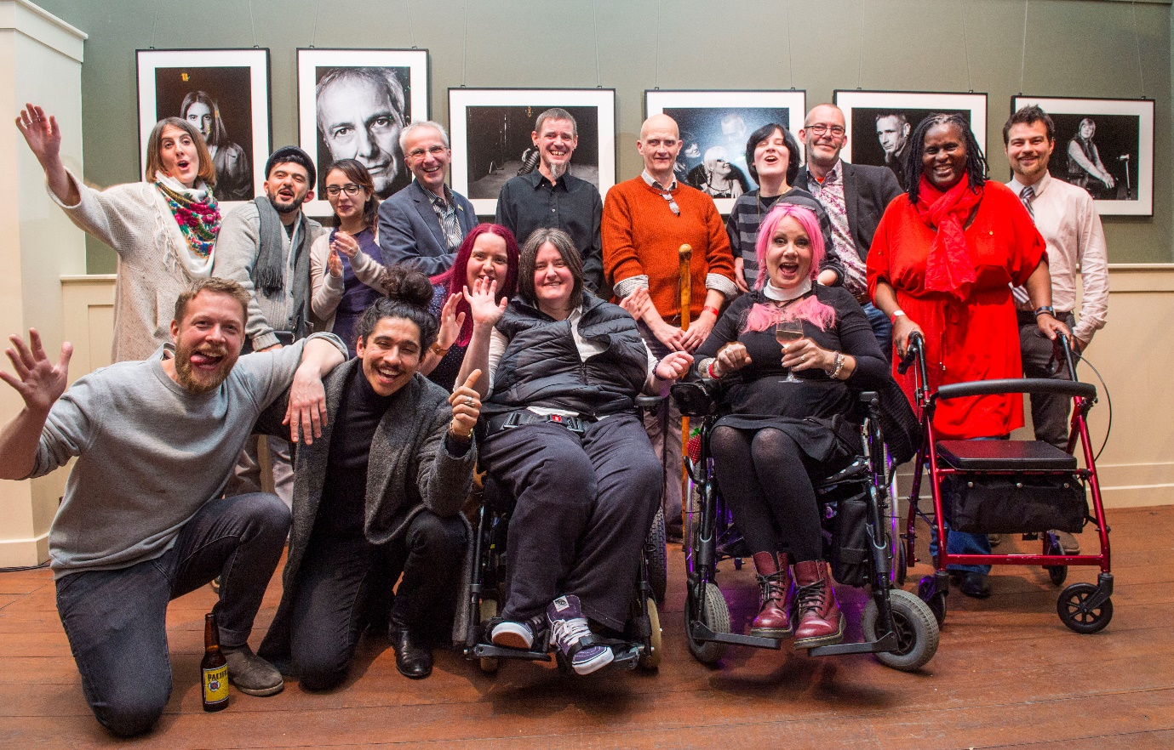
Thanks to our recent survey on loneliness and social isolation, we’ve got some great insight in to the impact our local groups have on people living with MS. The commitment and support that you all provide makes a huge difference to the MS community – thank you for all that you do.
Social isolation is when a person has limited access to a range and frequency of social contact. Loneliness is about how a person feels. It’s a painful emotion resulting from a person feeling they don’t have the quality of emotional relationships they need to be happy. Someone can still feel lonely within a family or social setting.
Read more on the next page.

Help, hope and voice
Continued from cover story
Our survey found that six in 10 people with MS feel lonely – this is 12 times higher than that of the general population. 58 per cent of people feel the condition has left them isolated.
The causes of this vary from losing employment, mobility issues or a lack of understanding from friends and family. But the survey also found that of those six in 10 people who felt lonely or isolated, 78 per cent of them said that being part of a local group reduced these feelings.
‘Meeting other people affected by MS’ and ‘friendship’ are the most common ways groups help, followed by services and then support provided by volunteers at the group.
Here’s what some respondents from the survey said:
“The first time I met other people with MS I felt a sense of relief and could talk about things I'd never even spoken to other people about.”
“The friendship and support that I have found through joining the group has been invaluable to the state of my MS journey.”
We’ve always known how important our groups are to the MS community, but hearing about people’s personal experiences really shows the incredible difference you make. Thank you for everything you do in your communities to support people living with MS.
Contact: Joe Hepworth, Service Insight and Impact analyst
Joe.hepworth@mssociety.org.uk

MS Society features in i-Paper
Throughout December and into January, the i newspaper featured us as their Christmas appeal charity partner, with articles about our work and community featured in the newspaper and online every day.

A huge range of stories have run, including features about the support we offer through our MS helpline, groups and grants; our campaigning work around disability benefits and social care; and the amazing research we fund. A whole host of people have told their personal stories about the impact MS has had on them, and researchers have talked about their work to find new treatments for the condition.

With almost 250,000 copies of the paper sold each day, and more than half a million UK adults reading it, the appeal will have gone a long way towards raising awareness of MS and our work. Letters have been published in the i paper praising the appeal and we’ve received some fantastic feedback about it too:

“I was having a bad Monday, my multiple sclerosis was reminding me quite how dispiriting things were… then I read i, and it immediately heartened me.”

We’ve already raised over £55,000 with donations still coming in, towards grants which help transform the lives of people affected by MS. We’ll update you on the final total in the next edition of Teamspirit.

Contact: Andrea Lisher or Lucy Conway, Press office
andrea.lisher@mssociety.org.uk or lucy.conway@mssociety.org.uk

Christmas and the new year in fundraising
Christmas Appeal
58,000 supporters will have received the Christmas Connections Appeal in November, raising funds to ensure no one faces MS alone. The appeal looked into the recent research which found that 60% of people with MS have felt lonely as a result of the condition, and highlighted what options are out there to help.
Christmas Raffle
The Christmas Raffle was sent out to supporters last October, with a chance of winning £5,000 or a number of other great prizes for just £1 per ticket! The draw took place just before Christmas and you can see if you were one of the lucky winners on the website here! (mssociety.org.uk/get-involved/give-in-other-ways/raffle)
February Advances
On 9 February look out for the MS Advances magazine which will be sent to around 55,000 supporters across the nation. The magazine will feature some of the amazing fundraising undertaken by supporters in recent months and upcoming events, as well as the latest news and research updates.
Weekly Lottery
A year and a half ago we launched our weekly lottery which gives players the chance of winning up to £10,000! Many supporters will receive a mailing about the lottery this month, inviting them to take part. Since we launched, we’ve already raised over £120,000 towards campaigns, research and services for people affected by MS with over 2,000 regular players who support this great work, every week!
For more info go to: lottery.mssociety.org.uk
Contact: Molly Amson Knight, Direct Marketing Officer
Molly.amson.knight@mssociety.org.uk

Garden gate closes on National Garden Scheme
We’re coming towards the end of our three year partnership with the National Garden Scheme (NGS) which has resulted in donations totalling a massive £365,000!
Many people from the MS community enjoyed celebrations including Festival Weekend and the Innovative Gardens for Health Week, which were part of for the NGS’s 90th anniversary in 2017.
Throughout the partnership, private garden visits for people affected by MS (which have been well received), have been organised by local groups with individual garden owners.
Our sincere thanks goes to everyone who has helped the partnership with NGS to be such a success locally, across England and Wales.
Please contact your Area Fundraiser if you would like to know more about the partnership or continue links with a local garden owner.
Contact: Your Area Fundraiser

Have you applied for Universal Credit?
Universal Credit is being rolled out across the UK, replacing a number of old benefits. Those replaced include income-based Employment and Support Allowance (ESA), Income Support, and Housing Benefit. The support included with Universal Credit could be vital to many people with MS. But we know it’s not working as well as it could for many.
If you’ve already applied for Universal Credit, please tell us about the process to help us understand how it’s affecting people with MS by completing this survey: surveys.parkinsons.org.uk/s/DBCBigBenefitsSurvey/
The survey is being run by the Disability Benefits Consortium (DBC), a group of 80 charities which we’re a member of.
By sharing your experience you’ll help us understand any changes we might need to call for to make sure Universal Credit works well for people living with MS.
If you have any questions, please email the Campaigns team.
Contact: Campaigns team
campaigns@mssociety.org.uk

Tell us what your doctor is saying about cannabis
On 1 November 2018, cannabis for medicinal use was legalised. This is an important milestone for people with MS, and over a thousand of our supporters made it happen, by calling on the Government for change.
But, while the change in law means specialists can now prescribe cannabis for medicinal use, we’re concerned that the temporary guidance will discourage specialists from prescribing it at all.
We’re asking for the temporary guidance to be urgently reviewed so that access to medicinal cannabis isn’t so restricted. We’ll also be doing all we can to make sure the longer term guidelines – due in October 2019 – work for people with MS. We need your help to do this effectively.
If you’re speaking to your GP or neurologist about medicinal cannabis then you could help us understand what the new law means for people living with MS.
Please tell us about your experiences to help us understand how this change is working in practice.
Contact: campaigns@mssociety.org.uk
Speaking up for progressive MS in Westminster
Ocrelizumab is the first licensed treatment for primary progressive MS, so it was incredibly disappointing when it was denied approval to be available on the NHS last year. The National Institute of Health and Care Excellence (NICE) said that ocrelizumab costs too much compared to the benefits it can provide.
More than 21,000 signed our petition against this, and we wanted MPs to join our call and speak up for people with progressive MS. So in November, we took our campaign for access to ocrelizumab to Westminster.
While this decision directly affects England and Wales, delays in making ocrelizumab available could have knock-on effects in Scotland and Northern Ireland – so we wanted MPs from across the UK to show support.
Thank you to the thousands who emailed and tweeted your MPs, asking them to attend. The event had a great turnout with MPs, representatives from Roche (the drug manufacturer) and NHS England hearing directly from lots of people who all live with primary progressive MS.
We’re following up with MPs, and are in close contact with NHS England, NICE and Roche about the need to find a deal to make ocrelizumab available. We’ll keep you updated as the campaign progresses.
You can get involved by joining our Campaigns Community: mssociety.org.uk/campaigns
Contact: Campaigns team
campaigns@mssociety.org.uk

Information for your group
Watch our research videos
Have you seen the growing number of videos we have about MS science and research? They’re a great resource to use at your meetings and events and highlight some of the research you fund.
Visit our YouTube channel to find all of the videos available at: youtube.com/MSSociety
MS Society Tissue Bank
The Tissue Bank gives people the opportunity to donate their brain and spinal cord tissue to MS research after their death. It's a vital resource, with donated tissue helping scientists around the world advance our understanding of MS.
Find out how you can become a donor and more about the work that the Tissue Bank does from the researchers who work there, by watching the video here: youtube.com/watch?v=zmaDW4mJWeE
Meet the Researchers
In this series of short interviews with some of the amazing MS scientists and clinicians working across the UK, you can see the cutting edge research going on across the UK, including at our Cambridge and Edinburgh Centres. Watch the series here to find out more about research from the people who make it happen: youtube.com/playlist?list=PLseEst8sYZkSCgJkLACpsBCwCW85Zdclx
A short animated history of MS research
Thanks to our ongoing investment in MS research, we’re closer than ever before to finding effective treatments for everyone with MS. But have you ever wondered how we got to this point? In this short animated history, Beccy Huxtable takes us on a journey through the MS history books.
Watch Beccy’s journey here: youtube.com/watch?v=wYyHhNSIpPY
Contact: Research team
research@mssociety.org.uk

Get involved with Learning and Development (L&D)
There are so many new things to pick up and learn how to do in this modern age, from new apps, to different devices, ways to pay council tax, do your weekly shopping… all sorts. And it often feels overwhelming.
What we need to learn to carry out our volunteering roles can sometimes feel just the same!
During 2018, we worked with a small group of volunteers on our policy guidance panel. In 2019 we’ll be involving a wider range of volunteer roles to bring more of our learning resources to the table for discussion and feedback, and we need you!
One volunteer said “I’ve learned a lot by being involved and it’s been a great help when dealing with challenges that have arisen locally”
If you’d like to help us review the Group Handbook, Welcome and Induction materials, or what face to face events or new eLearning would help volunteers in your role most; please email us by 18 February.
You’ll join a ‘consultation pool’ with a wide range of opportunities to input on different topics with varying time commitments. Meetings will be held on Zoom or by phone so there’s no need to travel.
Contact: Volunteer training team
volunteertraining@mssociety.org.uk

Health and Safety policy update
We all know that Health and Safety (H&S) keeps us safe every day, however it’s often confusing, especially when we have a responsibility to keep others safe.
To ensure you understand your individual responsibilities and know where you can get help and support, you should read our health and safety policy.
This has recently been reviewed, updated and approved by our Executive Group and Board of Trustees. It is a statement outlining our commitment to meeting health and safety standards.
Please visit the links below to read the policy.
Link to statement of intent:
volunteers.mssociety.org.uk/resources/439
Link to health and safety policy:
volunteers.mssociety.org.uk/resources/health-safety-policy
Contact: Jo Duffy, Head of Health and Safety
jo.duffy@mssociety.org.uk 0208 438 0882

Tips on moving and storing data
We collect personal data by email, paper forms, telephone, video recordings, photographs, and we move data around to each other every day.
But what’s the safest way to do this?
Data collected should be kept to the minimum for your purpose. It must also be kept no longer than needed; see page 12 of the Group Handbook.
When you collect personal data, always include a privacy statement. The Resource Library has guidance on learning how to write a privacy statement.
Here are some ways to move and store data safely:
- Cloud (online) storage. Please only use cloud providers we’ve approved, e.g. OneDrive on Office 365. If you use any other storage please contact us.
- Emails. If you need to send personal information via an email attachment, password protect the document and telephone the recipient with the password. Please use MS society email accounts when you can and remember to use the BCC field.
- Paper forms and applications. Lock these away until you can upload them to a secure network (office 365 or your password protected device) and/or they can be safely destroyed. If out and about, be responsible for papers, don’t use transparent folders or leave them unattended.
- USB sticks/flash drives. We don’t favour these, but to use them, they must be encrypted or password protected. Files should be uploaded to a secure network as soon as possible and then deleted from USB device.
Please check here for ways to encrypt your stick: online-tech-tips.com/computer-tips/encrypt-usb-flash-drive/
Contact: Data governance team
datagovernance@mssociety.org.uk

New grants application process
In the New Year, fully completed applications will be considered on a monthly basis in review meetings. Therefore we’ll no longer list application deadline dates on the website.
Also from 2019 we’ll no longer be offering grants for boilers. This is because we offered these grants in partnership and this partner has now stopped offering them. Boilers are needed by everyone, not just people living with MS, and without our partner, we can’t cover the cost.
We want to provide grants to as many people as possible living with MS and their carers. Due to the limited funding we have compared to the amount of applications for grants, do be aware before applying, that we’re not able to award grants to all applicants.
In some instances, grants may not be awarded at all or part funding may be offered. Our Grants Officers work hard to help find top up grants from other sources and will offer to signpost applicants to alternative funding options.
Please visit our website for further information about how applications are assessed.
Our Supporter Care team can assist you with your application, so please do get in touch if you’d like assistance.
Contact: Supporter Care team
supportercare@mssociety.org.uk

Recognising our volunteers
During 2019 we will be reviewing the way we work to ensure we continue to maximise our impact supporting you to support people living with and affected by MS. We recognise that as volunteers, you make a difference to the MS community, you have an enormous impact and it’s important to recognise this contribution.
To support this we are reviewing our current approach to recognising the amazing things you do and we’ll be asking you to tell us what you think. Whilst we’re reviewing our current approach we’ve decided that the MS awards ceremony will not be held this year.
Whilst this event was great, it only involved a small proportion of our volunteer community and we really want to ensure that in the future, we improve our reach and get the best value for money we can, for the greatest impact.
Please look out for information about how you can get involved in shaping the approach to volunteer recognition, we’ll be asking for your ideas and feedback over the next few months.
We continue to encourage you to use our relaunched Shining Stars awards when recognising the marvellous service and impact you all deliver on a consistent basis.
You can read more about the Shining Stars awards, as well as thank you cards and certificates on our volunteer website here. (https://volunteers.mssociety.org.uk/recognising-volunteer-contributions)
Contact: Lucy Read, Local Networks Projects and Communications officer
lucy.read@mssociety.org.uk

Support for volunteers
Awards and new services in our MS Helpline
Our MS Helpline provides a highly valued service to people living with MS; responding to a huge variety of questions and issues and giving support to those who need it. Last year they received some incredible awards for the help they provide, including Helpline of the Year 2018!
We’ve spoken to some of our helpline volunteers about their experiences:
Helen Cooke said: “I have MS, and I’m managing fatigue all the time, my greatest challenge was leaving work. Volunteering has restored the part of me that ‘went missing with MS’.
“It’s a privilege to support people and I take pride in reassuring callers they can trust our information, especially those who are newly diagnosed. I feel part of something bigger than myself.”
Stuart Thomson’s life-experience helps him to help others with MS. His feeling of appreciation following a personal call with the Motor Neurone Society, attracted him to the helpline.
“After being diagnosed in 1991, I didn’t want contact with anyone with MS. I didn’t read about it, just kept to myself. 23 years later I saw a tweet about joining the helpline. One of the first things I learnt was: not everyone’s MS is the same as mine – which I’d wrongly assumed! Everyone here works from the heart, and to be part of that is really special.”
Dorothy Sutton received a call from a lady who was really struggling. "She was not in a good way at all, and I feared for her safety. So as we talked I managed to get her address and arrange an ambulance. The paramedic assured me that she’d be alright, my helpline training was certainly put to the test!”
New: moving more with MS
Moving more with MS is a new behaviour change programme to help people get more active, and manage their symptoms better. Research suggests that physical activity improves balance, fatigue, muscle spasms, stiffness, low mood and depression.
Our new Physical Activities Specialist, Omar Tucker, will be running the programme.
Working with Sports England, this programme should help 155 people with MS to make positive changes to their lifestyle. If you currently do less than 30 minutes activity a week, Omar can help you to increase these activity levels.
Access to the programme is through the MS Helpline or via an enquiry form on our website followed by a phone call with Omar. If the service is suitable for you, support will include a personal action plan, lots of resources and regular phone calls.
Also new to our MS Helpline team is our Benefits Advice Specialist. Working alongside the Disability Law Service, Alan Blackett will be on hand to offer advice on what benefits are available to you, and to help with applications.
Contact: MS Helpline
helpline@mssociety.org.uk
08088008000

Claim your expenses back
Some new resources about expenses are now available, which aim to make it easier to:
- know what you can claim back as reasonable out of pocket expenses while volunteering with us
- claim your expenses
There are now three main resources to achieve this:
1. Example expenses claim form – this features some top tips to help you fill in your expense claim form (volunteers.mssociety.org.uk/resources/3294)
2. Expenses guidelines – this lists what you can claim as a reasonable out of pocket expense (volunteers.mssociety.org.uk/resources/3286)
3. Bank details request form – if you’re submitting your expense claim to National Centre you’ll need to fill in this form as you’ll be paid back by bank transfer (volunteers.mssociety.org.uk/resources/3291)
As mentioned in November’s TeamSpirit, the next step is to create a video about the importance of claiming expenses. If you’re interested in taking part, it’s not too late, just let us know!
Contact: Volunteering team
volunteering@mssociety.org.uk

New online shop launches
As you may know following the closure of the old site, this month sees our new online shop opening.
As before, the shop will stock information leaflets and marketing and fundraising material.
Benefits include:
- It’s really clear and easy to use
- You can now change your own password, no need to phone us!
- You’ll have one account per group so you can all see your order history

Feedback about the current shop has led to this change. Our new distributers are experienced within the charity sector and we’re confident they’ll provide an improved service.

To set up your group’s account, you’ll need to complete a registration form using your Group MS Society email address. This form will be made available on the volunteer website, but members of the Coordinating team can also request this from supporter care. We’ll verify your role against our records and then your account will be set up.

If you prefer to make orders over the phone, this is possible by calling 0300 500 8084, however you’ll still need a group account. Opening times are 9am until 5pm Monday to Friday.

Further information about the shop and registration process, will be put on the volunteer website.

Contact: Supporter Care team
supportercare@mssociety.org.uk
0300 500 8084

MS Society emails upgrade is going strong
You’ll have seen information about the upgrade and might be feeling nervous or hesitant to get on board. A number of groups have already upgraded, here’s some feedback:
“We always use our primary address on posters etc. but when we’re calling for support, that person’s [individual] email address gives a personal touch”
“If you want to have an open and easy to access platform for your Group Coordinating team then this upgrade is for you.”
Signing up means you’ll be able to:
- communicate on behalf of and with group colleagues
- receive direct messages to your individual address
- reset your own password and access emails on your phone or tablet
- share and securely store documents
- use the shared calendar to plan meetings and events
How do you sign up?
You’ll need to register as a group using the form on the volunteer website - all members of your team will be upgraded at the same time. Then, if you haven’t already done so, complete the GDPR eLearning.
The GDPR eLearning has now been upgraded and the technical hitches fixed! It will now also work on mobile and tablets. If you need any help, there are FAQs on the volunteer website:
- volunteers.mssociety.org.uk/gdpr-elearning-faq
- volunteers.mssociety.org.uk/handling-data/data-protection-gdpr-elearning
Online training sessions as well as technical guides, relevant group handbook sections and how to register your interest, are available on the volunteer website here: volunteers.mssociety.org.uk/MS-Society-email
Contact: Supporter Care or Volunteering team
Supportercare@mssociety.org.uk or volunteering@mssocuety.org.uk

Finance
Year end and online accounting
Finance year end
A big thank you for your help in meeting the deadline of January 31 2019 for submission of your receipts and payments report from Online Accounting – this has enabled us to make great progress with our 2018 consolidated statutory accounts.
Online Accounting - maintenance
We’re upgrading our online accounting system in January, which will result in loss of access for one or two days. We apologise for any inconvenience this may cause and will update groups once we have exact dates in January.
Upon review of your 2018 transactions, if we notice any incorrect analysis we’ll let you know and make any necessary adjustments.
Need help?
Please don’t hesitate to contact Finance Support, we’re here to help with:-
- Reset of Online Accounting login details
- Provide remittances for transfers from MSNC
- Provide guidance on the analysis of transactions
- Correct any transactions analysed incorrectly
If you have any further questions, or are concerned that your group is unable to meet the 31/01/19 deadline, please contact the Finance team
Contact: Finance Support
financesupport@mssociety.org.uk
0208 438 0700

Meet the team
(Picture of Bindu Dudhia)
Bindu Dudhia changed roles on November 1 2018, meaning the things you should contact her for have also changed. Moving from the role of ‘Accountant – volunteer groups’, Bindu is now a Financial Accountant. This new role includes financial accounting reconciliations, payroll and tax, investments, cash management and ensuring we have sufficient accounting controls.
Talking about her new role, Bindu said
“Having worked in the Group Finance Support team with volunteer groups for the past 18 months, I have now been given the opportunity to take my career into a new direction. It’s been a pleasure working alongside volunteers to support our groups. I have learnt a lot not only in this role, but as many of you may know, prior to that I was Treasury Officer for a number of years. I’m sure that our paths will cross from time to time as I undertake my new role as Financial Accountant.”
If you have any group related queries, the Finance Support team are still on hand to continue with advising and supporting you.
Contact: Finance support
financesupport@mssociety.org.uk
0208 438 0700

Invoice fraud awareness
There are many types of invoice fraud and every organisation is vulnerable.
The main types are:-
- An organisation is tricked into changing bank account payee details.
- Invoices seeking payment for goods/services that have never been ordered.
But how can we spot invoice fraud?
Here are some signs invoices you’ve received could be fraudulent:-
- You didn’t order the goods/services listed.
- You’re requested to make a payment to a different bank account.
- Some fraudulent invoices have poor spelling and grammar, low quality versions of logos or strange names.
- The invoice highlights the due date for payment has passed and threatens that non-payment will affect credit rating.
- Invoice fraud criminals are often aware of relationships throughout organisations. So don’t be fooled if the invoice is addressed correctly using your name and address.
How can we fight invoice fraud?
Here are some small actions which make a big difference:-
- Check with your Coordinating team members if you’re unsure why you’ve received an invoice for certain goods/services.
- Contact the supplier directly to confirm, if you are suspicious about a change of bank details request.
- Forward the invoice to Finance Support and we can investigate for you.
Contact the Finance team with any concerns.
Contact: Finance Support
financesupport@mssociety.org.uk

Charging for services or asking for suggested donations?
We’re making a slight change to our advice to groups – we now recommend you do not charge for services but ask for a suggested donation instead.
There are three primary reasons for making the change:
- Charging can discourage some people affected by MS from making use of a service that may really benefit them.
- Charging for a service is a VAT-able activity. For example, for every £10 you charge £1.67 will need to be paid to HM Revenue & Customs (HMRC). This VAT is currently being paid through our central budget.
- HMRC may penalise us if a group fails to enter charges onto online accounting within four weeks of the service being provided.
If you’re concerned that your group may not be able to cover the cost of providing a service if you stop charging a fee, please contact Finance Support on so that we can help you.
Contact: Finance Support
financesupport@mssociety.org.uk
0208 438 0700

Our groups and services
Lanarkshire group’s success with Co-op Local Community Fund
Last year our Lanarkshire Group successfully applied to the fund and received over £4,500, enabling them to support the delivery of 112 hours of counselling services to 19 people affected by MS in their area. The group also held bucket collections at their local store, which raised awareness of MS.
Congratulations to the group for successfully renewing this partnership for 2019!
Karen Henvey, Group Coordinator, Lanarkshire group said “We’re absolutely delighted to have this relationship with the Co-op. The counselling service makes a huge difference to the people affected by MS living in the Lanarkshire area, and we love being able to be in store talking to people about the work that we do.”
We’re delighted that our Shetland group have also secured a local partnership for the year, which will support access to complementary therapies on the islands.
How does the Fund work?
The Co-op Local Community Fund helps to support local projects that their members care about. Since its launch in 2017, Co-op members have raised £39 million pounds for over 12,000 local causes. When members buy selected Co-op branded products and services the Co-op gives 1% of that money to a local cause in their community.
Find out more about the fund at co-operative.coop
Contact: Regional External Relations Officers

aMaSing singing soon to be heard in South Wales
With two wonderful MS choirs already in Gwynedd & Môn and Conwy – it is now the turn of South East Wales to add their voices to the land of song.

South Wales Local Networks Officer Siân Tucker and Fundraising Manager Sian Dorward have been successful in getting funding from the Big Lottery ‘Awards for All’ grant scheme for an aMaSing Choir Project in 2019.

Sian Tucker said; “Our incredible aMaSing choirs in North Wales have shown how much singing together can reduce loneliness and social isolation among the MS community.

“You don’t need to be a Bryn Terfel or Rebecca Evans! If you live with or are affected by MS in South East Wales and enjoy singing please get in touch”.
The existing choirs have been featured in local and national media and even and appearance on ITV news. Those involved have found the experience to be hugely uplifting and confidence building, leading to many friendships being formed.

Contact: Sian Tucker, LNO South Wales
sian.tucker@mssociety.org.uk
Information services
Advanced MS, a carer’s handbook:
This is a guide for family, partners or friends who are caring for someone with advanced multiple sclerosis (MS) who need increased support. The guide also includes a carer’s assessment checklist.
Pain and unpleasant sensations in MS:
This booklet covers the physical side of living with pain and the emotional challenges people face. It explains the types of pain MS can cause, the treatments available and tips and skills to help manage MS pain.
Cannabis, an information factsheet:
This explains the changes to the law and provides people with information on legal cannabis products. Giving people the chance to weigh up the possible benefits against the risks.
You’ll find all these resources available in our new shop or can be download from the website. As you should be aware, the old shop has now been taken off line and the brand new shop is launching this month.
Contact: Supporter care
supportercare@mssociety.org.uk

For England
Patient experience survey
The Neurological Alliance, which we’re a member of, is conducting its third patient experience survey. Anyone living with a neurological condition/s in England, or cares for someone that does, is welcome to take part and share their experiences of treatment, health care, social care and welfare support.
The survey is open until 22 March 2019 and can be accessed here: www.tinyurl.com/neuro08
The Neurological Alliance is the only collective voice for 80 organisations working together to make life better for millions of people in England with a neurological condition.
The survey findings will help them deliver a powerful message to Government and local decision makers that support must improve for people living with neurological conditions and their carers.
The survey should take around 25 minutes to complete. Your responses will be kept completely confidential and anonymous.
Contact: Fredi Cavander-Attwood, Policy manager for Health and Care
fredi.cavander-attwood@mssociety.org.uk

For Northern Ireland
Neurology recall update
Earlier in 2018 the Belfast Health and Social Care Trust recalled 2,500 neurology patients after investigations into the treatment and care provided by a specific neurologist. Following further investigation an additional 1040 patients were recalled in November.
During this time, we’ve been engaging with the Belfast Trust and the Department of Health to ensure the interests of people affected by MS are represented, including those who have received life changing news including changes to diagnosis or treatment. We’d like to thank those who shared their experiences and provided evidence to the enquiry teams.
The Department of Health has announced a wider review of neurology, to determine the future of services and provision right across Northern Ireland. We’ll play an active role in this review fighting the corner of people living with MS. NI Director David Galloway will sit on the steering group with the Department of Health to oversee the review. We’ll be calling for patient forums and engagement processes to form part of the review.
If you want further information on any of this work, want to share your own experience of the recall or want to play a part in the review of neurology please get in touch.
Contact: Stewart Finn, Policy, Press and Campaigns Manager
stewart.finn@mssociety.org.uk

Run for Research is back!
(pic- Jennifer Coulter on the right)
We’re delighted to announce that our ‘Run for Research’ event will take place on Sunday April 14 at Hollywood Exchange, Belfast and we’d love to see you there. In it’s first year, 2017, we had almost 600 people taking part and we’re planning for an even bigger and better 2019.
‘Run for Research’, a fantastic volunteer led event, is delivered in partnership with husband and wife team Jennifer and Stephen Coulter and running enthusiast Ivan Prue. It’s a fun, relaxed and inclusive event so if you’re getting active in 2019, join us!
Other events coming up include:
- Belfast Castle Abseil, Sunday March31
- Belfast Marathon, May 5
- ‘Zip it for MS’ on May 18 and 19, zip across the Lagan at 40 miles per hour
New for 2019 ‘The Big Leap’, an MS Society Skydive event, on Sunday 2nd June. We’re aiming to get 20 people doing a tandem Skydive at the Moon Jumper Skydive Centre, Garvagh near Coleraine and you could be one of them! If you’re up for it, join our team of daredevils – training is provided on the day.
To register for any of these events contact us.
Contact: Eve Shearer, Community and Event Fundraiser
Eve.shearer@mssociety.org.uk
028 90802802

Newly Diagnosed course
The South Eastern Trust have been running a Newly Diagnosed Course for people with MS run by the MS team at the Ulster Hospital. The course aims are to inform, empower, educate and signpost those who have been diagnosed.
This five week course covers services and support available from the Trust; such as pain management, occupational therapy and physiotherapy. It’s also an opportunity for patients and their families to meet each other, talk and share experiences.
We provide information for this course on all of the local services & support that our groups offer and talk about the work we do in the MS Resource Centre in Belfast. Our volunteer counselling team, also speak about maintaining emotional wellbeing and the support and advice that our counselling service can offer to people affected by MS.
We’re also really excited to be co-designing a one day information session for those living with Progressive MS. We’ll be working with the MS nursing team from the South Eastern Trust to develop this informative symptom management session. If you’re living with progressive MS or are a carer we would love to hear what topics or information you’d like us to cover.
Contact: Marian Mawhinney, External Relations Officer NI
marian.mawhinney@mssociety.org.uk

Share chalets

The team in Northern Ireland have two fully accessible chalets for hire at the Share village in Lisknaskea on the tranquil shores of Upper Lough Erne in beautiful County Fermanagh.

Share is an outdoor activity centre open to everyone and with plenty of entertainment options for the whole family. Share works for the inclusion of disabled and non-disabled people by providing opportunities for all to participate in a wide range of recreational and creative activities.

We’re able to offer our chalets at a much reduced rate to people with MS and their families. Our chalets sleep eight and come with access to the onsite fitness centre.

To find out more please contact NI reception.

Contact: NI reception
nireception@mssociety.org.uk
028 90 802 802

For Scotland
Ocrelizumab accepted for relapsing remitting MS in Scotland
The disease modifying therapy (DMT) ocrelizumab (brand name Ocrevus) has been given the green light by the Scottish Medicines Consortium (SMC) for use on the NHS to treat relapsing remitting MS.
It can be taken if your MS is active (you’re having relapses, or have new lesions) and you’re unable to take the DMT alemtuzumab (brand name Lemtrada).
Earlier in 2018 the SMC declined to make ocrelizumab available on NHS Scotland for people with relapsing MS, due to its cost. The company which manufactures the drug, Roche Products Ltd, has now applied a discount.
Scotland Director Morna Simpkins said: “We’re pleased that ocrelizumab has been approved by the SMC for limited use on the NHS in Scotland for relapsing remitting MS.
“We want every one of the 11,000 people in Scotland living with MS to have access to the right treatment at the right time and this decision takes us closer to that goal.”
What about ocrelizumab for progressive MS?
Ocrelizumab is also licensed to treat early primary progressive MS, but it has yet to be approved for that use on the NHS. Earlier this year the drugs makers withdrew their submission to the SMC for ocrelizumab for primary progressive MS.
We’ll be working with the SMC and others to see a submission in the future.
Contact: MS Helpline
helpline@mssociety.org.uk

Help shape the future of neurological care and support
We need you! The Scottish Government is looking for views on its draft National Action Plan for Neurological Conditions.
This is the first action plan of its type in Scotland and a big opportunity to shape the future of neurological care and support. It’s open for consultation until 8 February.
The development of the plan will have a big impact on the MS community across Scotland. We’ll submit a consultation response and we need to gather as many views across the MS community as we can.
Could you help? You can share your feedback with us in a variety of ways, either in writing, a telephone conversation or possibly by attending a group discussion either online or in person.
You can read the plan online here: gov.scot/publications/national-action-plan-neurological-conditions-draft-consultation-2019-2024/. To find out more about how to contribute please contact us.
Contact: Keith Park, External Relations Officer, Scotland - East
scotlandcampaigns@mssociety.org.uk

Tick off your New Year’s resolutions
Tick off those New Year’s resolutions with the #MSSuperstars team
- Be more active
- Set yourself a challenge
- Do something that scares you
- Help stop MS
Many of us make New Year’s resolutions like these. Our 2019 events are a great way to tick off some of the items on the list.
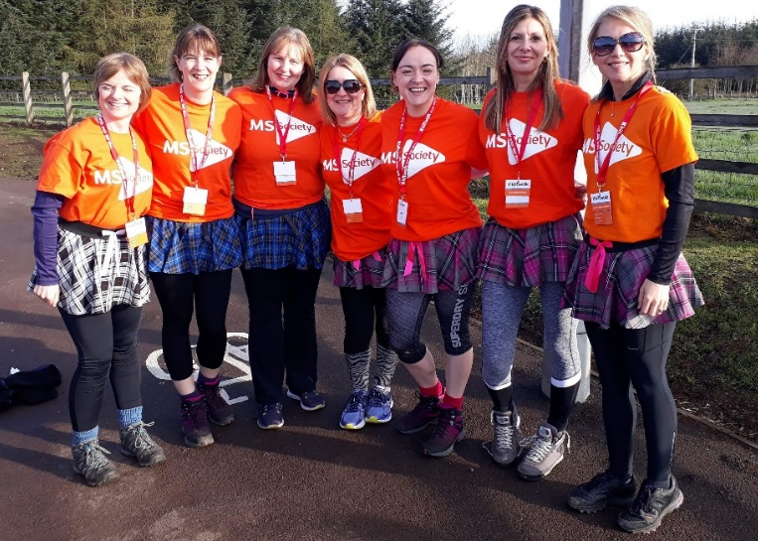
- The Kiltwalk, various dates and locations (be more active ✔)
- Our fully accessible Zipslide Zinger, 27 April, Perthshire (set yourself a challenge ✔)
- Daredevil Skydive, 3 August (something that scares you ✔)
- By getting involved in any of our events our wonderful fundraisers are helping to stop MS (✔)
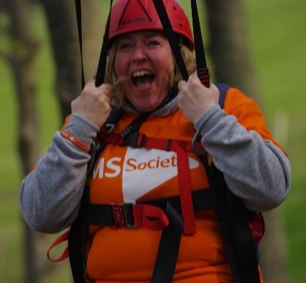
Could you join our team or help us spread the word? Check out our website for a full list of events in your area.
Contact: Fundraising team
msfundraising@mssociety.org.uk

‘Record’ fundraiser in Nairn
Dave, a former medical researcher and professor at the Centre for Rural Health in Inverness, was diagnosed with relapsing MS in 2005.
Dave Godden’s folk CD record ‘Life Stories’ launched at the beginning of December in Nairn with all proceeds from the gig and album sales coming to the MS Society Scotland. The album features original songs and has already received airplay on BBC radio.
Given his first harmonica by Santa Claus at the age of five, Dave has performed regularly with folk groups at sessions across the Highlands, playing a range of instruments from guitar to bouzouki.
Numbness in his hand means he has now given up some instruments but Dave is still very much able to play and enjoy music.
He said: “It is a great pleasure to give all the proceeds to the MS Society Scotland, which does superb work directly supporting people, as well as funding research.”
The album is available at: davidjgodden.co.uk
We know our groups and supporters come up with lots of creative ways to raise funds and here’s one great example. If you’ve got something a bit different going on please send us your stories!
Contact: Scotland Press Office
scotlandpressoffice@mssociety.org.uk

For Wales
My MS My Rights My Choices
Our ‘My MS My Rights My Choices’ project team have submitted their first end of year report to the Big Lottery - and what a year it’s been!
Project Manager Adele Gilmour outlines the main highlights and what’s coming next year:
“We formally launched the project in September 2017, following a 6 month set up period. We created marketing materials; referral processes, tested and completed our database and systems for recording casework; developed a complete set of volunteer resources including role descriptions, development pathways, recruitment processes and training.
“The project staff have supported 186 people with MS across Wales through applying for benefits and appeals; housing issues; employment issues; newly diagnosed and access to services.
“People are referred through the Helpline, Local Groups and MS Teams across Wales. The majority of the people we work are completely new to the MS Society.
“Alongside Local Network Officers, we’ve delivered Newly Diagnosed Days and Information Events for people with MS and their carers. In in total we have run 21 events with 672 people attending!
“We’ll be just as active in 2019 with more ‘Living Well With MS’ and Newly Diagnosed Days; information and mindfulness events; and we’ll continue to support people individually”.
Contact: My MS My Rights My Choices team
mymscymru@mssociety.org.uk
0808 800 8000

Getting Active project
Getting Active will promote fitness and friendship for people in Cardiff, Merthyr and Rhondda Cynon Taf.
Project Officer Bethan Moss and administrator Julie Cole are now in post and the team will be working with members of the project steering group and local MS groups to plan launch events in the New Year.
We want the project to reach as many people in the MS community as possible but we need your help!
We’ll be producing promotional materials and we need volunteers to spread them far and wide.
Please contact us for more information on getting involved.
Contact: Bethan Moss, Active Together Project Coordinator
Bethan.Moss@mssociety.org.uk

Council gathering
Our Cymru Council is a group of volunteers who represent people living with MS in Wales, and work on their behalf. The Council is accountable to our Board of Trustees, and work alongside staff in Wales, as well as with our local groups.
Cymru Council meetings will be taking place on the following dates:
13 April - Carmarthen
10 August – Llandrindod Wells
12 October - Wrexham
Social gatherings takes place 7:30pm-9pm on the evening before each of the MS Cymru Council meetings. These are a great opportunity for our local MS community to meet council members and staff, and learn about the latest news and activities.
Both social gatherings and council meetings are open to everyone. If you’d like to attend please get in touch.
Contact: matthew.witty@mssociety.org.uk
02921678921

Isolation and MS
“Tackling loneliness and isolation in Wales is a national priority” say the Welsh Government and they have developed a strategy to combat it.

We understand that social isolation and loneliness is a significant issue for people of all ages who are living with MS in Wales.

The results of the Wales Neurological Survey on Social Care showed us that people living with neurological conditions are being failed by the system – and this is having a real impact on them being isolated.

Some of the reasons that you’ve told us about include health and social care, housing, access to the built and natural environment, transport, a lack of opportunities to be involved in community and physical activities, poverty and the impact of welfare reform, lack of accessible public toilets and digital exclusion.

We know the vital part our local groups and projects play in reaching people living with and affected by MS who could be lonely or isolated in their community.

We’d like to say a huge thanks to everyone who shared their experiences in our response to the strategy and social care survey – we’ll keep you informed of developments.

To share copies of the WNA report and the MS Cymru consultation response with your groups, please get in touch.

Contact: Fiona McDonald, Policy, Pres and Campaigns Manager, Wales
Fiona.mcdonald@mssociety.org.uk

Group Contributions
Thank you to all groups for your contributions. They’re all gratefully received.

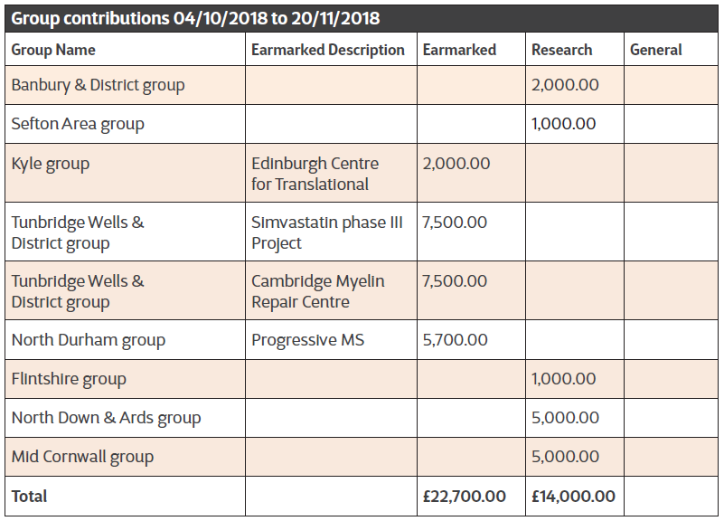
Table breakdown of each group donation since the last issue of TS.

