Teamspirit 223 – March
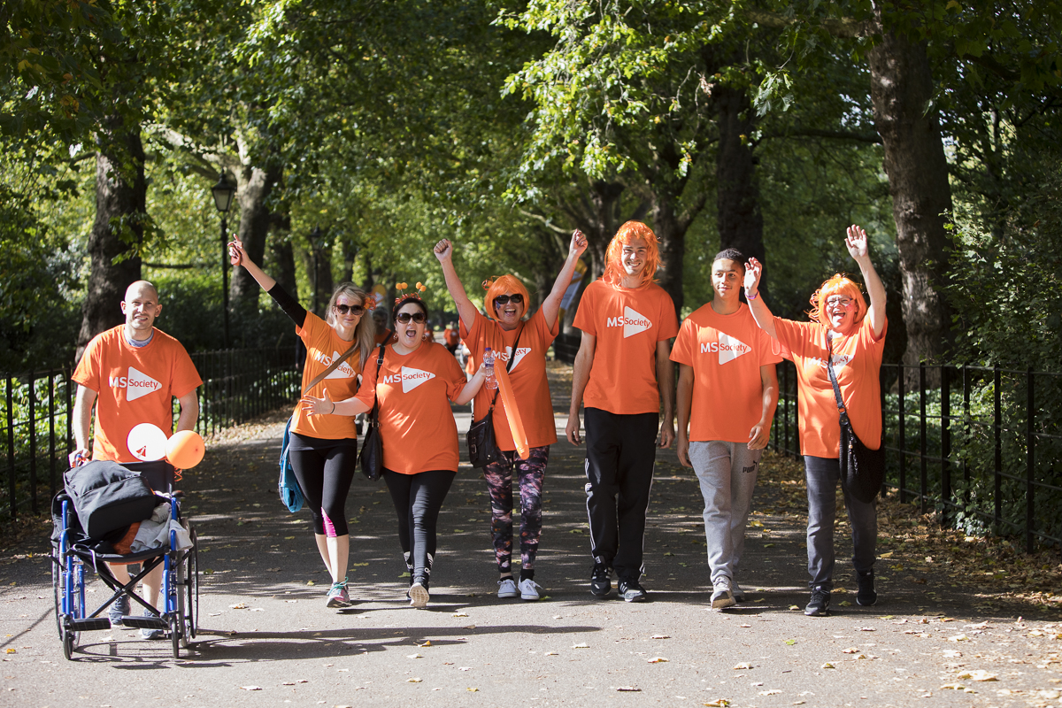
Walk for MS, your way
Since the first MS Walk in 2013, over £600,000 has been raised. With just 125 taking part in London in 2013, 2018 saw over 600 people braving the wet weather plus 72 taking part in Belfast, raising over £125,000 and £3,250 respectively that year.
This September, get involved by holding your very own MS Walk, in your very own way. However and wherever you get involved, you can become part of something special and together, we can stop MS.
Every penny you raise from your MS Walks will go to the Stop MS appeal which will fund vital MS research. The appeal is aiming to raise £100 million over 10 years to develop effective treatment for everyone living with MS.
This year, anyone, anywhere, can get involved with My MS Walk. It doesn’t matter how far you go or who you go there with; old friends, new friends or four-legged friends, the farther you go, the closer you will take us to stopping MS.
How to get involved:
- Pick a date in September and then plan a route (whatever the length) that's special to you, and walk, roll or stroll to stop MS
- Invite as many of your friends, family and colleagues as you like to your walk
- We will support you every step of the way and will send you everything you need to hold a fantastic MS Walk
- Please make it clear in all your communications with your donors and participants that all funds raised will go towards the Stop MS appeal.
If you are interested in holding your own MS Walk or have any questions, please do get in touch.
Contact: Joe Murray, Community & Events Officer
mswalk@mssociety.org.uk 020 8438 0725

Help, hope and voice
Investing in Volunteers - We did it!
We are delighted to announce that we have been awarded the Investing in Volunteers (IiV) standard!
IiV is the UK quality standard for good practice in volunteer management. We worked towards this achievement throughout 2018 and many of you took part.
Thank you!
A big thank you to everyone who made the time and effort to take part in the assessment, either in person or by phone, and the many more who took part by completing an online survey. Thanks also to the volunteers who joined our steering group, guided our thinking and contributed constructive criticisms and suggestions.
This award is based on your experience of volunteering with us - so this is despite the fact that for the last few years, there have been lots of changes; with local restructuring, updated volunteering roles, new legislation and technical challenges.
The process has highlighted some things we’re really good at, but also some areas we have room for improvement on.
What’s next?
We will begin by identifying what we need to do next, how we will do it and how best we can involve you.
Properly supporting our volunteers means that together we can continue to support people living with and affected by MS
Read more about IiV on the volunteer website here: volunteers.mssociety.org.uk/news/2019/02/investing-volunteers-iiv-we-did-it
Contact: Julie McWilliam, Volunteering Programme Manager
julie.mcwilliam@mssociety.org.uk

The difference we want to make
What’s most important to people living with MS? What’s most challenging and how do we make sure we’re meeting people’s needs?
Our current organisational strategy comes to an end this year. And as we develop our next strategy, we’ll need your knowledge and insight to make sure we’re focusing on the right things.
Why we need a strategy
Our strategy sets out the difference we want to make, and how. It defines our goals as a charity, and what we want to do now and in the long term. For us, our core vision remains the same: a world free from the effects of MS.
Building on what we’ve done so far
Like our current strategy, our new one will focus on the things that matter most to people living with MS. Our 2014-2019 strategy was endorsed by our members, after we spoke to the MS community about what they wanted.
And we’ve done a lot, with you and our community, to progress our seven 2014-2019 goals including:
• Speaking out and campaigning on access to treatments, the benefits system and social care
• Focussing research on developing treatments for progression, including co-funding a clinical trial testing of simvastatin, which can slow progression in secondary progressive MS
• Providing lots of new and long established services and support, both locally and nationally
You can read more about what we’ve achieved together at mssociety.org.uk/what-we-do/our-impact
Overcoming challenges
We know there’s still a way to go. There are still challenges accessing treatments, care and support and we strive to understand these the best we can (see My Ms My Needs article, page five). We want your input on what you think we should be focusing on and how we can support people living with MS now and in the future.
We may need to make some difficult decisions. But we’ll listen to you, people living with MS, our volunteers and staff– our whole community – to help make these decisions together.
Tell us what you think
Please take a few minutes to tell us what you think here: tinyurl.com/yyuu2yyw
Please also share this with your members so they can input.
Your feedback will be considered, along with all the feedback we receive - from members, our wider community and staff. It will also be discussed at the national council meetings in the spring to make sure all feedback is represented.
Thank you for taking time to tell us what you think. If you have any questions please let us know.
Contact: Strategy team
strategy2024@mssociety.org.uk

Let’s shout about Volunteers’ Week!
Volunteers Week is held from 1-7 June 2019 and it’s always a cause for celebration.
But this year is extra special for us. As mentioned on page two, we’ve achieved the prestigious Investing in Volunteers (IiV) accreditation and we want to shout about it!
We’re planning lots of events over the week to celebrate our volunteers’ achievements and we’re getting in touch now to give your group plenty of time to get involved.
Has a volunteer in your local group, or from another part of the organisation or country, done something to make you feel proud? Then what better way is there to celebrate this than by nominating them for a Shining Star award?
Now is the time to submit your Shining Star nomination and start planning a special celebration event to present your Shining Stars during volunteers’ week.
To make it even more special you could get local press involved, or take photos and videos to share on social media channels. Let’s get a record number of awards given out!
The volunteer website has lots of guidance to help with your celebrations:
- volunteers.mssociety.org.uk/shining-star-nomination
- volunteers.mssociety.org.uk/organising-events
- volunteers.mssociety.org.uk/press-and-publicity
- volunteers.mssociety.org.uk/online-promotion
We welcome your ideas and will be sending out more information over the coming months.
Contact: Volunteering team
volunteering@mssociety.org.uk

Help see our #MSSuperstars to the finish line at the London Marathon!
On Sunday April 28, nearly 300 MS Superstars will take their places in the world famous London Marathon, all aiming to run 26.2 miles to help stop MS.
Running a marathon is undoubtedly a huge challenge to undertake, and we need your help to motivate our fantastic team all the way to the finish line.
We will have three cheer points at Bermondsey, Tower Hill, and Westminster, we would love as many people as possible to volunteer and make sure the MS Society runners get the loudest cheers on the course!
On the day, you’ll experience the unbeatable atmosphere that the London Marathon has to offer, as well as showing your support for the MS Society team.
Here’s what one of last year’s MS Superstar runners had to say:
“Nothing could prepare me for the atmosphere … it was amazing, and having complete strangers scream your name in encouragement really gets you round!”
The team this year aims to raise almost £700,000; your support will make all the difference to ensuring the day is a success.
To sign up or for more information contact the team, or visit the website here: mssociety.org.uk/get-involved/fundraise/running/london-marathon
Contact: London Marathon team
londonmarathon@mssociety.org.uk

Win, donate or celebrate!
Enter our spring raffle
Our Spring Raffle was sent out to supporters recently. All tickets are in with a chance of winning a number of great prizes, with a top prize of £4,000 cash (!), for just £1 per ticket!
The closing date for online entries is 9 May, so get your entries in now at raffleentry.org.uk/mssociety.
Mobilise yourselves
An exciting new way to donate through your mobile phone has been launched! You can now donate £3 each month as part of your phone bill and you’ll have the option to stop or skip a donation, all via text.
Want to know more? Email Molly, our direct marketing officer, for information.
In Celebration
We’ve launched an exciting new range of products so that you can include the MS Society in your celebration.
Whether it’s a wedding, birthday or even a karaoke night, we’ve got lots of goodies you can use all while raising vital funds to support people with MS. Check out the new items at mssociety.org.uk/celebration and get partying!
Contact: Molly Amson Knight, Direct Marketing officer
molly.amson.knight@mssociety.org.uk

My MS My Needs
This year, we’ll be running My MS My Needs for the third time! This is one of the largest surveys of people affected by MS in the UK. The aim is to collect data about access to health and social care services relevant to people with MS, in different areas across the UK. Put simply – it asks whether people with MS are getting the treatments, services and support that they need.
Previous successes
My MS, My Needs was last run in 2016 and over 11,000 people affected by MS responded from across the UK. The results became the driving force behind a number of our campaigns and services. This time it will also be used to inform our next strategy (see page three).
Spread the word
We would love to hear from as many people affected by MS as possible, to see if things are heading in the right direction. Please spread the word to make sure everyone has the opportunity to have their say.
The survey is available online on the UK MS Register here: ukmsregister.org
You can also request a paper copy of the survey (available in easy to read, large print and Welsh language) by contacting our supporter care team.
Contact: Supporter care team
supportercare@mssociety
0300 500 8084
Information for your group
What’s new in the Group Handbook?
We’ve updated the Group Handbook to reflect all recent changes to the online tools and processes we all use.
What’s changed?
You can upgrade your MS Society email to give your group and individual volunteers better ways to communicate within your team and with others, whilst ensuring that you comply with data protection regulations. The Group Handbook now includes information about who needs an MS Society email address and when you must use it.
We’ve upgraded the Portal, so you can complete risk assessments online. And our new Online Shop is now open, enabling your group to order MS Society branded materials and information resources without charge. These changes are reflected throughout the Group Handbook, wherever we talk about our online tools.
We’ve also changed the way we support you to plan and deliver quality services. Instead of asking you to work towards formally assessed quality standards, we will support your group to provide accessible, safe, impactful services with our Service Level Agreement (SLA) templates and new safeguarding risk guidance. You’ll find links to these resources in the Group Handbook.
Where can I find the Group Handbook?
You can view the Group Handbook in its entirety, and in individual sections, on our volunteer website at volunteers.mssociety.org.uk/group-handbook. You can also click through to the relevant section of the handbook from any web page related to that particular topic.
You can request a printed copy by contacting our Services and Support Admin Team on 020 3828 6861 or ssadminhelpdesk@mssociety.org.uk.
When you’ve received your printed copy, please destroy any previous ones to ensure you’re always using the most up to date version.
Contact: Volunteer training team
Volunteer.training@mssociety.org.uk

South Devon Information day
On September 28 2018, our group in South Devon worked with Professor Jeremy Hobart from Plymouth NHS Trust, to deliver an information day at the Grand Hotel in Torquay.
The group organised the venue, advertising, bookings, programme and liaised with printers, speakers and delegates. Special thanks go to Christina, whose background in events really shone through, everything ran like clockwork and was really professionally ran.
Professor Hobart, who specialises in research into and treatment of MS, invited some of the leading researchers in MS from around the UK as speakers, including professors, doctors and specialists.
Due to the high quality of these speakers the event was over-subscribed by more than 100 people. It was therefore decided to record the event to ensure presentations would be available to the widest possible audience.
With thanks to Ben Noble at National Centre, the videos of each speaker are available online on youtube, here: youtube.com/playlist?list=PLseEst8sYZkSBHUI0_YUFbIa0OwyY7Owd
These videos are also available on DVD from the Group for £10.
We hope you find all the material interesting and informative, and like those of us who were present on the day; recognise that vital research is being conducted into our unpredictable and often debilitating condition!
Contact: Sandra Woods, LNO
sandra.woods@mssociety.org.uk

Support for volunteers
Reviewing how we support our local groups
We are very proud to have been awarded the Investors in Volunteering standard this year, however we recognise that there is more to do to ensure that we continue to improve the experience for our volunteers and in particular the support they receive from the organisation.
We want to be sure that the support we offer to our groups and volunteers reflects what is needed to enable them to be as effective as they can be – supporting the provision of vital local services and raising funds in the community. Whilst we need to manage risk and compliance with regulatory requirements, we recognise that sometimes our systems and processes can often seem burdensome and overly bureaucratic.
Therefore this year we will conducting a review into how we support our local groups and we want this to be led by the views of our volunteers. We want to understand the issues from your perspective and work together to design solutions that will improve our support. To this end we will be forming a reference group of volunteers from across the UK to input into the review and explore ways to enable all volunteers to contribute their ideas.
TThe first of these reference group meetings will be held at MS National Centre on Wednesday May 22, with further opportunities to meet face to face and via video conference throughout the summer and autumn.
If you would like to get involved in this reference group to help with this review, please let us know.
Contact: David Light, Local networks transformation manager
David.Light@mssociety.org.uk, 020 8438 0780

MS Helpline recruiting new Helpline Volunteers
Our MS Helpline answers roughly 18,000 enquiries a year, which would be impossible without our amazing Helpline volunteers. And we’re now recruiting new volunteers to help us support even more people with MS.
As an MS Helpline volunteer, you’ll provide information and emotional support to people affected by MS by telephone. Calls cover a range of topics including benefits, symptom management and the emotional effects of MS.
You’ll gain knowledge and learn new skills. And you’ll also be able to meet new people and be part of a supportive team. No previous experience is needed but we’re looking for people with good listening skills and a clear, warm telephone voice.
Our volunteers commit to a three or four hour telephone shift a week and volunteer from home. You’ll need a confidential working space, computer and broadband.
Get involved
If you’re interested in trying a new role at the MS Society or know someone who is, please apply online or contact us.
If you’re shortlisted, we’ll hold informal chats between 8-16 April. Face to face training for successful candidates is on 15 and 16 May in London. Following this, you’ll need to commit to 90 minutes of training over the phone per week, for the first eight weeks.
Contact: Emma Chudley, Interim Senior Helpline Support Officer for Volunteers
emma.chudley@mssociety.org.uk

Tee off with us
For many people, golf is a major part of their lives. What some may not know, is that it’s also an important way of raising funds to help stop MS.
If you or anyone you know is a keen golfer then it would be super to get them involved.
This could be by choosing the MS Society as their Captain’s Charity or through holding a charity golf day to raise funds.
We have lots of resources, ideas and enthusiasm to make such partnerships work and make sure that everyone involved has a great experience and knows the real difference that such support makes.
As part of this we have also set up a Facebook group for people interested in fundraising through golf to help them support each other’s events, share ideas and keep in touch, visit the page here: facebook.com/groups/MSSocietyGolf
Plans are also being developed for MS Society golf days in each nation in the autumn.
To find out more and for help to get your contacts involved, please let us know.
Contact: Your local Area Fundraiser.

Finance
Collection boxes and counting money
When organising a collection, please allocate an identification number to each collection box and make a record of it in a log. Also make a record of dates when collection boxes are issued, who they’re issued to/or store location, and when they’re returned to the group. Make sure to check boxes regularly to ensure they remain tamper proof and secure.
Following fundraising activities, it’s really important you follow some basic rules when counting money collected. These rules make sure you receive the correct funds and protects volunteers from wrongful suspicion of theft.
1. Always count money with at least two people, ideally with the collector and record the total. Never leave money unattended or in an insecure area.
If you struggle to find two people, please speak to your LNO, Area Fundraiser or Finance Support.
2. Please remember not to deduct any expenses from cash collected, all monies must be banked in full. Expenses should be claimed afterwards.
3. Bank all money into your group bank account ASAP. If this is not possible on the same day, please lock cash away securely.
4. Make sure that the amount shown in Online Accounting matches the income summaries/receipts you have. Contact us if there are mistakes.
Contact: Finance support team
financesupport@mssociety.org.uk

Transaction error in Online Accounting
Please accept our apologies for the recent error in Online Accounting. This occurred during the import of statements and was highlighted on the Online Accounting message board.
You will notice on your statement for the 24/01/19 the account balance is showing as an income transaction. To rectify this error you will see a reversing (expenditure transaction) entry of the same amount, on the same day.
Please kindly analyse both transactions into the same nominal account, so that they will cancel each other out and not affect your reports.
We suggest using the analysis ‘Other Costs’ for both transactions. When you click on ‘add detail’ for the income transaction, a box should pop up and the default is usually selected as ‘Income’. Please change this to the option underneath which is ‘Supplier Refund’. By doing this, you will be provided with the expenditure codes (within the nominal analysis box) and you will then be able to use ‘Other Costs’.
Again, we apologise for any inconvenience caused by this. If you have any questions or concerns, please let us know.
Contact: Finance support team
financesupport@mssociety.org.uk

Corporate Sponsorship – Fundraising Events
Corporate sponsorship arises when a business gives your group a donation and in return receives a benefit. This benefit could simply be in the form of using the company’s logo on printed matter, such as event banners or group newsletters, as this is viewed as a form of advertising by HMRC.
You can organise corporate sponsorship but only if it’s in relation to a fundraising event you organised. If you want to obtain corporate sponsorship in relation to anything else you’re doing, please speak to us first.
Before approaching other organisations for sponsorship, you may want to contact your local Area Fundraiser who can advise you and make sure all necessary agreements are in place
If you need an MS Society invoice raised, we can create one for you.
We hope you have an enjoyable and successful fundraising event.
Contact: Finance support team
financesupport@mssociety.org.uk.

Our groups and services
Equality, Diversity and Inclusion
Our vision is to ensure that we develop a fully integrated and embedded approach to Equality, Diversity and Inclusion (EDI) together. EDI should be present across all that we do, so that all people affected by MS in our local communities feel comfortable using our local group services.
We’ll support local groups to further understand the wider community they serve and to tailor their support accordingly. There are some things groups are already doing to encourage people from different cultures and background to join in their events and services such as:
- Choosing a community hall rather than a church hall
- Holding meetings in cafés as well as pubs
- Holding meetings during the day as well as in the evenings
- Including beef and vegetarian sausages at a BBQ and cooking these items on a different grill to pork and other meats
We expect that groups have other examples and useful tips of good practice in similar ways. We would love to be able to share these across the local group network, so please let us know what actions you have taken to open your events and services up to the wider MS community by emailing us.
Contact: Quality team
quality@mssociety.org.uk

Your MS Society group emails
With around a third of groups registered for the email upgrade, we’re making progress. We strongly encourage you to sign up for this upgrade as soon as you can so that your group are covered regarding GDPR legislation.
Please visit the volunteer website to read about all the benefits you will get when you have the new system, user and technical guides, and to access to registration form:
Information: volunteers.mssociety.org.uk/MS-Society-email
Form: volunteers.mssociety.org.uk/MS-Society-email#upgrade
E-learning
In order to use the portal and the email system, you’ll need to complete the updated GDPR e-learning. This is an easy to use, online piece of training which you can access via mobile devices on the move.
Volunteers who are in a coordinating role (plus some other volunteer roles), will have been sent this e-learning and we ask that you complete this asap please. Roughly 40% of those who’ve been sent the training have completed it, however, as above, this is a GDPR requirement and needs to be prioritised.
To find out more about the GDPR e-learning, visit the volunteer website here: volunteers.mssociety.org.uk/handling-data/data-protection-gdpr-elearning
Contact: Volunteering team
volunteering@mssociety.org.uk

Information services
Updated resources
- ‘Cannabis’ factsheet
The download-only factsheet from last November on medicinal cannabis has been updated. It now reflects what we now know about the difficulties in getting prescriptions. Find it at mssociety.org.uk/cannabis
- ‘Just diagnosed’ booklet
This key publication has been updated. Among the changes are mentions of HSCT and ocrelizumab, plus more on smoking, and a new cover. Order code remains the same (BK24). Find it at: mssociety.org.uk/care-and-support/resources-and-publications/publications-search/just-diagnosed-an-introduction-to-ms
- ‘Work and MS’ booklet
This popular booklet has been fully updated to reflect changes in support available to employees in the workplace. Find it at: mssociety.org.uk/care-and-support/everyday-living/working-and-ms/work-ms-and-you
New online shop and warehouse
The new online shop is now up and running! Access it through the same part of the volunteer website as you did before.
Please register for a group account using your group’s MS Society email address, by filling in the online form. You can find this form on the shop, by clicking the ‘log in’ button in the top right hand corner. Your registration can take up to 48 hours to approve before you can place orders.
The publications listed are all available from the online shop.
Please make sure to remove any old copies of these publications from circulation, as they are now out of date.
Contact: Supporter Care team
supportercare@mssociety
0300 500 8084

For England
Fundraising Forums and Training Workshops
If you’re one of our amazing Fundraising Volunteers, or maybe do some fundraising within your Group, there are some informative online (through Zoom) sessions coming up throughout the year, run by our talented and friendly Area Fundraising team.
Forums
These forums will be held bi-monthly beginning in March. You can bring your fundraising problems, questions, success stories and any other experiences you’d like to share with fellow fundraising volunteers from around England. They will be hosted by two of the Area Fundraising Team, who are not only there to support and facilitate; but also to make sure everyone goes away with answers to their questions.
To book onto an upcoming forum, please visit the volunteer website, here: volunteers.mssociety.org.uk/fundraising-forums-2019
Training
The training workshops will also be ran via Zoom, and are due to be held in April, June and October. These are structured training sessions on specific topics, details for April and June are listed below. Please note, the October session will be confirmed later in the year.
April - Organising an MS Walk - volunteers.mssociety.org.uk/events/2019/local-networks-learning-and-development-%E2%80%93-organising-ms-walk
As mentioned in the cover story of this issue, now is the chance to have your own local version of the MS Walk to raise funds for Stop MS, as well as raising the profile of your local Group. This session, run by Joe Murray (our MS Walk expert), will give you all the information, ideas and links to support you can tap into, if you decide to put on an MS Walk in your area. Whether it’s a large scale sponsored walk, or just a few like-minded friends going for a personal challenge, there’s an MS Walk for everyone.
June - Creating a Fundraising Calendar - volunteers.mssociety.org.uk/events/2019/local-networks-learning-and-development-%E2%80%93-creating-fundraising-plan
It is amazing how much smoother fundraising goes when you’ve got a plan! This session, run by Area Fundraisers, will be fun and interactive. The core objective is to encourage your group to set a fundraising plan to meet the needs of your spending plan, ideally ensuring you’re bringing in as much money as you’re spending! We’ll look at different events that can be organised, as part of a calendar year, to keep fundraising fresh and interesting for all concerned. We’ll also show how target setting and contingency planning can create some great successes!
Contact: your area fundraiser

For Northern Ireland
Personal Independence Payments
People affected by MS continue to transition from Disability Living Allowance to Personal Independence Payments (PIP) and some are applying for PIP for the first time. This can be a daunting and complicated process. With that in mind we have a referral process in place with Advice NI to provide specialist advice to people making an application or facing an appeal.
Despite this, we continue to hear about difficult and negative experiences with the PIP application process and assessment. In response we have also developed a relationship with the PIP assessor Capita in an attempt to find positive outcomes for people affected by MS.
We aim to apply pressure for solutions to be found to minimise and remove these negative experiences. Alongside taking individual cases and complaints to Capita, we also plan to provide specific training to their disability assessors and call handlers on MS. This work and a review of their existing training materials, will be led by people affected by MS who have experienced the PIP process.
If you have an experience of PIP we would like to hear from you. It could be something you think we should know or something you would like us to raise on your behalf.
Contact: Northern Ireland reception
nireception@mssociety.org.uk

Review of Neurology
In December, the Department of Health began work to fully review the delivery of neurology services in Northern Ireland. This is one of a number of steps being taken by the department following the recall of neurology patients under the care of Dr Watt.
The review will look at how the current services are planned, how well they’re working, how they can be improved and what resources will be required to provide a quality neurology service to everyone in Northern Ireland. Our NI Director David Galloway has been asked to sit on the steering panel for this review.
The Department of Health will be spending this year seeking views from patients and medical professionals before making proposals for improvements to the service. With that in mind, we’d love to hear from you and to have you involved in this.
Throughout the review, we’ll be highlighting the experiences and views of people affected by MS and how the service should be shaped to best meet the needs of the MS community. If you’d like to be involved in this or you’d like to share your views on the neurology service you currently receive and improvements you’d like to see, please contact us.
Contact: Northern Ireland reception
nireception@mssociety.org.uk

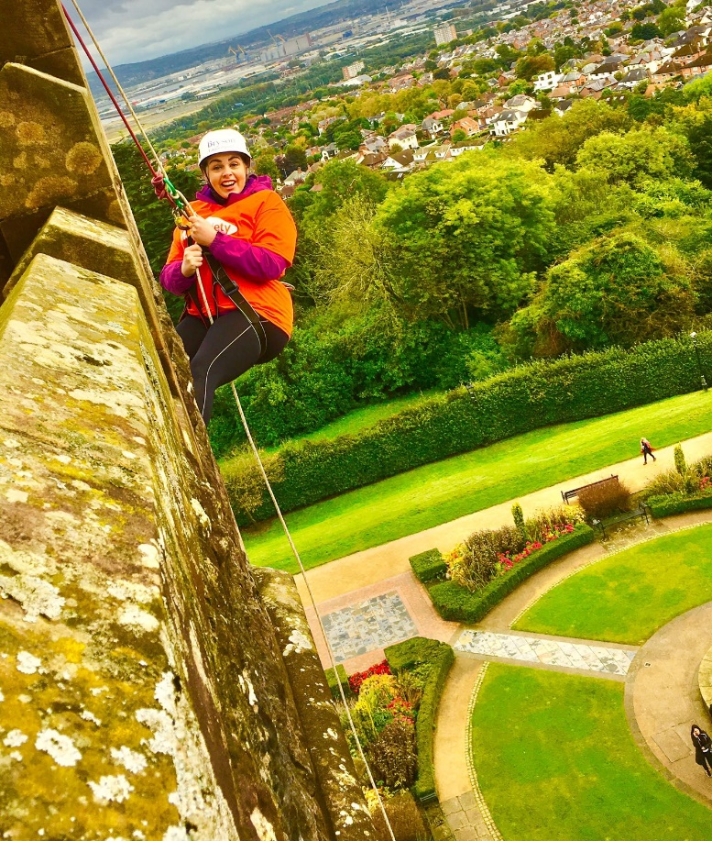
Fundraising opportunities for your group
We have a host of fantastic fundraising events lined up for 2019. These events are a real opportunity to raise funds for your group – and at no cost to the group. You can recruit participants to raise funds on your behalf and we take it from there – it couldn’t be easier!

We already have some great events for you to get involved with:
- Join our fantastic Belfast Castle abseil on Sunday March 31
- Take part in the very popular Run for Research event at Hollywood Exchange on April 14
- The Belfast Marathon takes place on May5
- Our super Zip it for MS event is on Saturday May 18
- And we have also introduced a new event for 2019 – our Big Leap skydiving event will take place at Garvagh on Sunday June 2
So lots of fantastic events taking place that you can use to raise funds for your group. Please get in contact to chat about how we can help you to recruit fundraisers at local level.
Fundraising volunteers required
We are always on the lookout for fundraising volunteers – people to help and support our fundraising programme by attending presentations, giving talks to local groups and generally helping to market and promote these events. Are you interested in getting involved or do you know someone who might be? If so, please get in touch.
Contact: Eve Shearer, Community & Events Fundraiser
Eve.Shearer@mssociety.org.uk 028 9080 2802
Share chalets

The team in Northern Ireland have two fully accessible chalets for hire at the Share village in Lisknaskea on the tranquil shores of Upper Lough Erne in beautiful County Fermanagh.

Share is an outdoor activity centre open to everyone and with plenty of entertainment options for the whole family. Share works for the inclusion of disabled and non-disabled people by providing opportunities for all to participate in a wide range of recreational and creative activities.

We’re able to offer our chalets at a much reduced rate to people with MS and their families. Our chalets sleep eight and come with access to the onsite fitness centre.

Contact: NI reception
nireception@mssociety.org.uk 028 90 802 802

For Scotland
Local groups help secure £151,000 in Tayside!
We’re delighted that hundreds of people living with MS in Tayside, are set to benefit from a new service– My MS, My Way: Tayside.
The service will assist more than 240 people with MS in Dundee, Angus and Perth and Kinross. Providing clinic support, counselling, self-management sessions and bespoke one-to-one peer support, this will run over two years.
Together with MS Therapy Centre Tayside, we’ll receive £132,773 from the National Lottery Community Fund, which is match-funded with £18,454 from the Community Innovation Fund, through the Tayside Health Fund. Our Angus, Dundee and Perth local groups played a key role in securing funding and will continue to work in the partnership.
Research found significant demand for increased support services in the area, particularly for people newly diagnosed with MS. This led to us co-producing My MS, My Way: Tayside with the local MS Therapy Centre.
The project was designed with input from a group of 35 local people with MS and activities will be delivered as part of a community partnership between local people living with MS, MS Therapy Centre Tayside, and our Scotland office.
A big thank you to everyone who’s made this vital work happen. Keep an eye out for more information!
Contact: Clair Bryan, Head of Services and Support, Scotland
clair.bryan@mssocierty.org.uk

Fan runs 150 miles to watch the Aberdeen game
Rangers fan and avid runner David Smith did the Proclaimers proud when he ran five ultramarathons in five days to attend February’s away match in Aberdeen!
David raised money for us as his wife has MS. Some donations also went to the Rangers Charity foundation. He’s been made a Rangers ‘True Blue Hero’ for raising over £7,000 and he’ll be presented with a medal by a first team player.
He started on Saturday 2 February following the Rangers v St Mirren match in Glasgow. After a pitch side interview and tunnel run, he received an incredible send off.
For the next five days David ran to Stirling, Perth, Forfar, Stonehaven and finally finished in Aberdeen, ahead of his club’s crunch-match against them.
Before starting his epic fundraiser David said: “I run to clear my head and be on my own so setting these kinds of challenges is something I really enjoy.
“I just hope to raise as much money as possible for some great causes that do fantastic work in Scotland.”
A huge thank you to David for his incredible support! Follow him on Facebook here: facebook.com/David-Smith-Runner-719822918122457/timeline/?ref=tn_tnmn
We know you come up with lots of creative ways to raise funds. So in each edition of Teamspirit we want to share examples from Scotland. We’d love you to send us your stories!
You can also contact the Scotland fundraising team for support if you’re organising a challenge or event.
Contact: Scotland press office / Scotland fundraising team
scotlandpressoffice@mssociety.org.uk / msfundraising@mssociety.org.uk

Gearing up to the Edinburgh Marathon Festival
An absolute highlight of our fundraising year in Scotland is the Edinburgh Marathon Festival weekend! Taking place on 25 and 26 May, we’ll be there to show the love and cheer on our huge group of #MSSuperstar runners, with the support of our fantastic volunteers!
There’s still time to sign up, either as a runner or a member of our volunteer Cheer Squad.
#MSSuperstar inspiration: Jo’s story
Jo Perrin, 24, from Edinburgh is running the Half Marathon in Edinburgh to help stop MS. She’s completing the challenge in support of her Dad, who’s lived with MS for over 10 years.
Jo said: “Not a day goes by that Dad doesn’t amaze me with how strong he is and he doesn’t let MS bring him down, even on the bad days.
“Signing myself up for a Half Marathon is totally out of my comfort zone but I want to make my dad proud just like he does me every single day.
“If my dad can achieve the things he does day after day then I can do this too!”
A huge thank you to Jo and everyone who’s taking part. Please help us spread the word and encourage more superstars to run or cheer for us!
Contact: Scotland fundraising team
msfundraising@mssociety.org.uk

Meet the researchers working to stop MS in Scotland
As part of MS Week 2019, we invite you to join us, along with our host George Adam MSP, at our MS Awareness Week 2019 reception at Parliament.
The reception will be an excellent opportunity to hear first-hand the positive impact research happening in Scotland has on the lives of people living with MS.
You’ll also hear about our ‘Stop MS’ campaign, which is launching later this year. This ambitious campaign aims to raise £100 million over the next 10 years for research, so that we can stop MS for good.
The event takes place on Tuesday April 23 at the Garden Lobby of the Scottish Parliament. Guests will be welcomed from 6.00pm with a drinks reception and speeches will begin at 6.15pm.
If you’d like to attend, please get in touch on the email address below. Please could you also let us know if you have any specific access needs or if you need personal assistance in the event of an evacuation.
To reserve your place at the reception please visit: eventbrite.co.uk/edit?eid=56879764908
Please get in touch if you want to know more.
Contact: Katherine Paterson, Communications and Campaigns Assistant, via the Scotland campaigns inbox
scotlandcampaigns@mssociety.org.uk

For Wales
MS Cymru leading the way for the MS Community
When it comes to accessing treatments and services, our evidence suggests that Wales’ offer is slightly behind the rest of the UK. This is why the Treat me Right campaign is our priority, you can read about the campaign here: mssociety.org.uk/get-involved/campaign-with-us/treat-me-right
People living with and affected by MS are at the forefront of this and alongside campaigning at a Wales wide level, lobbying Assembly Members and the Welsh Government, we also work locally to make changes; nowhere more so than in Llandrindod Wells.
For over four years, this group have worked tirelessly to make improvements to their services. They have engaged their local Assembly Member and the Local Health Board in what may have seemed like an endless battle - but it has paid off.
From spring 2019, people living with MS will be given a choice between staying with their existing service or the new provision from the MS Team based at Morriston Hospital.
We will continue working to improve services in all of the Local Health Boards’ areas. To get involved please contact us.
Contact: Fiona McDonald, Policy, press and campaigns manager
Fiona.mcdonald@mssociety.org.uk

Let’s get Active Together
Our Big Lottery Funded ‘Active Together’ project aims to support over 200 people in the Cardiff and Cwm Taf area to improve their quality of life, by getting and staying physically active and forming new friendships.
We are partnering with the National Exercise Referral Scheme (NERS) and the Physiotherapy Department from the School of Healthcare Sciences, Cardiff University. They’ll co-develop, deliver and monitor a 16 week bespoke exercise programme.
People living with MS will help to design and deliver the project, including being members of the advisory group.
Project coordinator Bethan is delighted with progress so far; “We’re developing a set of criteria so local mainstream gyms can benchmark; and people living with MS will be ‘mystery shoppers’ to assess how ‘MS friendly’ their exercise provision is.
“We’ll also be raising awareness in leisure centres on how to make their provisions more MS friendly.
“It’s been wonderful to have our first referrals to the project. People have told us that the lack of opportunities to exercise has affected their mental health and exasperated their MS.
“The project will also support our groups in Cardiff and Cwm Taf to put on exercise classes locally. If you’d like to be involved please get in touch”.
Contact: Bethan Moss, Project coordinator for Active Together / Julie Cole, Project administrator for Active Together
bethan.moss@mssociety.org.uk / julie.cole@mssociety.org.uk

Charity of the year round up
Last year, a number of clubs and associations who dedicated a whole year of fundraising activities for the MS Society. These included:
- Crynant Rugby Club near Neath
- Oprema Ltd in Cardiff
- St Marys Golf Club in Bridgend
- The Clwb Cefnogwyr Arsenal Gogledd Cymru - Arsenal North Wales Supporters Club
They pushed themselves to the limits and raised tens of thousands of pounds in the process. Activities ranged from auctions, tough mudder challenge events, pirate fancy dress competitions, dinners, golf tournaments, prize draws and even walks around monopoly landmarks in London.
Wales Fundraising Manager, Sian Dorward said;
“Local clubs, associations and businesses in our communities play a vital role not only in raising funds to support our work, but can also raise awareness of MS and promote our services.
“They are especially supportive if they have a local connection with someone living with or affected by MS.
“For example, the Masonic Charitable Foundation generously donated over £50,000 to support the work of our My MS My Rights My Choices project in Wales because they knew people living with MS.
“There are so many other business forums, sports clubs and so on throughout Wales who may be willing to support us.”
Please contact our Fundraising Manager here in Wales to find out how to reach out in your community.
Contact: Sian Dorward, Fundraising manager, Wales
Sian.Dorward@mssociety.org.uk

2019 Fundraising dates
March 23: Great Orme Giant Walk, Llandudno
June 2: The BIG Leap Cymru, Swansea Airport
June 8: Zip World Velocity 2, Zip World (Penrhyn Quarry) Bethesda
June 28 – 30: Snowdonia Challenge, Snowdonia
July 6: MS Choir concert St Asaph Cathedral, St Asaph, North Wales
July 6: TrekFest - Brecon Beacons National Park
August 15 – 18: Wales End to End 2019 (Cycling Challenge) Anglesey to Cardiff
September 22: Admiral Swansea 10km, Swansea
October 6: Cardiff Half Marathon
Contact: Sian Dorward, Fundraising manager, Wales
Sian.Dorward@mssociety.org.uk

Group Contributions
Thank you to all groups for your contributions. They’re all gratefully received.

