Teamspirit 225 – July
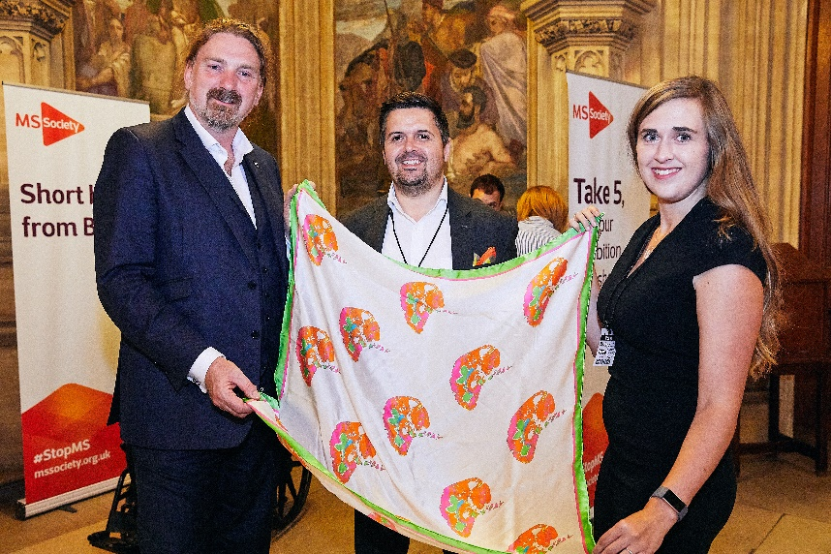
MS – the Research story.
Last month we went to Westminster with an exhibition about MS research for MPs and peers - Multiple Sclerosis – the Research Story. The exhibition was a fantastic way to raise awareness of the exciting potential of new MS research and to share people’s stories of what it is like to live with MS.
Politicians from across the UK came to visit the exhibition which was made up of stories from people with MS and scientists about their hopes for the future of research. It also featured objects which the people with MS and researchers featured in the exhibition had chosen to represent ‘what MS means for them’.
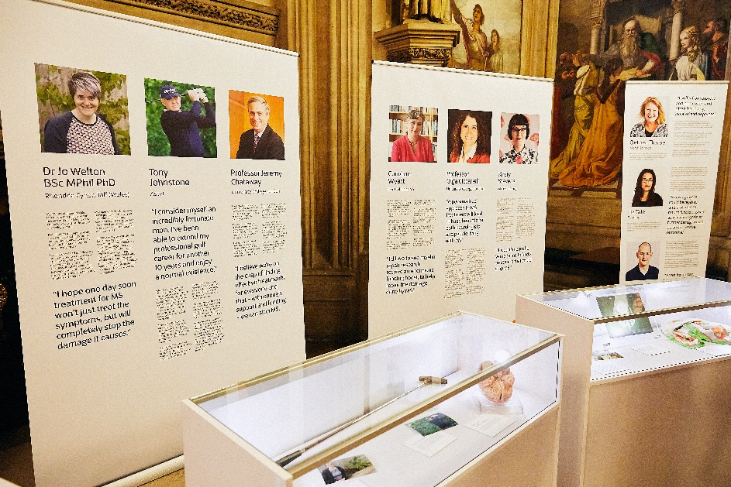
These featured objects ranged from clothing and jewellery to a walking stick and even a scrabble board. One of our case studies, Kirsty, who is an artist from Scotland, sent a silk scarf printed with a design she created from her MRI scans (pictured on the front cover being displayed by Kirsty's brother Ross, his partner Sophie and MP Chris Law.)The exhibition showed MPs how everybody’s MS is different and that new research could have a really exciting effect for our community.
Decades of research have got us to a critical point in research and we want everyone to know how we’re going to stop MS. As you know, we’re launching The Stop MS Appeal shortly which aims to raise £100 million to fund ground-breaking research, so we can find treatments for everyone living with MS.
The Appeal will be launching publicly in October with a big advertising campaign and there’s all sorts of ways to play a part in raising the £100 million together to stop MS. These range from hosting a Cake Break or a sponsored My MS Walk, to taking a big leap by doing a sponsored sky dive.
But this is just a starting point! If we’re going to raise the £100m, we’ll need as many different and innovative ideas as possible. More information and ideas for getting involved are on the volunteer website here: volunteers.mssociety.org.uk/stop-MS-appeal
Contact: Campaigns team campaigns@mssociety.org.uk
Help, hope and voice
Updates from Nick
As you’ll know, Nick Moberly, our CEO, started with us earlier this year. You should’ve received an email video message to your group email account and your personal email from Nick recently. Nick will be in touch regularly to share news and invite you to feedback and get involved in lots of things.
In January, Nick spent time with some local groups and got to meet many of our volunteers.
Nick said about his visits:
“It’s been great to speak to many members and understand more about the personal impact of MS… I was struck by how strong a sense of friendship and community there was, and people clearly valued all the activities on offer. Thank you for being so welcoming – our groups do such a fantastic job!”
2019 - an exciting year!
This year we’re developing our next strategy and looking at how we operate to ensure we’re set up to best support the MS community now and in the future.
Not only that, we’ll launch our biggest ever appeal – Stop MS.
Hearing from you
Your input is so important in helping develop how we do things and our focus for the future. There’ll be lots of opportunities to get involved and share your views. Nick will be in touch regularly (about every six weeks) with the latest.
If you didn’t receive an email from Nick and would like to please contact Supporter Care and provide your email address.
Contact: Supporter Care team
supporter.care@mssociety.org.uk
0300 500 8084

Celebrating Carers Week

10 – 16 June was Carers Week! To celebrate it this year we came together with six other charities to focus on getting carers connected. Carers make such a valuable contribution to the MS community, but we know that without the right help, caring for somebody can be really challenging.

Research tells us that unpaid carers who look after loved ones with an illness, disability or long term condition are seven times more likely to be lonely compared with the general public. This is why it’s so important carers are getting connected to the right financial, emotional and practical support. If you care for someone with MS, we have information and resources to support you.

Westminster and a Tailormade song

This Carers Week, we headed to Westminster with Charley and her dad Doug (who lives with MS) and Richard and his brother Rodney (who lives with MS) to speak to MPs directly about the challenges carers face and what could help – including the need for urgent funding and a long term solution to end the care crisis.

We also celebrated the caring relationship with ‘Team of Two’, a song written by singer Jack Frimston from The Tailormade. Jack, whose mum lives with MS, was inspired after meeting Marie who won Carer of the Year at the 2018 MS Society Awards, and her husband, our Ambassador Stuart Nixon MBE. Head to our website here to read more and hear the song!
mssociety.org.uk/care-and-support/online-community/community-blog/team-of-two

Contact: Campaigns Team
campaigns@mssociety.org.uk

The MS Register on the road
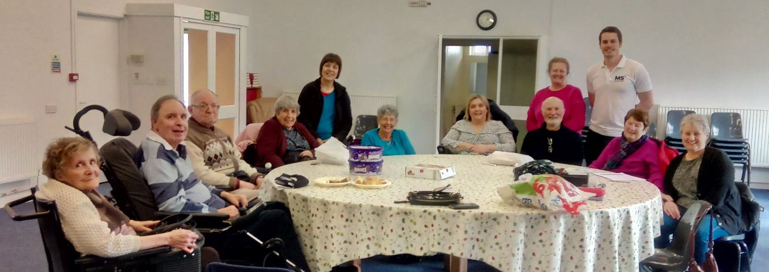
We’ve funded the UK MS Register since its launch in 2011. The Register, is designed, operated and maintained by the Health Informatics Group at Swansea University Medical School. It captures real world data about living with MS in the UK from different sources – most importantly directly from people living with MS and from the NHS. Last September, the Register re-launched its website with new features and functionality.
There are over 17,000 participants, a quarter of which have also linked their clinical data to their individual responses on the website. For the Register to be successful and lead to better research, it’s really important that people living with MS take part.
The MS Register team have been meeting participants and prospective participants by attending meetings at our local groups. Most recently Cambridge & District and Swansea & District groups
Following these meetings the MS Register Team said “we’ve learned a great deal, about our website and newsletter, how groups interact with our NHS partner sites and how we can spread our message further. We’ve met some fantastic people and we thank everyone for their valuable feedback.”
If you have MS, and you haven’t already, please register online with us at ukmsregister.org and tell us what you think. The potential for MS research is huge!
Contact: Evidence team
evidence@mssociety.org.uk

What’s coming up in fundraising?
Summer raffle
Our Summer raffle is now open! Why not take part for a chance of winning £4,000 or one of over 30 great prizes for just £1 per ticket! There’s also a bonus draw with a chance to win £300 just by filling in a crossword – keep an eye out for MS Matters with more information. The closing date for taking part online is 22 August, so get your entries in now at: raffleentry.org.uk/mssociety/entries
MS Advances
The July Advances magazine has just gone out to 45,000 of our supporters across the nation. The magazine will feature latest research news, some of the amazing fundraising undertaken by supporters in recent months and upcoming events, as well as a delicious recipe from Michelin-starred, TV chef Tom Kerridge!
Kiss Goodbye to MS
Following the success of last year’s launch we’re again excited to be joining forces with MS charities around the world to take part in Kiss Goodbye to MS.
To join the fun and help us Kiss Goodbye to MS, we are asking people to give up their favourite luxury or worst habit for the month of September!
What people choose to ‘kiss goodbye to’ and for how long is up to them. We’ll be sharing ideas and hope that there’ll be something for everyone – from giving up chocolate for a month to kissing goodbye to make up for a day!
Contact: Molly Amson Knight, Direct Marketing Officer
Molly.amson.knight@mssociety.org.uk

Walk, roll or stroll with the brand new My MS Walk!
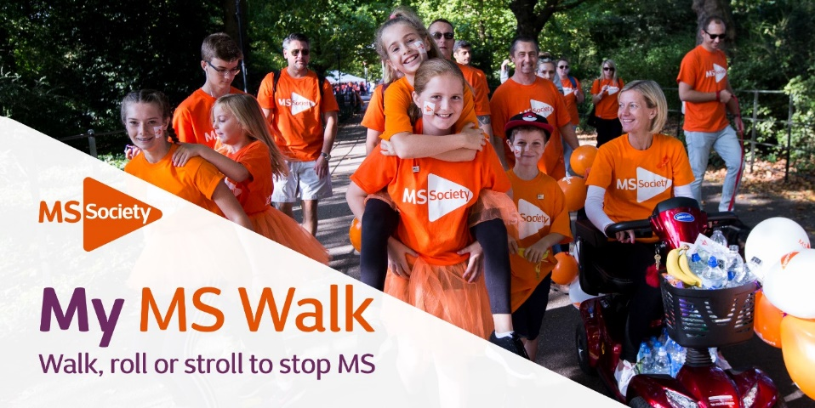
My MS Walk is brand new for 2019, and it’s the perfect way to raise funds for our Stop MS Appeal. Organise your own walk, roll or stroll, and the money you raise will fund life-changing MS research.
Whether you need practical support or fundraising materials, we’re here for you. When you sign up for My MS Walk, you’ll receive:
- The handy My MS Walk fundraising guide with loads of practical advice and fundraising tips
- Support from Joe and Angus in our My MS Walk team
- Access to plenty of materials to help you plan the perfect walk
- Access to the downloadable event toolkit to get started
If you’re thinking of organising your own MS Walk, visit volunteers.mssociety.org.uk/my-MS-walk where we’ve put together everything your group will need to get your MS Walk underway.
If you’re interested in taking part in MS Walk 2019 or have any questions, please do get in touch.
Contact: My MS Walk team
mswalk@mssociety.org.uk
0300 500 8084

Information for your group
Email support service for Newly Diagnosed
We know that being diagnosed with MS can feel overwhelming, but we have a whole community of people here to help. We’ve recently launched a new email service which provides support and information for anyone who has been newly diagnosed.
By talking to people with MS we have brought together information and advice on what was important to them when they were newly diagnosed. Our new email service can help people learn about MS and how MS affects each person differently. There is also support and information about managing the symptoms, so each individual can learn ways to help them to live well with MS.
Our MS community often tell us that it’s hard to tell people that you have MS and that receiving a diagnosis can also have an impact on relationships. So we’ve asked for tips on how to tell family and friends or work colleagues.
People who have been newly diagnosed will be sent a series of emails, once a month to help them make sense of their diagnosis. This email journey will tell them about all the support and information we provide including our online community and how to get in touch with a local group.
To sign up for this service, all someone needs to do is visit our newly diagnosed webpage here: mssociety.org.uk/care-and-support/newly-diagnosed
Contact: Resources team
resources@mssociety.org.uk

Simple sign up to our new online shop
You’ll already know about our new and improved online shop which launched not so long ago. If your group hasn’t yet signed up for an online shop account, the quickest way to do so is to pay a visit to: mss.ecgroup.net/
All you need to do is click on ‘Register’ and fill out the form with your group details. Please note, each group can only have one shop login and when registering your group for an account you need to use your group’s MS Society email address e.g. Leeds@mssociety.org.uk and not a personal or individual email address.
Once you’ve got an account set up you’ll see that there’s a huge number of our MS information leaflets and some great fundraising materials available
A handy tip whilst shopping online… if you find an item you’re keen to order but it’s out of stock, just click on the ‘notify me when available’ button and you’ll get an email once it’s back in store to order!
If you have an order query you can contact the shop team.
Contact: Shop team
shop@mssociety.org.uk
0300 500 8084

Changing how grants are paid
Our grants make a real difference to people’s lives. We know how hard you work to raise money for grants and how rewarding it is to support people affected by MS in this way.
Why they’re changing
Managing the finances for our grants is complex and we want to focus on simplifying this, so that the process, as well as our budget and expenditure is clearer. This will also help us make the most of our limited funds to achieve the biggest impact for people affected by MS.
We’d like to pilot a new approach for six months from June until December and then test if these changes have simplified things.
What’s changing?
At the moment, when National Centre and a local group both contribute to a grant, the full amount of money is paid up front to the supplier either by national centre or the group. Then either National Centre claims back the agreed proportion from the group or the group, claims back the proportion via transfer from National Centre.
But with the new process, there will be no need for these internal transfers of money back and forth between group and National Centre. Both parties will now pay their agreed proportion directly to the supplier, except in exceptional circumstances where this isn’t possible.
You can find full information on this on our volunteer website here: volunteers.mssociety.org.uk/changes-our-grants-process
Contact: Grants team
grants@mssociety.org.uk
0300 500 8084

Newspaper licensing regulations reminder
Like lots of other charities, we pay the Newspaper Licensing Agency (NLA) an annual fee so we can share media coverage we’ve achieved - or anything else that’s relevant to the MS Society or MS - with staff.
The NLA exists to copyright anything created by newspapers, and covers thousands of printed and online titles. However, it’s expensive and the licence only covers staff and not volunteers.
We understand you want to tell others about our work, but unfortunately the NLA’s regulations are strict. So we want to make sure you’re aware of the restrictions so that copyright isn’t accidently breached. A breach could happen if you photocopy any newspaper coverage or share those copies with other volunteers on email or social media and it could put us at risk of a fine.
The licence doesn’t, however, prevent you from sharing links to online articles, it just means you can’t copy and paste a headline or chunk of text.
Contact: Press Office team
pressoffice@mssociety.org.uk

Support for volunteers
Fundraising Training and Forums
Do you feel your fundraising skills could use a boost?
Well, we’re running some fundraising training sessions and forums to give you the skills you need, and all without even leaving the house.
All of these sessions can be joined online through Zoom, so they’re really accessible. We’re already having some great response to our forums so far and are looking forward to seeing more of you joining one of the upcoming events.
The forums help you with any problems you’re having with fundraising, along with the opportunity to chat with like-minded volunteers. Our Area Fundraising Team are hosting these events, which means you’ll get the latest updates. Our upcoming forum dates are:
July 16 – 12pm-1.30pm
September 24 – 6pm—7.30pm
November 21 – 12pm-1.30pm
Skills sessions
We’re also running some specific skills sessions based on topics we’ve been asked about.
October 17 – 12pm-2pm – Writing an Awards for All bid
Book your place now!
All sessions and forums are available to book in on our volunteer website here: https://volunteers.mssociety.org.uk/events
Contact: Simon Moran, Area Fundraiser
simon.moran@mssociety.org.uk

Property and Transport audits - 2019
Thank you for everyone who took part in our 2018 transport audits. It was the first time we’ve used an external contractor, SOCOTEC Ltd, to carry out the audits and our administration team only then had to process and follow up on them. Although there are a couple of areas we’re still working on, the process was more effective than any we’ve run in the past.
We also now have, for the first time, a full record of risk assessments and supporting documents for each group with property or transport that has completed the process.
SOCOTEC Ltd will be carrying out the audits again in 2019. Issues that were raised by you and the administration team in 2018 have been highlighted with them so that the audits can run as smoothly as possible and that the records the auditor takes away are accurate.
You will have been contacted during June and provided with contact details along with a list of documents you’ll need to provide for your audit. A contact from SOCOTEC Ltd will then communicate with you directly to arrange an audit, it is planned for this process to start in July.
If you have any questions in the meantime please do get in touch.
Contact: Jo Duffy, Head of Health and Safety
Jo.Duffy@mssociety.org.uk

Have you upgraded your group email account?

Great news! Well over half of our groups have already upgraded or started the process of upgrading to the new MS Society Email addresses.

Those groups are enjoying a new range of facilities such as:

- individual email addresses

- mobile and tablet access

- access to multiple Microsoft packages

- password self-reset

- shared file storage and calendar

Most importantly this means that these groups are now compliant with GDPR (General Data Protection Regulation) requirements and are handling data in a secure way.

Upgrade now

If your group has not upgraded yet, not only are you missing out on new features but crucially, if you continue sharing log-in details to your current group inbox (shared user name and password) you are breaking GDRP regulations and risk making personal data insecure (a data breach).

We’d encourage you to upgrade to the new system as soon as possible. It’s easy to do and there’s plenty of support along the way, both from our Volunteering team and on the volunteer website here: volunteers.mssociety.org.uk/news/2018/08/ms-society-email-upgrade

Sign up on the volunteer website now: volunteers.mssociety.org.uk/node/974/#upgrade

Contact: Volunteering team
volunteering@mssociety.org.uk

Help us to help you
We hope we’ve covered everything you could possibly want to know, and more, about data protection and GDPR (General Data Protection Regulations) by now!
If you want a refresher, our guidance can be found in the Handling Data section of the Group Handbook on the volunteer website here: volunteers.mssociety.org.uk/resources/group-handbook-a6-handling-data
There was also a GDPR Teamspirit Special Edition issued in May 2018 in time for the regulations, this is also available on the volunteer website here: volunteers.mssociety.org.uk/resources/teamspirit-data-special-pdf
Need more?
- Do you still have unanswered questions?
- Would you like more information on any of the processes you carry out?
- Are you unsure that you are doing the right thing?
- Are you not sure what a data breach actually is?
The data governance team is here to help with any questions, just send us an email telling us what you’d like more information on and we’ll make sure we cover these in informative articles in future issues of Teamspirit or in the updated FAQs on our volunteer website here: volunteers.mssociety.org.uk/resources/GDPR-FAQ
We’re here to help your group to be fully compliant and maintain that compliance so that we’re all protected.
Contact: Data Governance team
datagovernance@mssociety.org.uk

Finance
Reviewing your group finances
You know how important it is that your Coordinating Team meet regularly, to discuss and review your group’s finances.
Key queries to discuss at these meetings:
- Are we raising enough money to sustain the services and activities we currently provide?
- Are we getting the best value for our money?
- Are we using our funds in the best way to meet the needs of people affected by MS in our area?
- Are there excess funds in our account (more than 1 year of expenditure)? How can we use these in a timely manner?
Key topics to cover:
- Receipts and Payments Report - Finance Volunteers are responsible for presenting these. All transactions within Online Accounting need to be analysed before this is produced. The report should be circulated even if the Finance Volunteer produces their own report.
- Group bank balance –shown at the bottom of the Receipts and Payments Report, this must be monitored to make sure your group can continue group activities. If you’re concerned about not having enough funds, please contact Finance Support and your LNO.
- Agree income and outgoings – You’ll need to ensure you have sufficient income to support outgoing monies. Expenditure needs to be agreed between all members of the Coordinating Team.
- Review bank mandate – groups signatories need to be members of the Coordinating Team.
- Review of financial controls – you’ll need to ensure sufficient controls are in place as per the Internal Financial Controls Checklist – this is based on Charities Commission guidelines.
We’re here to help if you have questions or need support.
Contact: Finance Support team
financesupport@mssociety.org.uk
0131 335 4078

Online Accounting and HMRC
We are required to submit a VAT return to Her Majesty’s Revenue & Customs (HMRC) on a quarterly basis and to report on all income received, and any VAT paid on expenditure.
To ensure we don’t incur penalties from HMRC, you must ensure that all of your group’s transactions are analysed on a monthly basis on our Online Accounting system. For example, transactions dated June will need to be fully analysed by end of July etc. If you have transactions relating to an earlier period, these must also be analysed.
Your group co-ordinating team are collectively responsible for making sure that Online Accounting transactions are kept up to date. If you think your group will struggle to meet the above requirements, or aren’t sure how to analyse transactions without supporting paperwork, please contact Finance Support as soon as possible.
Contact: Finance Support team
financesupport@mssociety.org.uk
0131 335 4078

Contactless Payment Device
We know it’s something that you’ve been asking for, for your groups and we want to thank you for your patience whilst we looked into the various contactless payment devices on offer. We wanted to make sure that we offered a device that is easy for you to use, cost effective, and ensured that donations and supporting data are processed in a secure way.
iZettle
We have chosen the solution offered by iZettle.
An email providing further information on this was sent to all MS Society group email accounts on 17 April, with a full step-by-step guide on how to sign your group up to receive an iZettle contactless payment machine.
By the end of May we already had 6 local groups who had signed up to receive an iZettle device and they have so far collected donations totalling £625.
If you want to sign up, have any further questions after reading the guidance or if you aren’t able to access the email sent to your group, please get in touch.
Contact: Finance Support team
financesupport@mssociety.org.uk
0131 335 4078

Online Accounting – Login Details
The security of financial information is very important and here are some tips for using our Online Accounting system:
- Make sure your password is changed at least every 6 months. Passwords can be reset once you have logged in. This can be done by clicking on User Settings at the top right of the home page.
- If your web browser prompts you to ‘auto-save’ the login details or password to Online Accounting, please select ‘No’, otherwise it won’t let you log back in once you change/reset your password.
- Your login details shouldn’t be shared with anyone else – they are unique to you.
As part of the Internal Financial Controls Checklist requirements, a minimum of two members of your Coordinating Team need to be set up on Online Accounting. Ideally the Finance Volunteer should have administrative rights and the Group Coordinator would have view only access.
If you need additional login details for your group contact the Finance Team where we can issue these and provide one-to-one training for Online Accounting. Training on using Online Accounting and advice on how to run reports can be provided to all co-ordinating team members.
If you have any queries, please contact Finance Support.
Contact: Finance Support team
financesupport@mssociety.org.uk
0131 335 4078

Our groups and services
Group showcase: Aberdeen
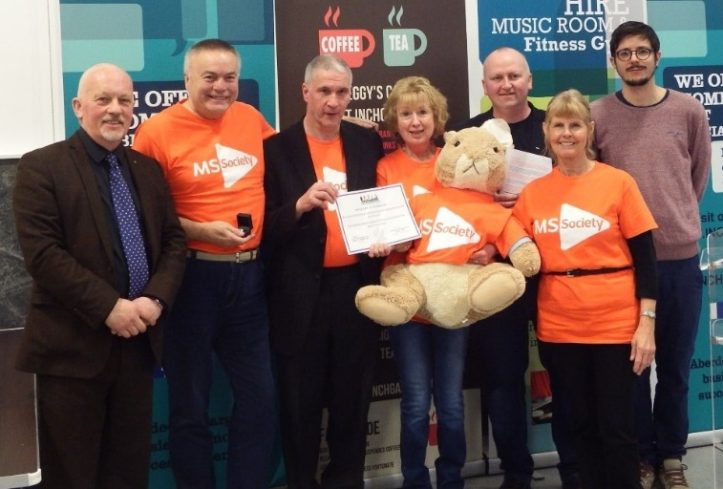
Our Aberdeen group have a jam-packed schedule of activities raising funds and offering support to the MS community in their area!
The group hold exercise classes six days a week as well as craft and mindfulness classes and a games club.
Further afield the team recently met up with their Dundee counterparts to plan a visit to the new V&A museum and they also hosted a Bingo and supper night.
Dedicated volunteers: Bob, Ian, Chrissie and Jules (pictured above with Paul O’Conner OBE and Councillor Gordon Townson) also gratefully received the Queens Award for Volunteering Services at the Inchgarth Community Centre recently.
You can find out more about their amazing work on their Facebook page: facebook.com/MS-Society-Aberdeen-118034518782779/
We love to hear about your success stories – please send us them for inclusion in one of our publications or online!
Contact: Scotland press office
scotlandpressoffice@mssociety.org.uk

Supporting fundraising cyclists and runners in our local groups
It’s great that so many people are keen to take part in an exciting range of cycling and running challenges to raise money for their local group. So that we can make sure that these people are getting the support and information they need as well as their vest/jersey; we’re asking everyone to register their participation in these events.
We’re asking for this, so that we can make sure that they’ll receive everything they need ahead of their challenge. Registering helps us to know who’s taking part, makes sure we transfer the money they raise through their online donation pages to the local group and helps improve their experience of supporting us. So if you or someone you know is taking on a challenge to raise money for your group, please make sure to get the support needed from us.
To register and take part visit our website here: mssociety.org.uk/fundraising
Contact: your local Area Fundraiser.

Membership for Group Coordinating teams
We know how difficult it can be to find new volunteers to join your coordinating teams and we want to make it easier for groups to recruit the people they need. So we’ve removed the requirement for coordinating team volunteers to be or become members of the MS Society before joining coordinating teams.
Being a member of the MS Society has great benefits, which include having a say at the AGM on the way that we’re run, and receiving regular news and features via our excellent MS Matters magazine, however, we feel that being a member should be optional for our group volunteers rather than a condition of their volunteering.
As you’ll already know, we’re currently reviewing our membership model and at the 2019 AGM in September, we’ll update members on our plans to grow our community by exploring the possible ways to modernise our membership model.
Contact: localnetworkprogramme@mssociety.org.uk

Membership data
It’s really important that the details we hold on our members is up to date. Having up to date information means that members can be communicated with in the way that they have told us they would like to be. This is one of the many things that our Supporter Care team are here to help with. So please get in touch if:
- a new member joins your group or if a volunteer leaves
- anyone at your group renews their membership
- your members make you aware of a change to their address or contact details
Open to all
Whilst data for members needs to be up to date, our services and support are open to all. The team have recently spoken to a few people affected by MS who have tried to access services provided by groups and were told that they need to be a member to do so. As a reminder, services that groups provide are open to both members and non-members as detailed in the Group Handbook under section A2, you can view the handbook on the volunteer website.
Contact: Supporter Care team
supportercare@mssociety.org.uk
0300 500 8084

For Northern Ireland
Neurology recall update
As you will be aware, last year the Belfast Trust conducted a recall of neurology patients under the care of Dr Watt. Since that recall was announced, the MS Society has been in contact with the Trust and the Department of Health.
We’ve been tracking how that process was being conducted and ensuring the interests of people affected by MS are represented, including those who have received life-changing news such as changes to diagnosis or treatment. Some of those most impacted by the review have been in touch with us, some have made use of our counselling service, and others have worked with us in presenting their experiences and concerns directly to health service and political decision makers.
We are expecting the Department of Health to publish its findings from the recall soon. We don’t know the exact date, so this may already have happened before this publication. But it’s not too late, if you’ve been affected by the recall, the publication of the findings, wish to talk to us about your experiences or to help us ensure the Department of Health learns from this and makes improvements to the neurology service, please let us know.
Contact: Stewart Finn, Press, Policy and Campaigns Manager NI
stewart.finn@mssociety.org.uk

Groups cash in
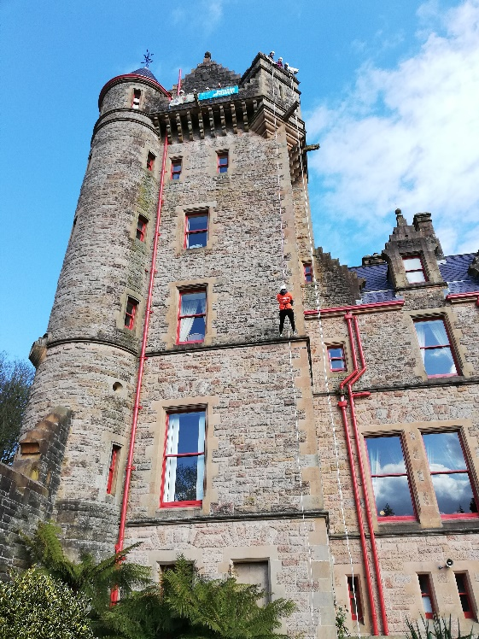
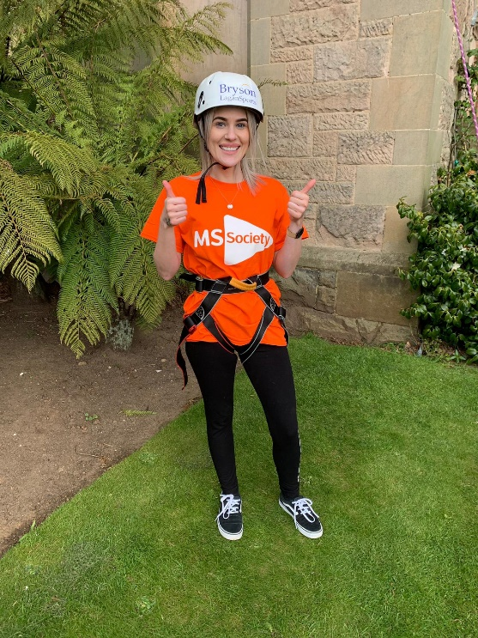
Our Fundraising team organise a range of events for your groups which are a wonderful opportunity to bring supporters together and raise funds.
Our Ballymena, Omagh and Craigavon groups recruited participants for our recent Belfast Castle abseil (pictured above with one participant Orlaigh Molloy) and raised a staggering £5000 between them! The funds raised on behalf of the groups will be used by them to provide services and support for local people living with MS. The real bonus for groups is that we take care of all the organisation and administration for these events. All you need to do is help recruit people from your group and local community who are prepared to take part and raise money for their local group.
We’ve got a range of exciting events coming up this year, including our all new Slieve Donard Sunrise Walk in August, our MS Walk in Belfast in September, our Europa Hotel abseil and our Darren Clarke golf events in October.
For more information on how to get your group involved
Contact: Fundraising team
nireception@mssociety.org.uk
028 9080 2802

Champion the ‘Stop MS’ Appeal
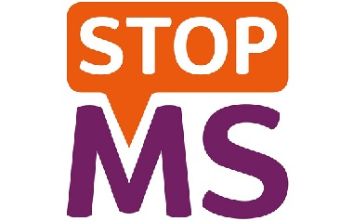
With the launch of the Stop MS Appeal public phase approaching, we in Northern Ireland are looking for potential Stop MS Appeal Champions.
We’re recruiting volunteers from across Northern Ireland to help us raise awareness and understanding of MS and to promote the Stop MS appeal. The Champions will represent the MS Society with a focus on the appeal.
What it will involve
The role will involve public speaking and approaching local companies, community groups, organisations, schools and individuals. Some public speaking experience would be helpful but we will provide training and ongoing support for all our Champions.
If you’re interested in the role, know someone who might be interested or if you would like more information please get in touch.
Contact: Tom Mallon, Fundraising Manager NI
tom.mallon@mssociety.org.uk
028 9080 2802

Share chalets
The team in Northern Ireland have two fully accessible chalets for hire at the Share village in Lisknaskea on the tranquil shores of Upper Lough Erne in beautiful County Fermanagh.
Share is an outdoor activity centre open to everyone and with plenty of entertainment options for the whole family. Share works for the inclusion of disabled and non-disabled people by providing opportunities for all to participate in a wide range of recreational and creative activities.
We’re able to offer our chalets at a much reduced rate to people with MS and their families. Our chalets sleep eight and come with access to the onsite fitness centre.
Contact: NI reception
nireception@mssociety.org.uk
028 90 802 802

For Scotland
MS Week puts research on the agenda
Scotland’s First Minister Nicola Sturgeon was one of 105 MSPs to pledge their support to the fight to stop MS during this year’s MS Week.
We’re delighted to have such widespread cross party support, following our reception in the Scottish Parliament.
140 guests attended our reception, including 20 MSPs and the Minister for Public Health, Sport and Wellbeing, Joe Fitzpatrick. The event focused on the positive impact of MS research happening in Scotland and our Stop MS campaign, which is launching later this year.
Hosted by George Adam MSP, the inspiring evening included fantastic speeches by Professor Siddharthan Chandran from the MS Society Edinburgh Centre for MS Research and by Stephen Ritchie, who is taking part in the MS-STAT2 trial in Edinburgh. The trial is testing if simvastatin can slow progression in secondary progressive MS.
The following day Mr Adam hosted a debate about MS in the chamber, keeping MS research high on the agenda among Scotland’s decision makers.
Across Scotland we got the message out about why research is so important, with coverage in over 40 newspapers and a great buzz on social media. Thank you to our groups for helping to spread the word!
Contact: Scotland Campaigns team
scotlandcampaigns@mssociety.org.uk
0131 335 4050

Scottish Government consultation on improving disability assistance
An amazing 525 people responded to our recent short survey about Scotland’s new social security system – Thank you!
This meant the voice of people living with MS was at the heart of our response to the Scottish Government’s consultation on the proposed new devolved benefits.
We said that it was really important that the new system understood the impact of hidden symptoms. And we are strongly pushing the Government to drop the 20m rule in the benefit that will replace Personal Independence Payment (PIP).
The Government will publish its response to the consultation in the autumn. The new draft regulations will then be considered by the Scottish Parliament.
We’ll update you with the changes to the system and when they’ll happen.
We can now confirm that people currently getting PIP will not have to complete new applications before being transferred to the new benefits. We know many people may be feeling worried about having to complete a new application and will welcome the news that people will not have to do this.
Thank you to everyone who took part in one of our focus groups or completed the survey. Your participation made all the difference to our submission to the consultation.
Contact: Scotland Campaigns team
scotlandcampaigns@mssociety.org.uk
0131 335 4050

Our new Tayside service launched on World MS Day
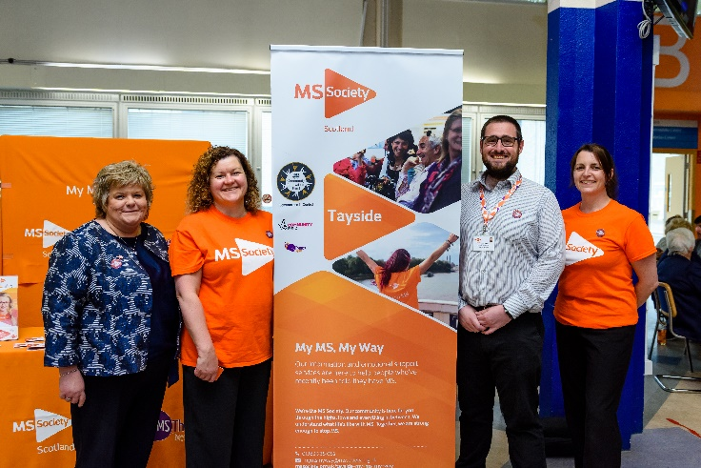
We’re delighted that My MS, My Way: Tayside launched on World MS Day (30 May). This new service will support more than 240 people recently diagnosed with MS in Dundee, Angus, Perth and Kinross, providing counselling, self-management sessions, one-to-one peer support and clinic support.
The service will run over two years, thanks to over £151,000 of funding from the National Lottery Community Fund and NHS Tayside Community Innovation Fund.
To celebrate the project launch, we held a stall at Ninewells Hospital Dundee on World MS Day, with project partners from the MS Therapy Centre Tayside. The stall had information about the project and staff were at hand to explain the benefits of the project and the referral process.
Volunteers will play a vital role in helping deliver this project, from providing support at the MS clinics to sharing their experiences as a Peer Support Volunteer. If you’re interested in volunteering with the project, visit: candidate.mssociety.org.uk/ms/volunteering
If you’re living in Tayside and have been recently diagnosed with MS, you can contact the service below. You can also find out more about the service on our website: mssociety.org.uk/care-and-support/local-support/my-ms-my-way---tayside
Contact: My MS, My Way
mymsmyway@mssociety.org.uk
01382 938082

Inspiring others to take on a fundraising challenge
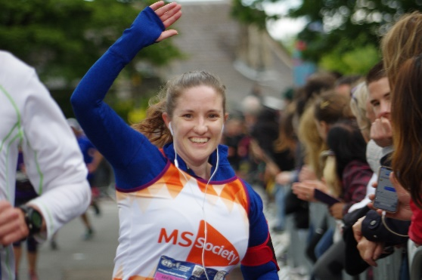
We had a fantastic weekend at Edinburgh Marathon Festival (25-26 May). It was our second year as a ‘premium affiliate charity’, with 184 amazing runners taking part across the weekend. We even had some of our Scotland Council members and MS Society staff taking part in the 5k!
The atmosphere in our tent was brilliant, with our runners celebrating their achievements with us and their family and friends.
“It’s a fantastic charity. Everything from the hand-written thank you notes to the tent on the day is amazing” said one of our runners.
Take part in a challenge
Could you, your friends or family take on a challenge this autumn – or even the Edinburgh Marathon Festival next year?
Our fantastic events include:
Kiltwalk Dundee – 18 August
Great Scottish Run, Glasgow – 29 September
Kiltwalk Edinburgh – 15 September
Forth Rail Bridge Abseil – 6 October
Loch Ness Marathon – 6 October
Edinburgh Marathon Festival – 23 May, 2020
Contact our friendly fundraising team to get involved and get your fundraising pack.
Contact: Scotland Fundraising team
msfundraising@mssociety.org.uk0131 335 4050

For Wales
Make our voice heard!

The Cross Party Group on Neurological Conditions Inquiry into Neurological Services in Wales is well underway.

Over the years, we’ve spoken to the MS community from all over Wales who have told us about the difficulties they face when accessing treatments and services.

We’ve used this information to submit written evidence to the inquiry and now we’d like to invite people living with and affected by MS and other neurological conditions to get involved in further evidence gathering sessions. Please look out for further information on these sessions to share with your group.

We also need Assembly Members to attend so that they get to hear first-hand what living with MS is like for people in Wales. You can help with this by asking your group members to contact their constituency and also regional AMs.
Let’s make our voices heard!

Contact: Fiona McDonald, Policy, Press and Campaigns Manager for Wales
fiona.mcdonald@mssociety.org.uk

My MS My Rights My Choices Project

- 1571 people attended information events including Newly Diagnosed Days, Living Well with MS Days, Mindfulness and Fatigue Management.
- 485 people received one to one support with things like benefit claims, grant applications and employment.
- Over £35,855 secured in grants for people in financial need living with MS across Wales

These are just some of the amazing achievements to date from our My MS My Rights My Choices project.

Also, since the project began in 2017, 63 people have been recruited as Information and Support Volunteers along with Stakeholder and Advisory Board Members – the majority of whom are living with or affected by MS.

Many of our volunteers have benefited from the project themselves and are now sharing their experience and skills providing support in their community, arranging information stands in clinics and helping people to complete grant applications.

The project will end in March 2020. There’s no extension but hopefully a further application to the National Lottery Community Fund will be successful and we’ll be able to set up something similar. We will keep you informed!

There’s no doubt that this project has made a huge difference to the lives of those who have received help.

There’s only a short time left and we don’t want anyone missing out who needs support, so if you know anyone in your area tell them about the project and get in touch.

Contact: My MS, My Rights, My Choices team
mymscymru@mssociety.org.uk

Active Together

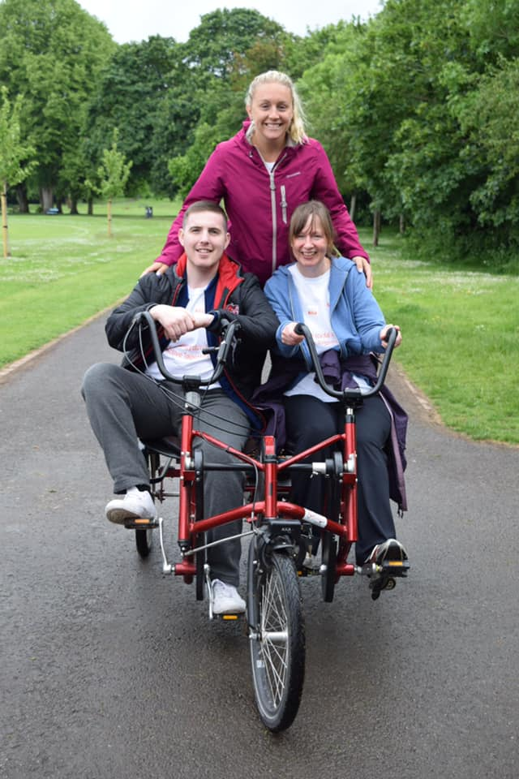

Our National Lottery Community Fund project Active Together across the Cardiff, Cwm Taf and Merthyr Tydfil area is off to a flying start!

The project, which promotes fitness and friendship has been recruiting volunteers and getting them involved in a host of events.

So far, we’ve been teaming up with Welsh Cycling and Pedal Power to organise a pop up event in Cardiff where people living with MS and affected by MS enjoyed a fun day, trying cycling in a traffic free and inclusive environment (pictured above with Andrew our Active Together Champion and Beth and Julie from the Active Together project team).

Beth and Julie are volunteers in the project team and have been running a survey to find out how our MS community would like to get more active.

The project team will be working closely with groups in and around Cardiff, Cwm Taf and Merthyr to find out which activities people living with MS would like to try and any ideas people may have to be active.

Give us your suggestions

From dancing to boxing, surfing to mindfulness walks and climbing, we’re open to suggestions! All activities can be adapted to be fully inclusive. So why not ask your group for their ideas and send them to Beth to see if we can make them a reality together!

Contact: Bethan Moss, Active Together Project Coordinator
Bethan.Moss@mssociety.org.uk

Calling All Cheerers!

We’re thrilled to say that our team of Cardiff Half Superstars is now complete! We have completely sold out of places which is the quickest sell-out ever for us!

Thank you so much to everyone who has signed up to our team in support of our community in this year's event! If anyone is wishing to participate they might still be able to secure a place.

Our runners will be joining 25,000 other participants who will take to the streets of our beautiful capital to tackle this 13.1 mile race - now one of the biggest half marathons in the UK!

Cheer them on!

We’ll be needing lots of cheerers on the day to help make as much noise to give our MS Superstars support. Join us at any of the below events and cheer our participants on:

Wales End to End 2019 (Cycling), August 15 – 18, Anglesey to Cardiff

Admiral Swansea 10km, September 22, Swansea

Cardiff Half Marathon, October 6, Cardiff

Contact: Sian Dorward, Fundraising Manager for Wales

Sian.Dorward@mssociety.org.uk

Group Contributions
Thank you to all groups for your contributions. They’re all gratefully received.

We recently noticed a glitch in our group donations reporting system, with a number of groups missed from Teamspirit from the beginning of the year. Please accept our apologies and see a full breakdown of donations since the last issue of Teamspirit and any missed group donations from the start of the year.
Group Donations (24th Jan 2019 to 9th June 2019 (and missed donations from start of the year)
Name | Earmarked by the group towards | Amount
Alnwick & District Group | Progressive MS Research | £1,000.00
Andover Group | General Research | £1,000.00
Barnet & South Hertfordshire Group | Cambridge Myelin Repair Centre | £2,500.00
Barnet & South Hertfordshire Group | Stem Cell Research | £2,500.00
Bradford & District Group | General Research | £5,000.00
Braintree Group | Progressive MS Research | £500.00
Bridgend & District Group | Cambridge Myelin Repair Centre | £1,250.00
Bridgend & District Group | General Research | £1,250.00
Camden Group | General Research | £2,000.00
Campbeltown & District Group | General Research | £3,000.00
Cardiff and Vale Group | Grant 94 - Oxysterols & the brain | £5,000.00
Chesterfield & District Group | General Research | £2,500.00
Dereham & District Group | Cambridge Myelin Repair Centre | £2,500.00
East Berkshire Group | General Research | £2,500.00
East Berkshire Group | Progressive MS Research | £20,000.00
Exeter Group | Stem Cell Research | £10,000.00
Gosport & Fareham Group | Cambridge Myelin Repair Centre | £1,000.00
Hambleton and Richmondshire Group | Stop MS | £2,500.00
Kyle Group | Edinburgh Centre for Translational Research | £3,000.00
Oswestry & District Group | Cambridge Myelin Repair Centre | £2,000.00
Sheffield and Rotherham Group | General Research | £3,000.00
Skegness & District Group | Progressive MS Research | £500.00
South Central and East Suffolk Group | General Research | £5,000.00
South East Essex Group | General Research | £3,587.00
Tameside Glossop & District Group | Stop MS | £2,000.00
West Oxfordshire Group | Grant 98 - Molecular mechanisms of neurodegeneration in progressive multiple sclerosis | £5,000.00
Wigtownshire Group | Research in Scotland | £250.00

