Teamspirit 226 September
Stop MS – Our biggest ever appeal is almost here!
It’s almost here! The public phase of our Stop MS Appeal is launching in early October. It’s going to be our biggest campaign ever, and we’re all coming together as Team Stop MS!
Together, we’ll be sharing loudly and proudly what we’re trying to achieve together – raising £100 million to find treatments for everyone with MS.
Whether it’s letting your friends and family know on social media or sharing with your local group, it’s time to get loud about stopping MS together. There’ll be all you need to do this on the Volunteer website when the campaign launches next month.
At the heart of the campaign will be a very special film featuring four people living with MS. In this edition of Teamspirit we give you a sneak preview and share more about plans for the Appeal…
The film
This very special film has been a long time in the making. The fi lm shoot happened back in July, after months of work with our wonderful pro bono partner Publicis, a leading advertising agency, which developed the creative idea.

Four people with MS are the stars of the film. Each person is singing the lines of a song while going about their lives. The song has been chosen to reflect the ambition of the Stop MS Appeal, and the hope for a future where nobody has to worry about their MS getting worse.

We’ve also been testing the concept with lots of people with, and affected by, MS, from around the UK. In total, we spoke to more than
100 people as the concept was developed.

Going behind the scenes
Glyn, who has MS and lives in Cardiff, is one of the stars of the film. Here, he shares what it was like to be on the shoot and why he wanted to be at the very heart of the Stop MS Appeal…

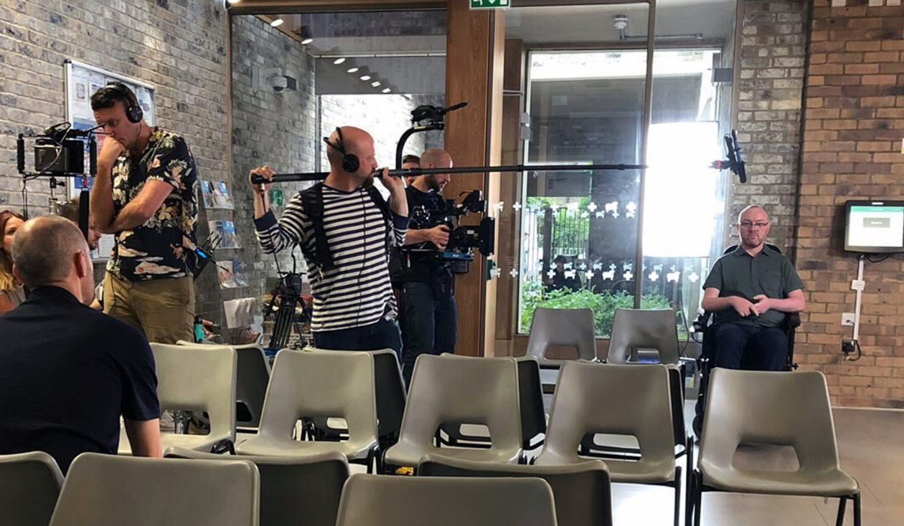
“It was great having the opportunity to be the centre of attention for a day, I couldn’t resist it! I enjoy being a foghorn for MS. And because it is my story and the story of other people with MS, it didn’t really feel like acting.
The film shoot actually took place on my birthday, and although mine was the last shoot of the day, everybody was in remarkably good spirits. The best thing was the cake and the whole fi lm crew singing ‘Happy Birthday’ to me. The worst bit was trying to sing in tune! But the more I thought about the words of what I was singing, the more positive I felt about the future.
The Stop MS Appeal really could be life changing for the next generation with MS. In the 15 years I have had MS we have gone from no treatments to a lot. And now I have secondary progressive MS there are no treatments again. There is a door opening now, it feels like there is a precipice coming up. Unfortunately, you can’t just do it on a credit card, it needs a lot of support and a lot of backing.”
We’ll be revealing the fi lm in early October so keep an eye on our website and social media!
Contact: Supporter Care team
supportercare@mssociety.org.uk 0300 500 8084
What will the Stop MS Appeal fund?

We believe that increasing our research efforts now will significantly speed up the time taken to find new treatments for everyone living with MS.

We’re working in collaboration with researchers from across the UK to build a clinical trials ‘platform’. The platform will provide a structure through which trials of both re-purposed and novel drugs can be run faster and more cost efficiently. This new type of trial will allow us to:

• Test multiple drugs at once
• Try combinations of treatments that target different mechanisms, like myelin repair and neuroprotection
• Add new treatments as they’re discovered
• Stop testing drugs that aren’t working
• Move seamlessly through trial phases

The Stop MS Appeal offers huge potential to accelerate the development of new treatments through this innovative approach. It will mean we can continually adapt and improve the trial, so new participants can be given the best potential treatments. It also means we can try to match people with the treatment that suits their individual situation.

With the right funding, by 2025 we plan to be in the final stages of testing for a range of treatments for relapsing and progressive forms of MS.

Contact: Research team
research@mssociety.org.uk

My MS Walk – Lyn’s story

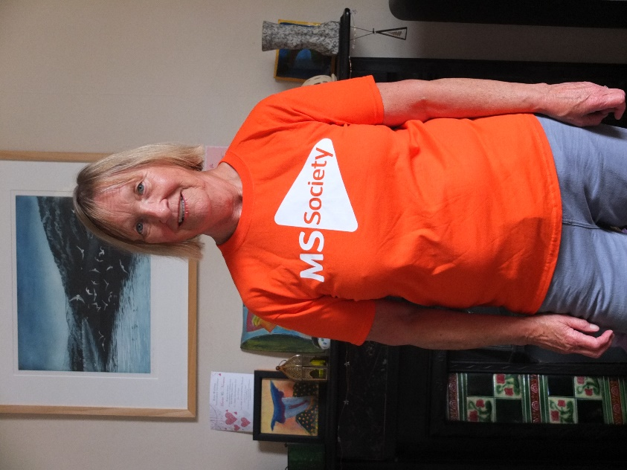

There’s still time to sign up for My MS Walk and organise your own MS Walk to raise funds for vital MS research.

Lyn Tubbs is a member of the England Council and together with the Plymouth and Tamar Valley group is organising a My MS Walk on Sunday 22 September. This is Lyn’s story.

“I was diagnosed with relapsing and remitting MS 17 years ago which led to early retirement from my job as a Primary teacher in an inner city school. I was prescribed DMTs and have been stable on them up to now.

I have been inspired to organise a My MS Walk by the Stop MS appeal as I have many friends with progressive forms of MS who don’t have access to treatments. I see this as a chance to change this situation, we need to raise as much money as possible to make this happen and hopefully, change lives.

For those organising a walk, the MS Walk team will provide plenty of help and support in the form of advice and resources. Local contacts can also be very useful, Councils, disability organisations, health & wellbeing hubs and walking groups to name a few. You don’t need to be alone.”

Like Lyn and her group, you can walk, roll or stroll to stop MS. Whether you need practical support or fundraising materials, we’re here for you. If you’re interested in taking part in My MS Walk or have any questions, you can visit our website here: www.mssociety.org.uk/my-ms-walk, call 0300 500 8084 or email
mswalk@mssociety.org.uk.

Contact: Joe Murray,
Senior Community and Events Officer
mswalk@mssociety.org.uk

Bake or leap to Stop MS

If organising a My MS Walk isn’t for you, here’s a couple of our other favourite ways you can fundraise to Stop MS or encourage others to do so…

Join us to hold a Cake Break on 4 October
Whether you’re a keen cake baker or savvy treat shopper, you can get together with friends, family or colleagues to take a Cake Break however suits you, and mostly importantly – raise some dough to help stop MS.

This year, Hairy Bikers Dave and Si (pictured on the right) are backing Cake Break, and we’ll have some tasty recipes from the duo in our fundraising packs. Plus posters, games, and tips to make organising your event as easy as pie.

If the 4 October doesn’t suit you, you can host your Cake Break on a different date.

Sign up for your pack now on our website here:
mssociety.org.uk/get-involved/fundraise/cake-break, or get in touch with the team here to find out more: cakebreak@mssociety.org.uk

Take a Big Leap
Do you or anyone you know fancy being a daredevil? Who wants to feel the rush of flying through clouds from over 10,000ft up? Then skydiving could be the perfect option for your group’s bravest supporters or maybe even you! Anyone taking on this challenge, can jump across the UK, on a date that suits them.

To find out more or you can ask your supporters to sign up on the email address below.

Contact: Community and Events team
challenge@mssociety.org.uk

Help, hope and voice

Our cannabis campaign
Last month, the National Institute for Health and Care Excellence (NICE) published draft guidance for clinicians on cannabis for medicinal use. The draft guidance recommends against the use of medicinal cannabis to manage pain and muscle spasms in MS. We’re bitterly disappointed by this, and are concerned people with MS will continue to be denied effective treatment.
This comes after the law changed last November, to allow specialist doctors to prescribe cannabis based medicinal products legally. This was an important milestone in our campaign. But we know very few people with MS have been able to access medicinal cannabis.
In March, we took our campaign to Westminster and gave evidence to a committee of MPs. We called on the UK Government to take this issue seriously and highlighted that people with
MS continue to be denied a treatment option that could help with pain and spasticity.
Last month, we held an event bringing together people with MS and healthcare professionals to share their views on the draft guidance published by NICE. We’ve spoken out against it in the media, and in our response to the NICE consultation, the experiences of people with MS were front and centre.
We’re continuing to work with NICE, parliamentarians and pharmaceutical companies, calling on them to improve access to cannabis based medicines.
Join our Campaigns Community on our website here mssociety.org.uk/campaigns to keep up to date on the campaign.
Contact: Campaigns team
campaigns@mssociety.org.uk

New information resources available now
MS and your bladder
Did you know that as many as 9 in 10 people with MS may get a problem with their bladder at some point? We’ve created an information booklet to explain how your bladder works and some useful tips.
You’ll find ‘MS and your bladder’ (BK30) in our online shop here: https://mss.ecgroup.net/ms-info-leafle or you can download a copy from our online library on our website.
Genes and MS
With the help of our fantastic research team we’ve also produced a new factsheet that explains what genes are and how they may play a part in affecting MS.
We know that genes do play a role in MS, but they’re only part of the story. There’s no single gene that will definitely cause someone to get MS. But we know that certain genes can make a person more likely to get MS.
We’re funding and supporting new research into better understanding the role that genes play. To find out more, download a copy by visiting our website and searching for Genes and MS.
Did you know?
All of our resources in addition to the new ones mentioned above, can be found on our online library on our website here:mssociety.org.uk/care-and-support/resourcesand-publications.
Contact: Carmel Barrett,
Information Resources Manager
carmel.barrett@mssociety.org.uk

Come along to one of our events!

Do you ever feel like information about living with MS is constantly changing?

Would you like to hear about the latest MS research?

Are you looking for more opportunities to meet other people with an understanding of MS?

We have a number of free events taking place across the UK from Research Talks and Information Days to Living Well with MS Events.

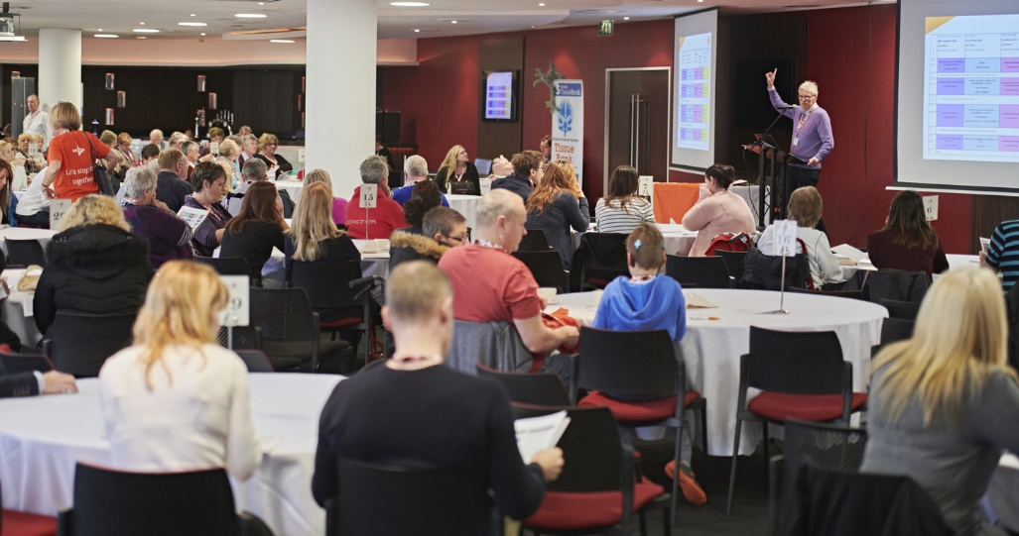

What can you expect?
• A mix of informational and inspirational talks on different aspects of life with MS
• An opportunity to meet other people affected by MS (and make new friends!)
• An update on the latest MS research
• A chance to chat with professionals, relevant exhibitors and MS Society staff

To see our upcoming events, head to the MS Society Eventbrite page here:
mssocietyevents.eventbrite.com

Contact: Hannah Lydford,
Conference & Events Coordinator
event.info@mssociety.org.uk
020 8438 0891
Information for your group
Our Volunteer Survey 2019 is live

1 July marked the launch of our new Volunteer Engagement Survey!

It’s been almost two years since we last ran this survey. The feedback we received last time prompted us to do lots of work to improve volunteers’ experience at the MS Society, such as:
• providing an online volunteer recruitment process along with an improved range of publicity materials to help us attract a wider, more diverse pool of volunteers
• more online training products for volunteers, enabling more people to join in
• improving the way we reward and recognise our amazing volunteers through our Shining Stars scheme and during the annual ‘Volunteers Week’
• simplifying and shortening our policy for resolving volunteer issues – making it a kinder and easier process

One thing many of you told us was to avoid too many surveys! So, we’ve decided to run this survey once every two years, rather than yearly.
It’s still a really important chance for you to tell us what you think, help us to shape our work and to improve the experience of volunteering with us.

Not long left, to give us your feedback!
The survey will be open until 22 September 2019 so make sure to let us know your views soon.

You should’ve already been contacted about how to complete this survey, but you can also find the link to the survey here on our volunteer website:
volunteers.mssociety.org.uk/news/2019/07/volunteer-survey-2019-live

Contact: Volunteering team
volunteering@mssociety.org.uk

Membership Information

We’ve recently been looking into finding a more environmentally friendly version of our current plastic membership cards. Unfortunately we’ve not been able to source a suitable alternative.

Having reviewed how the card is used, the decision has been made to stop producing membership cards for the moment as all services and activities run by groups should be available to all people affected by MS – whether they’re members or not. However, in line with the review of our membership model (as mentioned in our latest issue of MS Matters) we’ll be looking again at the information provided to new members in the future.

For now, new members will be able to find their membership number on the letter in their membership pack. For any other members wishing to know their membership number, they can contact their local group or the Supporter Care team who’ll be able to provide it.

Contact: Supporter Care team
supportercare@mssociety.org.uk
0300 500 8084

Support for volunteers
Claiming Gift Aid on donations your group receives

We hear from lots of groups who would like to claim Gift Aid on their donations, so we’re currently reviewing Gift Aid at local group level to see if we can simplify this process to encourage groups to maximise their fundraising in this way.

Can your group help us?
We’re looking to understand:
• how does your group fundraise for the majority of your donations? This is important because not all donations are eligible for Gift Aid.
• how do you receive donations from your supporters and how are these funds banked into your group bank account? This information is vital for us as it will help shape any potential new process which could help maximise your donations with Gift Aid.

We’re looking for groups to help us with this, if you’d like to get involved please contact us.

Contact: James Cooper, Gift Aid Manager
james.cooper@mssociety.org.uk

Email with Office 365 – what’s in it for you?

More than 150 of our groups are now using the new email system on Office365 and individual email addresses.

All groups need to be using this new email system by the end of the year, because of its secure features, storage and sharing platforms which have been risk assessed as part of our data protection obligations. We can’t confirm the security of other email systems in use, and our IT team can’t help if things go wrong.

Apart of being compliant with GDPR and IT security standards, when using the MS Society emails your group will also benefit from:

• a recognisable group and individual MS Society address which lets those you communicate with know that it is a legitimate email
• the ability to work together on documents from anywhere by storing it on cloud storage that’s easy to access for all group volunteers who have MS Society emails
• the ability to access your MS Society emails securely via remote devices such as mobile phones or tablets
• access to help with numerous topics via online resources, written and video guidelines and training sessions and helpline resources

If you’ve not migrated yet, please do so as soon as possible. Complete the form on the volunteer website here: volunteers.mssociety.org.uk/
MS-Society-email or speak to the Volunteering team to find out how you and your group can get access to MS Society emails.

Help us work together more efficiently and keep everyone’s personal information safe.

Contact: Volunteering team
volunteering@mssociety.org.uk

You tell us – how well do we support you?

A huge thank you to everyone who shared their views with us on how we’re supporting our local groups. We held five face to face Volunteer Voice events in July around the UK. They were well attended by a range of volunteers and most importantly we took away plenty of feedback to work with!

Some of you also took the time to send us your feedback remotely via our online feedback form, so a thank you to those of you who took time to do this.

As you’ll know, our Volunteer engagement survey which opened from 1 July and will close 22 September also had some specific questions related to support for local groups. So, we’ll be adding these responses to our feedback as well.
We’ve also been speaking to the staff teams who are involved with directly working with and supporting groups for their views on what works well and what doesn’t with our current approach.

Next steps
Our reference group of volunteers has been meeting monthly since May to steer and plan this review and now we’ll be working together with them to look at all feedback and put some recommendations together for potential changes and improvements.

Contact: David Light,
Local Networks Transformation Manager
david.light@mssociety.org.uk

Online shop – first six month successes

Now that the online shop’s been running for six months we thought it would be a good opportunity to tell you about the great things it’s achieved so far.
Positive feedback has flooded in from volunteers, fundraisers and staff praising its simple website navigation, ease of ordering and delivery of items and its new professional look.

We recently did a mystery shop which was completed to a high standard. 5 days is now all it takes between the times you order an item and the time you’ll receive it.

We can now better manage stock, budget and wastage – which means that you have access to products for fundraising and information when you need them.

Some other key successes since shop launch:
• 468 signed-up users, including 191 groups
• Monthly average of 550 orders.
• Orders for information resources have jumped nearly 20% and continues to grow.
• A recent social media post advertising one information resource generated 280 orders in just one day!
• Users love that they can track their order and if placed via courier they can now arrange delivery on a day that suits them.

If your group is yet to register for a shop account you can sign up on our volunteer website here: volunteers.mssociety.org.uk/online-shop

Contact: Shop team
shop@mssociety.org.uk
0300 500 8084

Training and support for fundraising

The Area Fundraising team are pleased to offer some autumn dates for the popular Fundraising Forums and Training.

The Fundraising Forums are for any volunteer involved in fundraising. They’re helpful, peer support meetings which are run through the easy to use Zoom online conferencing app, so you can join a session from the comfort of your own home.

Upcoming forum dates are:
• Tuesday 24 September – 18:00 to 19:30
• Thursday 21 November – 12:00 to 13:30

There’s also a training workshop, focussing on Applying for an Awards for All Bid. This is a wonderful introduction to securing up to £10k for a new or existing group activity or service. So far this year, we’ve already helped groups raise £43,000 towards local services.

This workshop will take place on:
• Thursday 17 October – 12:00 to 14:00

To attend any of the above, please register on our volunteer website here:
volunteers.mssociety.org.uk/fundraisingforums-2019

Try our brand new E-Learning Module!
Again focussing on Awards for All, this module has been co-created with volunteers, who’ve made successful bids for their group.

You can find out more by visiting our volunteer website here: volunteers.mssociety.org.uk/awards-for-all

Contact: Simon Moran, Area Fundraiser
simon.moran@mssociety.org.uk

Finance
Preparing for 2019 Year End

We’ll be sending the Finance 2019 Year End pack to you via your group e-mail on 17 September. It will contain information about the Year End process and also some useful tips on how to plan ahead.

How can you prepare?
2019 year-end documents must be submitted by 31 January 2020, which is a requirement of our Financial Rules. Here are some useful preparation tips to ensure we receive your paperwork on time:-
• Make sure all coordinating team members are aware of the 31 January 2020 deadline, and what’s required of them.
• Arrange a team meeting in January 2020 (before the deadline) where the year-end documents can be completed, signed, and submitted to our London office by the 31 January.
• If your group can’t meet in January, then a copy of the Receipts & Payments Report, and Internal Financial Controls Checklist must be emailed to all coordinating team members for review and approval.
• The Finance Team are here to help! If you have any queries or need help please contact us as soon as possible, ideally before 20 December, to ensure your group is able to meet the deadline.

We’re here to help – new support sessions available
This year we’re delighted to offer a range of interactive support sessions via Zoom video conferencing app to help your group complete their Year End paperwork.

These sessions will be held on a number of different days and times and will last
45 minutes. You’ll receive details on dates and how to join one of these sessions in the Year End email that your group will be sent in September.
These sessions will be run by our friendly Finance Support team. We’ll be discussing what’s required from your group and how to plan ahead so you don’t miss the deadline. There’ll also be time for Q&A’s, and an opportunity for you to share your own top tips with other groups.

The Year End process is a collaborative process so these sessions are open to all coordinating team members in your group.

Important: Failure to comply with the 31 January deadline will cause delays in completion of our statutory accounts, which may result in an increased audit fee, and a finance visit to your group.

If you don’t receive the Year End email to your group address or have any queries, please notify the Finance Team as early as possible.

Contact: Finance Support team
financesupport@mssociety.org.uk
0131 335 4078

Signatory Responsibilities

As you’ll know, all Coordinating Team members (including non-signatories) are responsible for the funds held in your local group bank account.

Our Financial Rules are in place to safeguard our assets and prevent any allegations being made against individuals. Failure to comply with these rules can result in all Coordinating Team members being asked to stand down, and the group being temporarily closed with bank accounts being frozen.

Some key responsibilities of group account signatories are:-
• Never sign a blank cheque – under no circumstances should a blank cheque be signed, or should you be asked to do so! If you are, or have concerns this may be happening, it must be raised with Finance Support immediately.
• No blank spaces – making sure that cheques are written without blank spaces ensures alterations cannot be made after signing.
• Document to support payment – it’s not acceptable to sign a cheque, or authorise a BACS transfer without agreeing the payment supporting documentation (e.g. invoice, expense claim form).
• BACS payments – before authorising a BACS transfer via Barclay.net online banking, check all of the details match the supporting documentation (e.g. bank account number, sort code, payee name).
• Fraudulent invoice – scammers may send you fraudulent invoices, pretending to be one of your regular suppliers (i.e. village hall, physio etc.). If in any doubt, do not arrange payment, and instead send a copy straightaway to the email address below.

Contact: Finance Support team
financesupport@mssociety.org.uk
0208 438 0700

Online payments with Barclays.net

With more and more companies refusing payments by cheque, Barclays.Net could be the answer.

Barclays.Net is a secure, internet based corporate online banking system which comes with a number of benefits for groups. With full access, groups can view up to date balances and transactional information as well as setup and authorise same or 3 day BACS payments via dual authorisation.

We currently have 115 active users over 54 groups who regularly make payments online using Barclays.Net. For existing users there’s a handy help tool on Barclays.Net, with some interactive guides on how to use the system. We recommend downloading the guide for Viewing, Submitting, Authorising, Releasing and Repairing Payments.

This is a detailed guide on how payments pass through Barclays.Net from start to finish.

If you’re a current user, remember that smartcards and PIN’s mustn’t be shared.

If your group would like to sign up to Barclays. Net or have any further questions, please get in touch and we’ll arrange for an information pack including Frequently Asked Questions and software/hardware requirements to be sent out to you.

Contact: Treasury Support
treasury.support@mssociety

Our groups and services
Lymington & New Forest group celebrates 30th anniversary

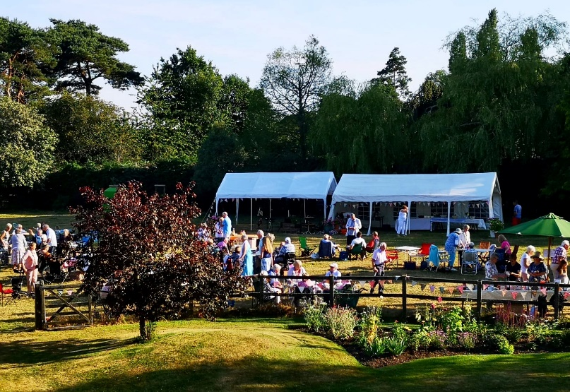

Almost 150 people attended the 30th anniversary celebration of our Lymington and New Forest group in July. The group also paid tribute to Caroline Birch who has played a vital role within the group during that time.

Group Coordinator Sue Niekirk told us that:
“Caroline was a founder member and first Secretary of our group and has always been closely involved with it. She was the Chairperson for six years and has been a Support volunteer since then. As a Support volunteer Caroline has initiated and led the exercise classes, male carers groups and numerous social events – it’s certain that the group wouldn’t be as flourishing without her. She is the leading light of our group and held in deep affection and great respect by all of us”.

Congratulations to Caroline and all involved with making this group such a great source of support. The time all of our group volunteers dedicate to our MS community locally is invaluable.

Would you like your group to be featured in Teamspirit? Then contact us on the details below.

Contact: Teamspirit Editorial team
teamspirit@mssociety.org.uk

Reaching out to different areas of our community

We know that it can be a challenge to reach out to people who’ve been newly diagnosed, those who may still be working and to younger people affected by MS. However, there are some groups that have been successful with encouraging new audiences to attend group activities and link up with the support they offer.

Some ideas to try
Some groups have managed this by developing connections with their local neurology team and MS nurse who’ve then helped to promote the group to new people who may not have been aware of any local presence of the MS Society.

Another way that groups have managed to reach out to new and diverse groups of people has been by selecting different styles of venue for their activities and offering different days and times of the week to meet.

Get some tips
The Croydon group and the Nottingham group are examples of two of our local groups who’ve been successful in attracting new people to their activities. They’d be happy to share with other groups what worked for them, so if you’d like to know a bit more you can email:
• Trevor Kenward at the Croydon group on:
croydonsupport@mssociety.org.uk and
• Tazmeen Lindsey at the Nottingham on:
nottinghamsupport@mssociety.org.uk

Contact: Chris Evans,
Quality & Safeguarding Manager

For Northern Ireland
Volunteer Awards

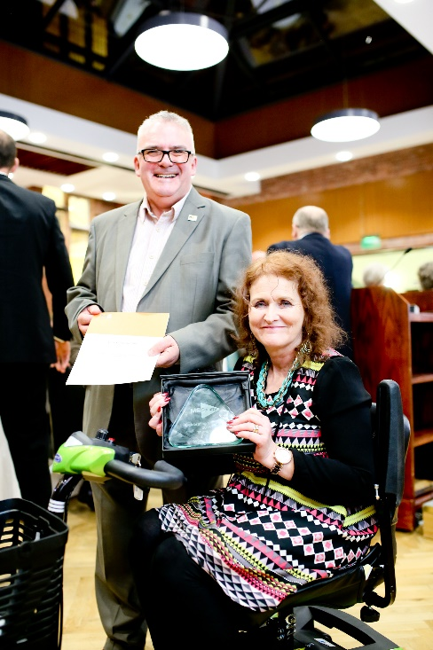

On the afternoon of 1 November 2019 MS Society NI will be celebrating the very best of our community.

Belfast City Hall will play host to an event celebrating volunteers. We’ll be presenting a series of awards to those who go above and beyond in supporting people affected by MS. This is an opportunity to recognise the outstanding contribution made by volunteers, group members, fundraisers and service providers.

MS Society NI is a nominated charity of High Sheriff of Belfast Cllr Tommy Sanford. We’re delighted that Cllr Sandford is hosting this event in the surrounds of Belfast City Hall.

Pictured above are previous winners Derek McCambley and Grace Rodgers. Grace from the Belfast group received an award after 19 years of volunteering with us. Grace is a previous Chair of the Belfast group, volunteer receptionist and prolific organiser.

Derek received recognition for everything from fundraising and service development to representing the organisation at key events. A central and active volunteer at MS Society NI, Derek was recognized as one of the stars of the organisation. For more information on the event, to register to attend or to find out about the nomination process for awards contact below:

Contact: Susan Carey, Local Networks Officer
susan.carey@mssociety.org.uk

Join us at our information event!

On Saturday 19 October, the Newry, Mourne and Armagh group will be hosting an information day in the Banville Hotel in Banbridge. The event is particularly aimed at reaching out to people affected by MS living in the Southern Trust Area.

The event will include a talk from Dr Jamie Campbell. Dr Campbell is a Consultant Neurologist based in the Craigavon Area Hospital. There’ll also be a question and answer session with Community Advice who’ll be discussing available benefits to those affected by MS.

In addition to the speakers, the event will host over eight information stands. Health professionals who support people with MS will be represented with an MS Nurse, Neuro Physio and an Occupational Therapist all in attendance. Other stands will include mobility providers and information on alternative therapies.

It’s a great opportunity to hear directly from health professionals and put your questions to the range of experts there on the day.
The event begins with registration at 10.30am and will end at 3.00pm. Numbers are limited and priority will be given to those living in the
Southern Trust affected by MS.

If you’d like to book a place or to find out more information please see below for contact details.

Contact: The Newry Office
sharon.mcburney@mssociety.org.uk

Living with MS 2019

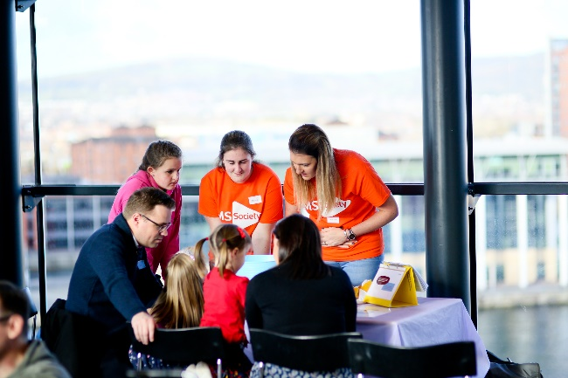

Join us on Saturday 14 September for Northern Ireland’s largest MS event.

Hear about the latest developments in MS Research, get an update on the on-going neurology review, visit our various information zones throughout the day or speak directly with an MS professional in our Health Professionals Zone.

On the day there’ll be:
• Active Zone
• Mental Health and Wellbeing Zone
• Networking Zone
• Carers Zone
• Finance and Employment Zone
• Leaflet Zone
• Health Professionals Zone
Living with MS is the biggest gathering of people affected by MS. It brings together people with MS, their families, the professionals and organisations who support them as well as the researchers working to stop MS.

It will take place at the Crowne Plaza Hotel Shaw’s Bridge, Belfast, runs from 10am to 3pm on 14 September and is open to everyone with an interest in MS.

You can register for the event by visiting living-with-ms-northern-ireland.eventbrite.co.uk or contact us with the details below.

Contact: NI Office reception
nireception@mssociety

Meet your MS Nurse

We’ve long been involved in a campaign for the provision of MS Nurses in the Northern Trust. It’s been an area of concern and frustration to those in the community.

We’re pleased to say that after lots of influencing work from both staff and the local group, the Northern Trust now has MS Nurses in post.

This is fantastic news for people living with MS in the Northern Trust area. Together with people living with MS we’ve also been actively involved in the recruitment and selection process.

We’re delighted to invite the two new MS Nurses; Brenda Hamill and Martina McKenna, to host a ‘Meet the MS Nurse’ evening in the following locations:
• Monday 2 September – 7pm Wilson House Day Centre, Broughshane
• Thursday 26 Sept– 7.30pm Terrace Hotel, Magherafelt
• Wednesday 9 October – 7.30pm Comfort Hotel, Antrim
• Thursday 24 October – 7.30pm Pavestones Day Centre, Coleraine
We also plan to host an event in the Larne/ Ballyclare area, with the details to be finalised.

If you’d like to find out more, you can contact the local group via their Local Network Officer with the details below.

Contact: Charlotte Shirley,
Local Networks Officer
charlotte.shirley@mssociety.org.uk

For Scotland
Could you volunteer with our new service in Tayside?

This summer we successfully launched our new service in Tayside: My MS, My Way. The service supports people who’ve been diagnosed with MS in the last five years in Perth and Kinross, Angus and Dundee.

To increase the support we can offer, we’re recruiting a team of volunteers in the following roles:
• Clinic Volunteers – you’ll attend MS clinics at the Perth Royal Infirmary and at Ninewells hospital in Dundee and be the first point of contact for people who’ve been recently diagnosed.
• Information volunteers – you’ll help facilitate our information events and run information stalls in local areas to promote the My MS, My Way service.
• Peer mentors – you’ll provide one to one support, talk to people, share your experiences and ways to help overcome the challenges people with MS face. You’ll help people access information about local and national services.
• Advisory board members – you’ll share your experiences of living with MS and help shape our services.

Volunteering with the project is a great way of developing your listening, communication and people skills, as well as your knowledge of MS and local services. You’ll meet virtually with other volunteers every month, to offer your views on how best to attract people with MS to these services.

Interested in finding out more? Visit our website here: mssociety.org.uk/tayside-my-ms-my-way

Contact: Hamish Leese, Project Coordinator – My MS, My Way: Tayside
hamish.leese@mssociety.org.uk
01313 354050

Cartha rugby club raises awareness of MS

This summer, Cartha rugby team took on their rivals in Ayr while experiencing simulated symptoms of MS, to highlight the effects of the condition. All proceeds raised came to the MS Society Scotland.

Players followed the regular 80 minute match with a series of short games and activities imitating some of the symptoms people living with MS experience.

Carolyn Baker, who plays for the team, was diagnosed with relapsing MS last year. She said:
“Rugby is an incredibly caring and inclusive sport and the support I’ve had from the squad at Cartha since my diagnosis has been amazing. I’m still playing, though the symptoms of my MS make it more difficult to play and train, particularly with the fatigue and the affect it has had on my eyesight.

This year we’re delighted to be supporting a charity that is fighting MS and to be giving my teammates and opposition a taste of what a few of the symptoms are that I experience.”

We know our groups and supporters come up with all sorts of creative ways to raise funds. So if you’ve got something a bit different going on please let us know by emailing us with the below contact email.

Contact: Scotland Press Office
scotlandpressoffice@mssociety.org.uk

Award winning campaigning from the Borders group
Anne Weston from the Borders group tells us about their MS Award-winning campaign.

Why did you start campaigning?
“We heard from people that calls to the neurological service were going unanswered or it took a long time to get a response. The Borders has one MS nurse who works part time. It could take a while to get an appointment to see her and she had no administrative cover. On occasions when people with MS were admitted to hospital, the communication between the hospital and the MS nurse was not very effective.”

What were your goals in campaigning for change?
“If it was not possible to get extra MS nurse hours, we wanted at least for the Health Board to train a nurse to cover holiday and sickness.”

What support have you had?
“The team at MS Society Scotland helped get us information. With them we put on some information days to find out what the biggest issues were. Keith from the team has been at a number of our meetings with the Health Board, and has taken on the role of linking with them and keeping the momentum going.”

What has your campaign achieved?
“We’ve achieved extra clerical support for the MS nurse – although more is needed. We’ve developed a good relationship with her, which helps communication. We haven’t managed to achieve all we set out to do yet. It can take a long time so we’re committed to continue campaigning. We’ve had an MS Award in recognition of our campaigning. But what pleases me more is that our members will ring up and discuss issues with us, knowing we will assist them.”

Would you like to campaign for change in your area? Our team is here to help!

Contact: Scotland Campaigns team
scotlandcampaigns@mssociety.org.uk
0131 335 4050

For Wales
MS Cymru team update

We’re delighted to announce that our MS Cymru staff team is back to its full strength!

• Brian Watson joins us as our Local Networks Officer for North Wales. He’ll be supporting groups on a range of services including health, wellbeing and accessible sporting activities, developing social groups and making funding applications.

• Emily Owen and Cat Shorney-Jones are our new Information & Support Officers for our Big Lottery funded My MS, My Rights, My Choices Information, Advice and Advocacy project for North East and North West Wales respectively.
The project provides one-to-one support for people living with MS on a range of issues including accessing treatments, health and social care services, employment rights and welfare benefits.

• Sophie Dyment who was previously Information Officer for North East Wales has been appointed as External Relations Officer for Wales. Sophie will be working to influence change to make sure there’s effective treatment and care for people living with MS.

A warm welcome to our new team members and huge thanks to all our groups and coordinators especially those in North Wales for bearing with us as we have gone through the recruitment process.

You can meet the whole team on our website here:mssociety.org.uk/contact-us/wales/meetour-team

Contact: MS Cymru team
0208 438 0700

Access to treatments update

Ocrelizumab, is the first and only licensed disease modifying treatment which has been licenced for people living with early primary progressive MS (PPMS). This intravenous infusion treatment has been proven to slow the progression of this highly disabling form of the condition.

MS Specialists from across Wales have identified that currently there aren’t sufficient resources and infrastructure to deliver this treatment safely.
There are particular difficulties with limited clinical time; lack of sufficient infusion beds; MRI capacity and clinics which are currently overbooked for people living with Relapsing Remitting MS.

This means that for over 200 people living with early PPMS in Wales, who are already pushed down the waiting lists with little or no support, may be denied the only disease modifying treatment available to them.

We’re campaigning hard to ensure that this doesn’t happen and we’re asking anyone living with early PPMS to get in touch with their neurologist.

For more information and to get involved in the campaign use the contact below.

Contact: Fiona McDonald, Policy, Press &
Campaigns Manager for Wales
fiona.mcdonald@mssociety.org.uk

Stop MS Appeal Champions

Our Stop MS Appeal aims to dramatically increase the investment in MS Research over the next 10 years, with the hope of developing treatments – for everyone with the condition.

We want to slow, stop or even reverse the damage caused by MS, but we need the support of our community to help us achieve our ambitious goal to Stop MS.

We’ve funded pioneering research which includes the MS Register based in Swansea, a three-year PhD studentship at Swansea University – undertaking a project on progressive forms of MS.

We need champions within communities across Wales, willing to represent our community on a local level, and secure financial support in aid of MS Research.

If you’d like to help us to research local groups, clubs, associations, and schools in your area; approach and form relationships with groups in your community; and deliver compelling presentations and speeches on behalf of the MS Society Cymru then we’d love to hear from you!

We’ll provide training and support; opportunities to work alongside others in the MS community to share ideas and we’ll reimburse agreed out-of-pocket expenses, such as mileage.

If you’d like to get involved please get in touch.

Contact: Sian Dorward, Fundraising Manager for Wales
sian.dorward@mssociety.org.uk
029 2167 8920

Upcoming autumn fundraising

Carl Bennett MS Walk - 28 September
Tredegar woman Emma Bennett will be joining forces with MS Society Cymru for the first Carl Bennett MS Walk at Parc Bryn Bach Blaenau Gwent to raise funds for pioneering MS research.

Emma has organised the sponsored walk in memory of her father Carl who had MS, to help raise awareness of MS and funds to support our research programme.

Emma said; “I may have lost my dad but he lives on through me and his other children. I will help in any way I can to fight for awareness and fundraising, to develop effective treatments – for everyone with MS”.

To sign up please visit eventbrite.co.uk and search for ‘The Carl Bennett MS Walk’

Cardiff Half Marathon – 6 October
Join our cheering squad, as we show support and appreciation for our team of 60+ Cardiff Half Superstars, taking part in this years’ race. We’ll also be holding a post-race reception to celebrate the team’s success, and thank our wonderful community for their incredible support.

Following the race, we’ll also be holding the Welsh Premier of the Stop MS Appeal film!

Contact: Sian Dorward, Fundraising Manager for Wales
sian.dorward@mssociety.org.uk
029 2167 8920

