Teamspirit 227 November

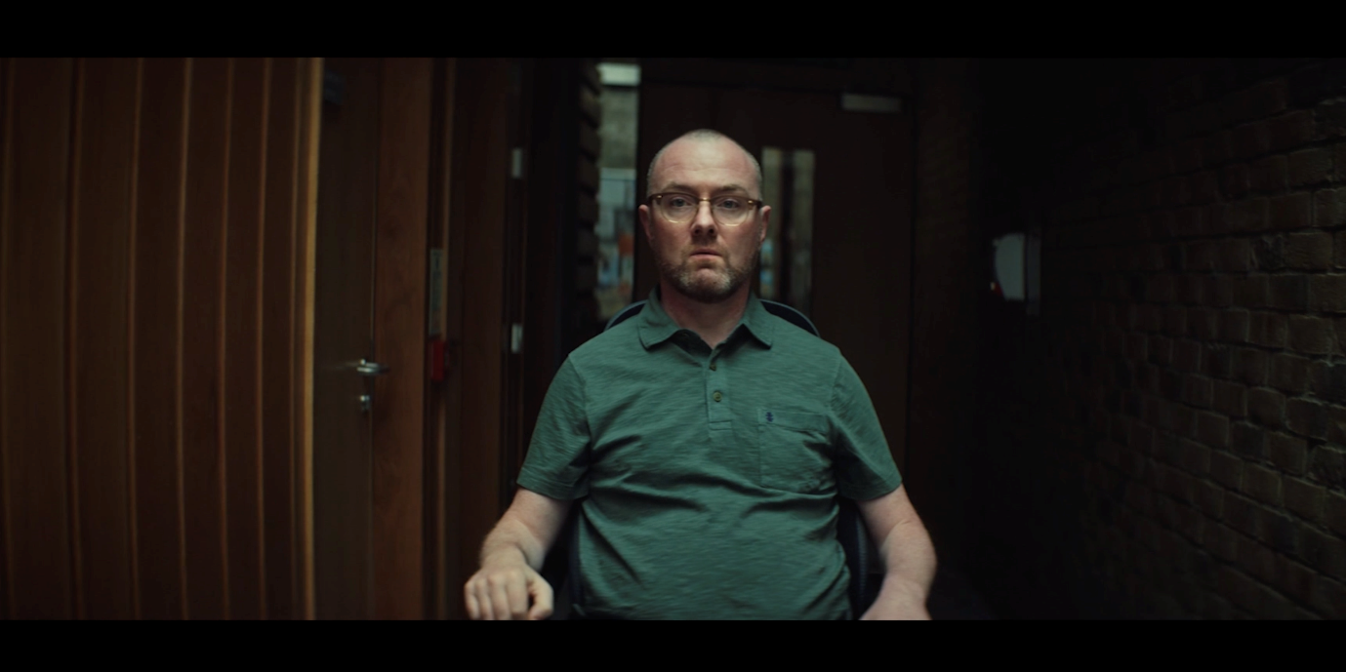

Together we will Stop MS
Our Stop MS Appeal launched on 8 October with a huge advertising campaign and events across the UK. It’s our biggest ever fundraising appeal, aiming to raise £100 million to find treatments for everyone with MS.
Our TV advert was shared by thousands of people in the MS community and shown on national television. Through our partnership with the Telegraph, our ads have appeared in print and all over their website, and we secured coverage in a whole host of national and regional news outlets too.
Together, we’ve reached more people than ever before!
Will you join #TeamStopMS?
There are all sorts of ways you can help Stop MS. With MS Walks in Belfast and London, and a number of My MS Walks and cake breaks being held across the UK, we’re all coming together as #TeamStopMS.
Could you spread the word on social media or via your group newsletter? Or organise your own fundraiser?
There’s a range of resources on the volunteer website to promote the appeal. These include a guide to using the logo and Stop MS messages, a ‘Research Story’ explaining our plan to Stop MS, and a presentation so you can give talks locally.
Together, we will stop MS.
Contact: Supporter Care team
supportercare@mssociety.org.uk 0300 500 8084

Help, hope and voice

We are Undefeatable
We are proud charity partners of the latest Sport England campaign, We Are Undefeatable. You might have seen the advert on TV, heard it on the radio or seen a poster at your local pharmacy.
Over one in four people in England live with a long-term health condition, including MS and new research shows that over two thirds of these people say they would like to be more active. Despite this, they are twice as likely to be inactive.
Fifteen leading charities, including us, have come together for the first time, with support from Sport England and the National Lottery, to launch the inspirational We Are Undefeatable campaign. The aim is to inspire people living with health conditions to get active in a way that’s right for them.
The campaign features real-life experiences of people with long-term health conditions getting active despite the ups, downs and unpredictability of their condition. It launched on national TV, radio and social media in August.
Rebecca, who has MS, is one of the advert’s stars. As her condition progressed, she found it increasingly hard to be active – and impossible to do the job she’d trained for.
Taking up wheelchair dancing helped her manage the depression that came about after her diagnosis and has become one of the activities she loves most.
For Rebecca, there’s no better way to get moving than dancing. She’s able to let loose and have fun, no matter the style of dance.
She says it’s completely changed her life, and she always comes away from her sessions feeling much better than when she’d started.
Visit weareundefeatable.com for inspiration and tips on how to be active.
Contact Zouhoure Holden
Marketing Manager
zouhoure.holden@mssociety.org.uk

The current treatment landscape: how supporters help us
2019 has brought huge developments in the MS treatment landscape. From a new treatment for secondary progressive MS (SPMS), to a drug that improves walking and mobility, we have been led by our community every step of the way in advocating for action on MS treatment.

June 2019 saw the National Institute for Health and Care Excellence (NICE) approve ocrelizumab (Ocrevus) for use on the NHS in England by people with early primary progressive MS (PPMS). This means people who have been diagnosed with PPMS in the last 15 years and have evidence of ‘active’ disease will for the first time have a treatment option.

In August, NICE published its draft recommendations on cannabis-based medical products. It recommended against the routine use of Sativex for treating spasticity (muscle spasms), citing cost reasons. We spoke to over 300 people with MS about their experiences and called for the manufacturer and the government to come up with a solution.

In September 2019 we had confirmation that fampridine (a treatment to improve mobility for MS patients), will be appraised by the All Wales Medicines Strategy Group and hopefully made available to people in Wales by the end of the year. We will be calling for fampridine to be made available across the UK.

Also in September, NICE opened a consultation on the drug siponimod, a potential treatment for SPMS. We have spoken to many people about their experience of living with SPMS and what a treatment option would mean to them. We will be responding to the consultation and making sure our MS community’s voice is heard. We expect NICE to make a decision in spring 2020.
We continue to be led by our MS community to ensure the most effective treatments are available to all on the NHS across the UK.

If you are interested in finding out about new treatments and supporting our evidence gathering, sign up to our Research Network:
https://www.mssociety.org.uk/research/take-part-in-ms-research/research-network

Contact:Tom Harrison
Senior Policy Officer
tom.harrison@mssociety.org.uk

New eLearning session to help manage MS Fatigue
MS fatigue is often seen as a silent symptom, but it estimated that up to 90% of people with MS experience severe fatigue. The MS Society is a leader in developing resources to help people manage their fatigue. We sponsored a research trial with the University of Bournemouth to develop a face to face management programme. This has been very successful but the number of people that can be reached is limited, so our Information Resources Team was tasked to develop an online eLearning resource that could potentially reach thousands of people on their computer, tablet or smartphone.

In November 2019 we will launch our new resource MS Fatigue Self-Management Course. This 6 part eLearning programme has tools, tips and advice on how to manage your MS Fatigue. The sessions will help you to understand what is MS Fatigue, how to explain it to others and features tools such as sleep and activity diaries to help you.

The eLearning has been thoroughly tested with two groups of people with MS. We asked for their ideas, experiences of having MS fatigue as well as their experience of using the sessions. The feedback has been extremely positive and they have given us the thumbs up to launch. Watch out for the launch on our website at the end of November.

Contact: Nikhil Lakhani
Nikhil.lakhani@mssociety.org.uk

Calling young people!
In June we ran a Friends and Family survey alongside the My MS My Needs survey. This aimed to get a better understanding of the experiences of those who help and support someone living with MS. The response was incredible, with 549 friends and family members completing the online survey. This included 17 young people (below the age of 25) who provide invaluable support to parents, siblings and family members every week.

Over the next few months we will be holding virtual meet-ups with these young people to find out what the MS Society could be doing to help them. We are calling on other young people around the UK to get in touch with us to share their ideas, experiences and voices. You can take part in different ways, by joining a virtual meet-up, dropping us an email or having a chat on the phone. If you would like to participate please contact campaigns@mssociety.org.uk.

While what you tell us will help to shape our activities, all personal information gathered will remain confidential and anonymous.

Contact: Campaigns Team
campaigns@mssociety.org.uk

Christmas cards, raffle and appeal

This Christmas, why not celebrate and support vital MS research all at the same time? With three excellent ways to give, there’s something for everyone.

Donate to the Christmas research Appeal
Our research aims to speed up the time it takes to make vital new treatments available. With your help we can make this possible. Support our Christmas appeal by donating at mssociety.org.uk/xmas2019
Enter the Christmas Raffle
Have the chance of winning £10,000 and feel full of festive cheer, by entering our Big Christmas raffle! When you play, each £1 raffle ticket you buy will fund essential MS research and we’re hoping to raise over £170,000. Enter online at raffleentry.org.uk/mssociety. The draw closes on 18 December – what are you waiting for?

Christmas Cards
Connect with old friends, family and neighbours this year by sending them a Christmas Card. Find out more about MS Society Christmas cards and where to buy them here: mssociety.org.uk/get-involved/fundraise/christmas

Contact: Stuart Bell
Direct Marketing Officer
stuart.bell@mssociety.org.uk

Information for your group

It’s a Group Thing!
The National Grants Panel and Grants Team want to share just how grateful we are to our wonderful MS Society volunteers.

Both MS National Centre Grants Officers and groups around the country have been working hard to ensure Health and Wellbeing grant applicants have the best chance possible of receiving the funding they need to live well with MS. Grants have been awarded for essential items including mobility scooters, safe flooring, and riser recliner chairs.

In addition to grants given by groups to applicants who have applied locally, groups have contributed over £50,000 so far this year to applications received at MS National Centre. Some of these have been funded in full by the group; others have been co-funded with National Centre. In all cases, the willingness of the group to work with the central Grants Team has been greatly appreciated.

The impact of the grants the MS Society provide can be life changing. We celebrate our volunteers for their hard work and dedication.

Please note we’ve made a small but important update to our grant application form, this in respect of the privacy notice and GDPR.
The latest version of the application form will need to replace forms you may have printed. The application forms on the volunteer website and MSS website are in the process of being updated.
Please contact the Grants Team if you have any questions.

Contact:
Grants Team
Grants@mssociety.org.uk

MSS emails upgrade
We now have over 200 local networks groups signed up to use MS Society emails. We’ve come a long way from the start of the year when we only had 10 groups using the facility and we would like to express our huge thanks to all groups who have taken this project on board and worked with us to get their email accounts set up.

All those groups are now compliant with GDPR and IT security standards, as well as benefiting from a recognisable group and individual MS Society address with the ability to access shared documents via remote devices such as mobile phones or tablets.

All groups need to be using this new email system by the end of the year, so if you have not migrated yet, there is no time to waste. Complete the form on Volunteering Website volunteers.mssociety.org.uk/MS-Society-email or speak to the Volunteer Team to find out how you and your group can get access to MS Society emails.

Help us work together more efficiently and keep everyone’s personal information safe.

Contact: Volunteering Team
Volunteering@mssociety.org.uk

Support for volunteers

Volunteer Portal “how to” guides now available
We’ve put together a collection of step by step guides covering the aspects of using the portal you contact Supporter Care about most frequently.

These new how-to guides cover the following topics:
- resetting your password
- viewing, sorting and downloading your group member and contact details lists
- downloading labels
- adding, editing and removing an event or service to the portal for your group

You’ll find our portal how-to guides on our volunteer website at https://volunteers.mssociety.org.uk/portal#htg.

There are also guidance notes on the portal under the ‘guidance’ tab.

We’re busy working on guides to cover the most frequently asked Web to Print questions too so watch this space!
Contact: Supporter Care team
supportercare@mssociety.org.uk
0300 500 8084

Who is your Shining Star this Christmas?

We have a huge number of fantastic volunteers who deliver incredible services to people affected by MS. We know that our volunteers don’t do what they do for rewards, but it is important that we recognise and celebrate what they do day in day out to improve the lives of others.

Recognising volunteers' efforts makes a huge difference to how they feel about their volunteering. Volunteers who are made to feel appreciated and thanked regularly are more likely to continue their involvement with us and find their experience rewarding.

With your Christmas events coming up, what better way to celebrate your group achievement this year than rewarding some of your great volunteers with a Shining Star?

The Shining Star nomination process is very simple. Everyone can nominate an outstanding volunteer for this award, and we promise to do all we can to ensure our lovely Shining Stars badges and certificates reach you in time for your Christmas party.

For information about the Shining Star nomination process have a look at the Volunteer Website https://volunteers.mssociety.org.uk/shining-star-nomination or speak to the Volunteer Team.

Contact: Volunteering Team
Volunteering@mssociety.org.uk

Improving our support for local groups

This summer we spent time talking to volunteers about how we can improve the support we offer our local groups.

You told us that you would like volunteers to be involved in making the decisions that affect our local groups, so that our systems and processes are developed for and by people affected by MS.

You would like more technical support to help you access our online systems such as the Volunteer Portal, and to bring all of these resources together in one place so that you don’t need to remember more than one password.

You would like us to improve the way we communicate with you so that you are not over-loaded with messages and have the clear and concise information you need to do your role.
You would like more support with admin tasks so that you have more time to focus on the aspects of volunteering that you enjoy. And you would like us to create more opportunities for you to link with other MS Society volunteers across the country so you can share ideas and work together.

Our Volunteer reference group has used this feedback to produce some recommendations which we will be taking forward. We will be able to share more details about these plans for improvement in the New Year.

Contact: David Light
Local Networks Transformation Manager
David.Light@mssociety.org.uk

Training and support for fundraising

The Area Fundraising team are pleased to be hosting another Fundraising Forum on Thursday 21 November – 12:00 to 13:30

The Fundraising Forums are for any volunteer involved in fundraising. They’re helpful, peer support meetings which are run through the easy to use Zoom online conferencing app, so you can join a session from the comfort of your own home.

To attend the above, please register on our volunteer website here:
volunteers.mssociety.org.uk/fundraisingforums-2019

Try our brand new E-Learning Module!
Focussing on applying for Awards for All funding, this module has been co-created with volunteers, who’ve made successful bids for their group.

You can find out more by visiting our volunteer website here: volunteers.mssociety.org.uk/awards-for-all

Contact: Simon Moran, Area Fundraiser
simon.moran@mssociety.org.uk

Improving Web to Print

We would like to improve our Web to Print service which helps our groups to produce printed materials such as posters and newsletters. We have created a short online questionnaire so that we can get an idea of how volunteers are using the system and what they like and dislike about the service.
If you would like to tell us what you think, please go to our Web to Print online survey at; mssociety.org.uk/web-to-print-survey
Contact:
Lyndsay Muotoh
Marketing Team
Lyndsay.Muotoh@mssociety.org.uk

Are you holding old and unloved MS Society collecting buckets and tins?

We’re having a bit of a tidy up and really need your help. We know that groups have collecting tins and buckets taking up space and in many cases don’t need them anymore. In particular items with our old logo on!
We’re really keen to recover any unused or old brand collecting buckets and tins you may have. To enable that to happen someone within your group should get in touch so we can arrange for them to be collected at no cost to your group. If that person is not the person who maintains the list of where collection boxes/tins are then they will need to co-ordinate them to ensure your group list of collection boxes remains accurate.

The person co-ordinating this activity should then email the shop team on shop@mssociety.org.uk. Or if you’d prefer to call, the telephone number is 0300 500 8084. Phone lines will be open 9am until 5pm Monday to Friday and we’ll need to know how many of each item you want to return.
shop@mssociety.org.uk
The two designs below are the only ones that we should be using for all collecting activity. If you have one of the old counter top tins (with the sloping top) these will need to be returned to us too so we can update them with, amongst other things, a new label and the Fundraising Regulator logo.

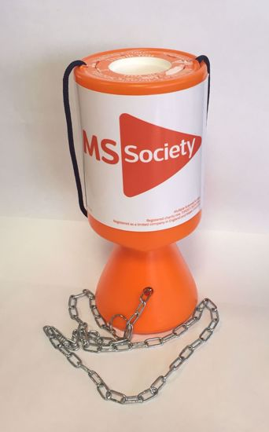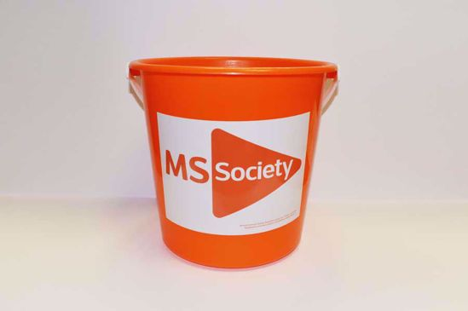

We hope that by doing this we can reduce the amount of new reusable equipment purchased each year and decrease the risk of excess/old equipment being used fraudulently. We also want to reduce our environmental impact.
We’ve put together a Frequently Asked Questions (FAQ’s) document if you would like more information. Please go to https://volunteers.mssociety.org.uk/resources/collection-tin-amnesty-faq
Thanks for your help!
Contact: Shop
shop@mssociety.org.uk
0300 500 8084

Finance

Approving expenses for group signatories
When a group signatory has submitted their own expenses, these need to be approved by two individuals that are not the payee. Group signatories cannot sign/approve payment for their own expenses, as per the MS Society Financial Rules for Groups.

To avoid any delays in the reimbursement of expenses, we encourage you to review your group bank mandate, to make sure you have a minimum of three active signatories.

If you need to update your group’s bank mandate or if you have any queries, please contact our Treasury Officer via Treasury.Support@mssociety.org.uk

Contact: Treasury Officer
Treasury.Support@mssociety.org.uk

iZettle update

Back in May we announced the launch of the iZettle device, a contactless payment device which allows your group to collect donations from people using their bank card.

Since May, 16 groups have obtained the iZettle device and the feedback has been positive. Over £1,500 has now been collected by groups via iZettle which has been deposited directly into their group bank accounts.

Please contact Finance Support (financesupport@mssociety.org.uk) to request a copy of the iZettle information pack, together with easy to follow setup instructions.
Contact: Finance Support
financesupport@mssociety.org.uk

2019 Year End – New Financial Rules

This year we have made changes to our Year End Checklist – the information contained within the MS Society Financial Rules for Groups has now been combined with the Internal Financial Controls Checklist.

A link to the new version can be found within the year end email which was sent out to your group in September.

This Year End Checklist needs to be completed by your Coordinating Team and returned to us by 31 January 2020. If you respond with ‘Don’t comply’ to any line of the checklist, please ensure you include a comment to explain why.

If you have any queries, please contact Finance Support via email at financesupport@mssociety.org.uk or by telephone on 0131 335 4078.

Contact: Finance Support
Financesupport@mssociety.org.uk
0131 335 4078

2019 Year End – We’re here to help

You should all have received the Year End pack which was sent to your group MS Society email address in September.

To help your group meet the submission deadline of 31 January 2020, we offer the following support:

- Online Support Sessions – these will be available to all members of your Coordinating Team throughout October and November via Zoom. See your Year End email for dates, times and joining instructions, including the password you’ll need to take part.

- Finance Support – if at any point you need help, please don’t hesitate to contact us via email at financesupport@mssociety.org.uk or by telephone on 0131 335 4078
Thank you so much for your effort and time in ensuring your group meets our year end deadline - we really appreciate this.

Contact: Finance Support
financesupport@mssociety.org.uk
0131 335 4078

For England

Patient Engagement Forums

We know there is a lot of variation in MS services around the country, and sometimes where you live can affect the services you receive. The MS Society is hoping to agree a set of standards for MS services to ensure everyone gets the same access and same quality of service. We are organising a series of patient discussion groups to find out from people with MS what they think a good quality MS service should include and how we can measure this. The MS Society is planning to carry out a national audit of MS services next year and we’d really like to hear from people what they expect and want from their services and professionals.

Please sign up to join one of our forums in person:
- 29th October, Beefeater Norman Jepsom/Premier Inn, Preston (contact Yvonne.trace@mssociety.org.uk)
- 14th November, Brightwell Centre, Bristol (contact Leila.Middlehurst-Evans@mssociety.org.uk)
- 19th November, The Durham Centre, Durham (contact angie.stewart@mssociety.org.uk)
Or online via Zoom:
- 7th November 6pm
- 11th November 12:30pm
- 18th November 6:30pm
- 23rd November 11am (contact ruth.stockdale@mssociety.org.uk)

Contact: Your Regional External Relations Officer

Thank you to our lovely Great North Run volunteers!

We would like to say a huge “Thank You!” to our lovely volunteers from the Teeside, Sunderland and South Tyneside Groups who helped us out at the Great North Run. We’ve had some great feedback from the runners about the day and you played a big role in making them feel supported, so thank you again to all those who took part.
Contact: Emilia Tynkkynen
Community and Events Fundraising Officer
challenge@mssociety.org.uk

For Northern Ireland

‘Mind My MS’ Update
The MS Society in Northern Ireland is delighted to have received £155,973 from the Big Lottery's People and Community Fund to deliver the 'Mind My MS' project in Mid and East Antrim.
MS Society NI has been hard at work alongside the local MS community to plan 'Mind My MS'. We are really pleased to be working with Big Lottery and to have received the support of the People and Community Fund. The result will be a brand new community-led partnership between people with MS, the MS Society and partner organisations Aware NI and New Life Counselling.
Over the next two years, people with MS will be given regular opportunities to meet, get information about living well with MS, and participate in counselling and mindfulness activities.
We have now recruited two Mind My MS project staff who will start with us on Monday 4 November. Rachel Creighton is joining us as Project Coordinator and Lisa Hanvey as Project Administrative Officer. November will be a busy month for the project as Rachel and Lisa get familiar with the different elements involved. We hope meetings with our project groups will help them feel connected and ready for the next phase of the project. It’s an exciting step and we look forward to welcoming them!
Contact Stewart Finn
Policy Press and Campaigns Manager
Stewart.Finn@mssociety.org.uk

Celebrating Volunteers

There is a new date for our celebrating volunteers event. It will now take place on the afternoon of 9 December 2019 when we will be celebrating the very best of our community.
MS Society NI is a nominated charity of High Sheriff of Belfast Cllr Tommy Sandford. We are delighted Cllr Sandford is hosting and attending the event at City Hall and are grateful for his support. Current Deputy Lord Mayor and MS Society NI Council member Cllr Peter McReynolds will also be welcoming us to City Hall.
On the day there will be a series of awards presented to those who go above and beyond in supporting people affected by MS. This is an opportunity to recognise the outstanding contribution made by our volunteers, group members, fundraisers and service providers. For more information on the event, to register to attend or to find out more contact susan.carey@mssociety.org.uk
Contact Susan Carey
Local Networks Officer
susan.carey@mssociety.org.uk

Events

Santa is Back
Our Santa Dash & Dander at Stormont was postponed last year due to the inclement weather. We are pleased to say it’s back! We are currently finalising plans for the 2019 event. We will be announcing details on our Facebook page and via social media in the near future. So watch out for more information about our super family Santa Dash.
Volunteers Required
We have a number of street collections coming up before Christmas and we are looking for volunteers for:
- Belfast city centre collection Thursday 28th November
- Belfast, city centre Santa collection (Santa suits provided) Thursday 12th December
- Derry / Londonderry Santa collection (Santa suits provided), Friday 13th December

If you or anyone you know can spare a few hours, please let us know.
Contact: Eve Shearer
Community & Events Fundraiser
028 9080 2802
Eve.shearer@mssociety.org.uk
Bright Ideas
We are continually trying to refresh and add new events and activities to our fundraising programme. Do you have an idea that could become one of our annual fundraising activities or even a one off fundraiser? Get in touch, we’d love to chat to you about your fundraising ideas and plans.
Who do you know?
We are keen to talk to businesses and companies about our Stop MS appeal and in particular about charity partnerships. If you, a family member or friend knows or works for a company that might be interested in supporting the MS Society, please get in touch with us.
Contact: Tom Mallon
Fundraising Manager, Northern Ireland
028 9080 2802
Tom.Mallon@mssociety.org.uk

For Scotland

Launch of Clackmannanshire and Stirling Local Group

We’re delighted that our Clackmannanshire and Stirling Group has relaunched, offering local support for people affected by MS in the area.

The group organised a launch event in August which proved to be a huge success. The event was opened by MP Stephen Kerr and was supported by local businesses and over 30 members of the MS community attended, many of those had never previously been involved in the group.

The group have already hit the ground running by setting up a counselling service for people living with MS and lots of creative activities including photography and craft modelling sessions. In the coming months, the group hope to encourage more people with MS to get active by holding seated yoga.

The Clackmannanshire and Stirling group are a great example of the fun, creative and supportive network gained from getting involved in a local group.

If you’re interested in finding out more about the Clackmannanshire and Stirling local group, get in touch on: stirling@mssociety.org.uk or visit the group’s Facebook page on: https://www.facebook.com/mssclackstirling/

New service launched in Lanarkshire
We’re delighted to have secured £24,118 of funding from the ALLIANCE, Scottish Government and William Grant Foundation through the Self-Management Fund to launch a new Living Well with MS project in Lanarkshire.

The funding will be used to support people at different stages of their MS journey, in partnership with the MS Society Lanarkshire local group and healthcare professionals..

Through the project, people affected by MS will have access to events and services, including virtual and face-to-face Living Well with MS sessions, virtual “time to chat” sessions, newly diagnosed days and themed information events. There will also be Digesting Science events open to children aged six to 12 years old, using fun activities to teach young people some of the science behind MS.

Activities and events that are part of the project aim to offer self-management support to people affected by MS at whatever stage they might be in their journey - friends and family, people who are newly diagnosed and those who have been living with the condition for a number of years.

Contact: The Self-Management Team
receptionratho@mssociety.org.uk
0131 335 4050

Snickerfest as comedians complete 1,000 joke marathon
Richard Pulsford, a comedian who specialises in one-liners, organised a marathon show ‘1,000 One-liners in Support of MS Society’ at this year’s Edinburgh Fringe Festival.

The pun-raising stand-up show had a line-up of comics including two previous winners of ‘Best Joke of the Fringe’ and several nominees. In fact, this year Richard was shortlisted for the 2019 Best Joke Award with witty one-liner:
‘After learning six hours of basic semaphore, I was flagging.’

Audiences were left laughing for hours, with 20 comedians treating audiences to 1,002 jokes over five hours. Amazingly, only 4 jokes were repeated over the 5-hour marathon show!

We were delighted that Richard’s show proved so popular that it was moved to a larger venue! The show was an amazing effort, raising awareness and funds through some light-hearted Fringe fun.

We know you come up with lots of creative ways to raise funds, so in each edition of Teamspirit we want to share examples from Scotland. We’d love you to send us your stories! You can also contact the Scotland fundraising team for support if you’re organising a challenge or event.

Contact: Scotland press office/ Scotland fundraising team
scotlandpressoffice@mssociety.org.uk/ msfundraising@mssociety.org.uk
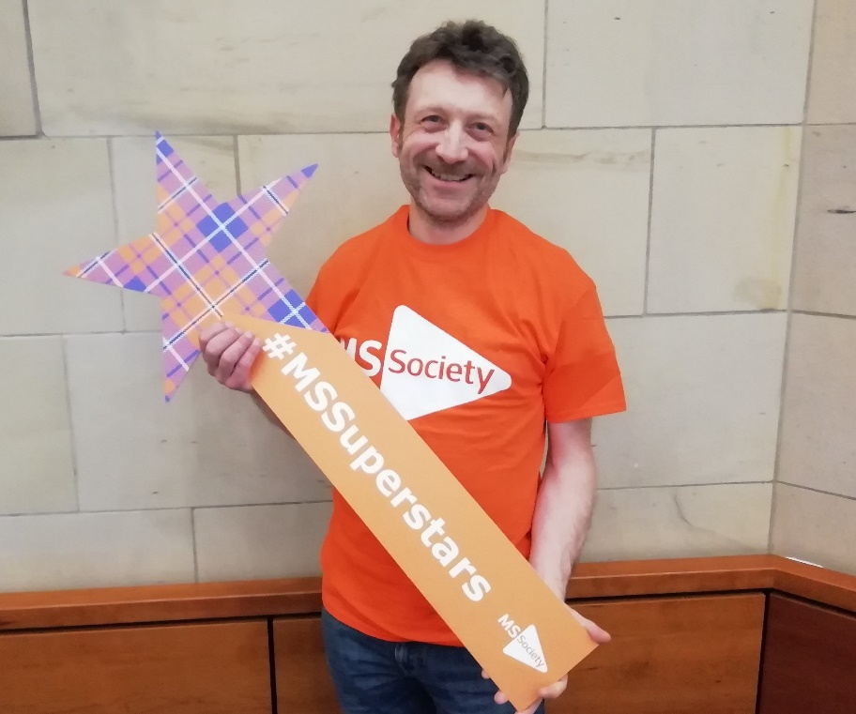

Our fully accessible zipslide is back!
Soar through the trees and enjoy Perthshire’s beautiful scenery in our fast, fun and fully accessible Zipslide Zinger. Back for another year by popular demand, this adrenaline adventure is so exciting that it has even been nominated for an award!

Our 2020 event will take place at Crieff Hydro on Saturday 25 April and is a great fundraising activity open for people of all ages. Adult registration is £15, £10 registration for children.

From 7 November-25 December, we’re offering £5 entry for all of our Teamspirit readers! Simply register and use the code ‘teamspirit’ on EventBrite.

Find out more and sign up here: https://www.eventbrite.co.uk/e/zipslide-zinger-ms-society-scotland-tickets-69404756495
Contact: Scotland Fundraising Team
msfundraising@mssociety.org.uk

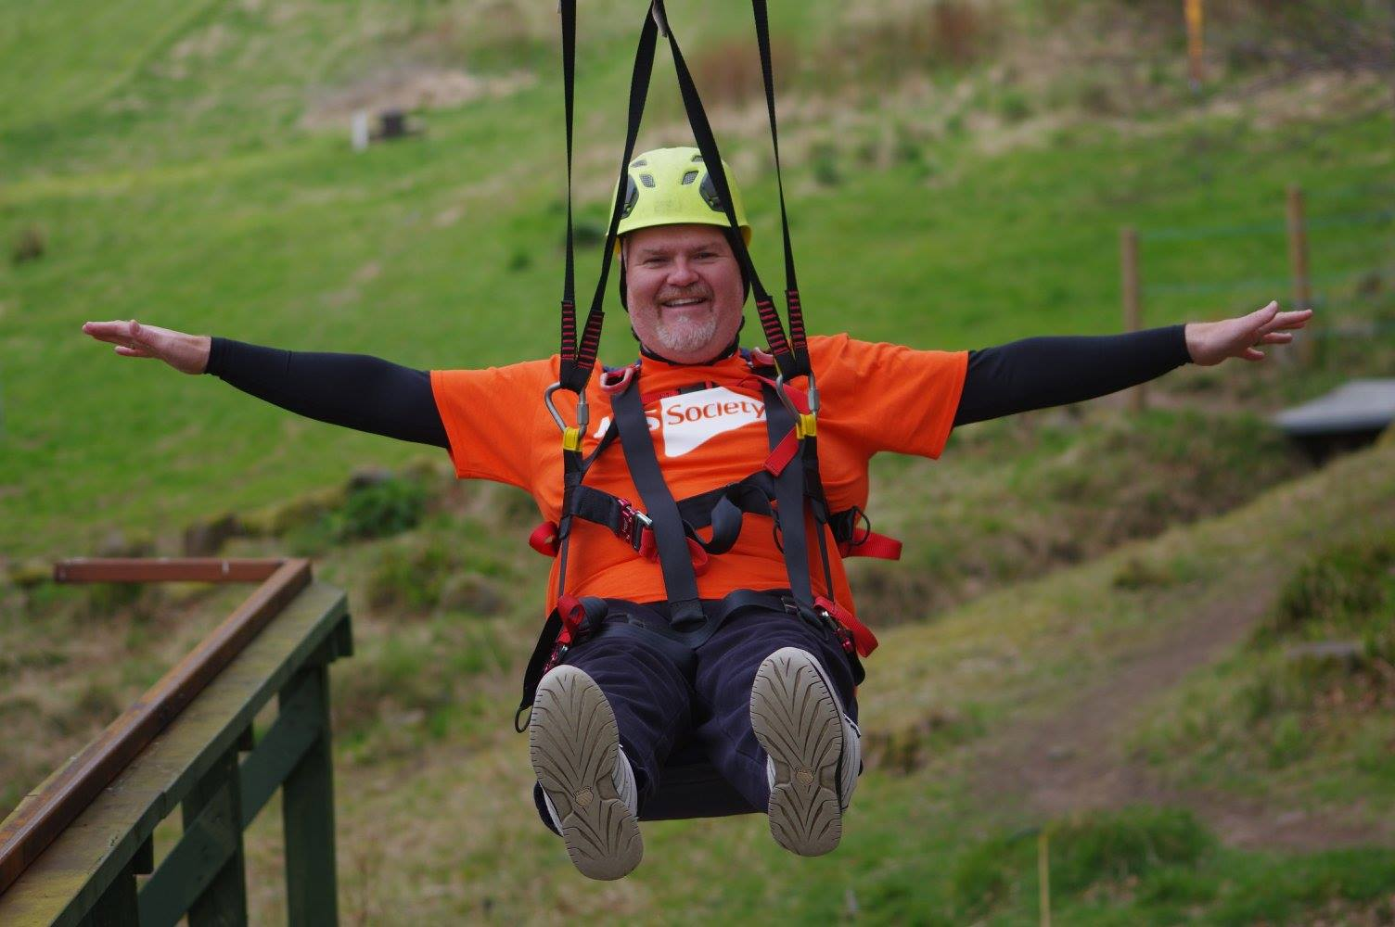

For Wales

Having Your Voice Heard on the Welsh Government’s Neurological Delivery Plan
People living with neurological conditions, clinicians, NHS Managers and Neurological Charities came together in two meetings in July and October in South and North Wales to discuss how well the Government’s Neurological Plan was being implemented.

Some areas of good practice were highlighted; in particular, investment in neuro-rehabilitation services, the creation of patient reported outcome and experience measures, and joint working with the Wales Neurological Alliance. People attending felt strongly that Welsh Government needs to keep a dedicated plan for the delivery of health and care services for people living with neurological conditions.

However, many of those people felt that this progress has not made sufficient impact on the lives of people living with neurological conditions in Wales. Many warned that pockets of good practice are not being effectively replicated across the country.

As well as this, it was felt that there are still major issues in levels of awareness of neurological conditions within the NHS, often resulting in lack of timely diagnosis, and that too many people are not able to access the care and treatment they need.

A final report from the Cross Party Group will be published in January 2020

Contact: Lynne Hughes,
Country Director
lynne.hughes@mssociety.org.uk
02921678923

Active Together: Fitness and Friendship
Active Together is a pilot project covering Cardiff, Merthyr and Rhondda Cynon Taf. We’re planning an exciting programme of active taster sessions, including wheelchair rugby, cycling, indoor climbing, yoga, Pilates, Tai Chi, pottery and craft.

Active Together aims to support people with MS to get and stay more active. Our programme has been informed by people with MS who support and guide the project and all our taster sessions have been chosen and organised by Active Together volunteers.

You can also get involved in Cardiff University’s pilot MS National Exercise Referral Scheme. Designed with people with MS, our first participants are currently attending a bespoke exercise class twice a week. Cycle two will start in January and we are looking for new participants. Transport is available if needed.

We also want to make sure all leisure facilities are accessible for everyone. We are looking for ‘Mystery Shoppers’ to assess their local leisure centres and after suggestions from our volunteers we will be launching a disabled parking campaign.

Contact Bethan Moss (Active Together Project Coordinator) for details of how to get involved. We look forward to seeing you soon.

Contact: Bethan Moss
Active Together Project Coordinator
07920 429476
Bethan.moss@mssociety.org.uk

Amazing Autumn Fundraisers

September 26th was very wet and windy, but the typical Welsh weather didn’t dampen the spirits of the MS Walkers completing the Carl Bennett Memorial Walk at Bryn Bach Park Tredegar. The idea was initiated by his daughter, Emma, and organised with the help of the MS Society Cymru’s South Wales Fundraising Group. This first commemorative walk was a great success and a fitting tribute to Carl.
Stuart Nixon, former MS Society Trustee and Vice-Chair, who inspired the annual London MS Walk welcomed everyone and thanked the nearly 70 participants for joining the day.

If you're thinking of organising your own MS Walk to help raise funds for life-changing MS research, contact Sian Dorward (Fundraising Manager).

On Sunday 6th October, our biggest single fundraising day for the MS Society here in Wales took place, with this year’s team of Cardiff Half Marathon Superstars exceeding 70 people!

The event has grown to become one of the UK's biggest Half Marathon events, attracting over 25,000 participants. Our team of Superstars completed the epic 13.1 mile challenge and raised thousands in support of our MS community.

Contact: Sian Dorward, Fundraising Manager (Wales)
sian.dorward@msscoiety.org.uk
02921678920

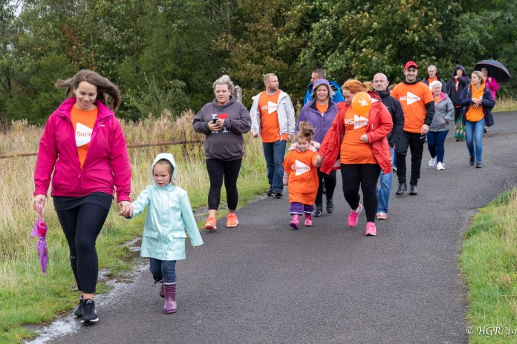

North Wales Community Engagement events
From November 2019 through to March 2020 we will be holding small informal open events throughout North and Mid Wales to promote the ‘My MS, My Rights, My Choices’ project along with more information on local activity delivered by our wonderful groups across the area. The ‘My MS, My Rights, My Choices’ project provides a free and confidential support service for people living with and affected by MS in Wales. We offer information and support on:

- employment rights and welfare benefits, including Personal Independence Payment (PIP) and Employment and Support Allowance (ESA) claims
- ways to manage your MS
- accessing treatments, health and social care services

These events are a great opportunity to chat to your local team as well as our amazing network of volunteers. Challenge us to find the information and support you need over some tea and cake.

Dates will soon be available on our website, social media and local group networks.

Contact: Brian Watson, LNO for North and Mid Wales
brian.watson@mssociety.org.uk
02084380731 / 07809100804

South Wales MS Groups Celebration Event
On the 14th September MS Cymru and the South Wales MS Groups held a Celebration Event at the Future Inn, Cardiff. The main purpose for the event was to celebrate the talents and achievements of people living with MS in South Wales.

The South Wales aMaSing Choir performed 4 songs and also invited attendees to join in a choir session at the event.

There were a displays of photographs for each group and fundraisers and our talented artists, photographers, dolls house designer, cake decorators, authors and poets displayed their amazing work.

After lunch we all enjoyed the South Wales Boccia League Team and Individual Finals. Rhondda Cynon Taff team played Pembrokeshire team and Nigel Scott (RCT) played Mark Carey (Pembrokehire) in the individual final. Two very tense and competitive games. Pembrokeshire MS Group were team champions for the second year and Mark Carey, Pembrokehsire, won the Individual Final.
The atmosphere at the event was wonderful everyone chatting and laughing and sharing their achievements. A great day was had by all!
Contact: Sian Tucker
Sian.Tucker@mssociety.org.uk

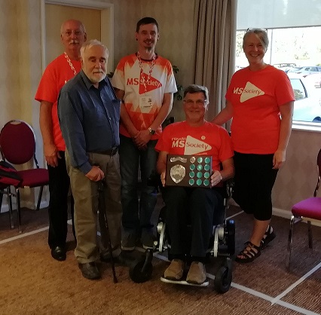

Group contributions 16th Aug 2019 to 17th Oct 2019

Group Name | Where You Wanted Your Donation | Amount
Clacton & District Group | General | £2,000.00
Derby Group | Research | £259.69
Furness Group | Research | £20,500.00
Great Yarmouth & Waveney Group | Stop MS | £400.00
Hinckley & District Group | Research | £2,000.00
Kings Lynn & District Group | Research | £5,000.00
Kings Lynn & District Group | Cambridge Myelin Repair Centre | £5,000.00
Salisbury & District Group | Cambridge Myelin Repair Centre | £25,000.00

