Teamspirit 229 – March 2020

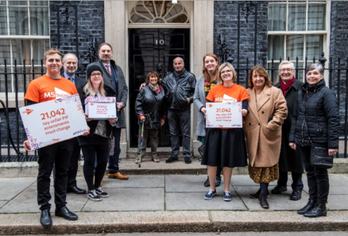
Over 21,000 of us say ‘PIP must change’
In January, we went to Downing Street to hand in our open letter, signed by more than 21,000 people, demanding the UK Government change unfair PIP assessments.
The letter highlights some of our concerns with PIP, including uninformed assessors, inaccurate reports and excessively complex forms.
Our Downing Street team was made up of people from our Campaigns Team and our wider MS community - including our MS Society Ambassador Janis Winehouse, who has secondary progressive MS, and campaigner Ashley Arundale, who has relapsing remitting MS.
Janis Winehouse said:

“I’m here today to support the people living with MS whose voices still aren’t being heard. Some of my closest friends have been through the exhausting and demoralising process of claiming PIP, and it can’t go on any longer.”

PIP must change

Last year saw 8,000 of us email the then Work and Pensions Secretary, Amber Rudd MP, calling for the 20 metre rule to be scrapped.

Now, more than 21,000 of us have come together to demand a PIP process we can trust.

We won’t stop campaigning to make PIP make sense. Visit this link to get involved with our campaign: mssociety.org.uk/get-involved/campaign-with-us.

Contact: Campaigns Team
campaigns@mssociety.org.uk

Help, hope and voice

Over 130,000 people living with MS in the UK

Public Health England and the MS Society have just published a new estimate of the number of people with MS in the UK. We estimate that there are over 130,000 people living with MS in the UK. This means that 1 in every 500 people in the UK is living with MS. And that around 6,700 people are newly diagnosed each year in the UK.

This study estimates that there are more people with MS in the UK than we previously thought, but we don’t think this is because of an increase in the number of people getting MS. The higher estimate is likely to be due to a number of different factors. These include better recording and data management, changing diagnostic criteria so that people are diagnosed earlier and more accurately, and people with MS living longer.

Crucially for the MS Society and people with MS, having a more accurate picture of the number of people affected by MS means that we are able to present the true impact of MS on the many different services and support structures that are needed by people affected by MS. And, we are better able to show the impact when these are not working well.

The full report with age and gender breakdowns for the UK and each of the four nations is at mssociety.org.uk/what-we-do/our-work/our-evidence/ms-in-the-uk.

Contact: Evidence Team
evidence@mssociety.org.uk

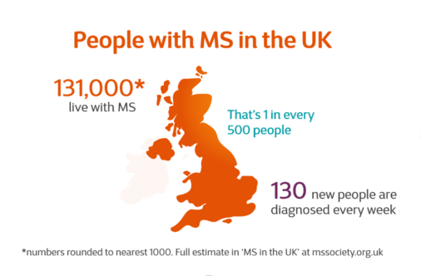

Trustee and Council elections

Join our Board of Trustees

We’re looking for talented people to join our Board of Trustees. People who want to help us to become even more effective and who share our commitment to stop MS. The Board is responsible for setting our strategy and monitoring its implementation. It agrees annual business plans and performance targets, approves and monitors our budget, and monitors risk and compliance.

Make a difference in your nation

We also need new volunteers to join our Cymru, England, Northern Ireland and Scotland Councils. National Councils are a vital link between the Board and our local groups, members and wider MS communities. They help us make sure our strategy is informed by voices from all over the UK.

How to apply

The deadline for applications is 5pm on Monday 11 May. Successful candidates will be put to our members for election, with voting results announced at our Annual General Meeting on 19 September 2020.

To find out more, visit www.mssociety.org.uk/what-we-do/our-people.

Contact: Danielle Walker, Governance Manager
governance@mssociety.org.uk or 020 8827 0839

In your area - our new local campaigning programme

This year, we want to do more to help you campaign in your local area on the issues that matter to you.

We’ve recruited a group of people with, and affected by, MS from across the UK who will work on this programme, to make sure it speaks to the experiences of people with MS. The group will work together to shape our exciting new offer, including new resources and training for campaigners so we can support anyone who wants to campaign on MS issues. With the help of this group, we want to support the MS community to campaign in their area, wherever they live.

There’ll be lots of ways to get involved in local campaigning once the programme launches later this year, so watch this space! We’ll be looking for people who are interested in campaigning in their area and need support with their activities.

If you’re already developing a campaign in your area and would like support from us, just get in touch.

Contact: Campaigns Team
campaigns@mssociety.org.uk

MS family and friends survey

Last year, we ran a survey with family members and friends of those living with MS in the UK, to get a better understanding of their experiences. 549 people completed the survey, providing invaluable insight into what needs to change to better support them.
Shockingly, the survey found that half of those supporting someone with MS are without the practical, emotional or financial support they need, despite two in five respondents spending 35 hours or more a week providing support.
One of the changes that people said would make a positive difference would be the availability of appropriate care for the person with MS. We continue to campaign for a fairer and more effective care system, in which family members and friends are not left to care for their loved ones without support.

The survey also asked what the MS Society can do to better support friends and family members. You told us you would like to access information and advice about services and support regarding your personal situation, financial assistance, and practical training in moving and handling. We will be working hard this year to improve the support we offer, and to campaign for the UK Government to do the same.
You can find the full survey results at mssociety.org.uk/what-we-do/our-work/our-evidence/care-and-support.

MS Walk 2020 is coming to a city near you

MS Walk is back for 2020 and is bigger and better than ever.

We heard when you said you wanted more accessible walking events outside of the capital. Now we’re delighted to be able to take MS Walk to four brand new locations in 2020! As well as returning to London and Belfast, MS Walk will be coming to Bristol, Manchester, Cardiff and North Wales for the very first time.

Each event will be a fantastic celebration of the MS community with something for everyone, no matter what your ability is.

Not only can you sign up and walk, roll or stroll, you can also go that extra mile and volunteer on the day. Get in touch with us to find out about the volunteer roles available.

Wherever and however you get involved, you will be raising vital funds for the Stop MS Appeal and life-changing MS research.

- MS Walk Bristol - Sunday 31 May
- MS Walk Manchester – Sunday 12 July
- MS Walk Belfast – Sunday 13 September
- MS Walk Cardiff – September (TBC)
- MS Walk North Wales – September (TBC)
- MS Walk London – Sunday 20 September

For confirmed dates for all walks, please keep an eye on our website - www.mssociety.org.uk/ms-walk - or contact the relevant team.

Contact:
England - Joe and Gus - mswalk@mssociety.org.uk
Northern Ireland – Eve - eve.shearer@mssociety.org.uk
Wales – Sian - sian.dorward@mssociety.org.uk

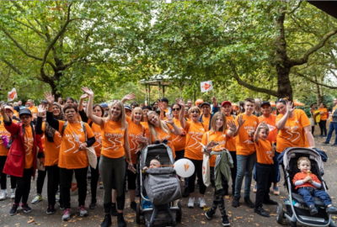

Information for your group

Changes to Health & Wellbeing Grants awarded by UK Grants Team

The UK Grants Team receive around 1,000 grant applications each year. In 2019, we were able to award 841 individual grants from the national grants budget, supported by a total of £73,000 from our local groups. This was fantastic and made a significant difference to people’s lives; so a big thank you to those groups who contributed.

This year, due to the challenging fundraising environment, we (like many other charities) find ourselves in a financial situation where hard choices have to be made regarding where to best focus our funds.

Our national grants budget is significantly smaller for 2020, and the Grants Team have had to make some difficult decisions about how to use limited funds to create maximum impact for those most in need.

The scope of the Health & Wellbeing Grants programme has therefore been reduced. Carers’ Grants remain unchanged.

So what has changed?

The key changes we have made from January are:

- Reducing our savings limit from £16,000 to £6,000.
- Reducing the list of items we can consider.
We are no longer able to fund standard holidays, Motability advance payments, car adaptations, driveways, gardens, driving lessons, domestic repairs or complementary therapies.
- Reducing the maximum award we can make for each type of item.

The revised list of items and maximums can be found on the next page.

What does this mean for groups?

We would prefer to keep national and local grant giving aligned, but did not want to impose these sudden changes without consultation on those groups who award grants. Therefore, groups can either keep awarding grants under the previous categories and maximums, or choose to adopt the new rules, depending on their own budgets.

But if your group supports members with grant applications sent to the UK team, please ensure they are aware of the new guidelines, to set realistic expectations and avoid disappointment.

What happens next?

As the year progresses, it is possible that we will have to reassess things again in light of the reduced budget.

In the meantime, we will continue our ambition to streamline both national and local grant-giving processes, to make the service more responsive to need. This will start with a series of UK-wide conversations with volunteers who support grants.

REVISED GRANTS CATEGORIES AND MAXIMUM AWARDS
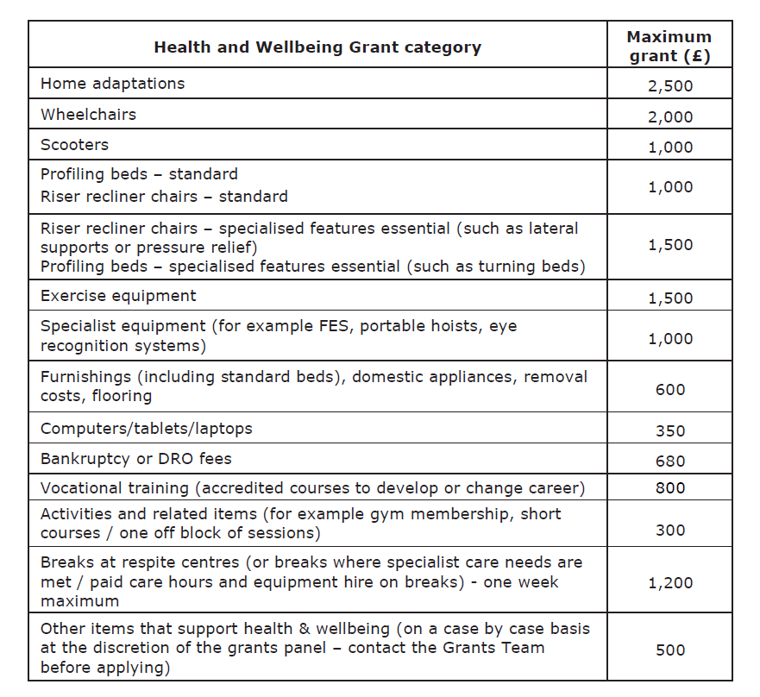

Volunteer Portal – new functionality added

We rolled out the Portal in January 2017 as part of the Local Networks Programme, and are delighted that 81% of our groups are now using it regularly.

We have been having ongoing conversations with volunteers to identify areas for improvement, and have received some excellent suggestions. As a result of this, we are pleased to launch two pieces of new functionality (Communication Sublists and Service Attendance lists), which we hope will be helpful.

We thought we would also take this opportunity to remind you of some important points about data, and ask for your help in ensuring that information on the Portal is as current as possible.

LIST OF MEMBERS AND CONTACTS

Member contacts

The Portal is your view of our secure central database. It gives you access to the most up-to-date information on members and contacts, which is a key requirement of data protection rules (GDPR).

We refresh the data we hold every 28 days to update the details of everyone who has requested to be removed, moved house, or no longer wants particular communications. We also remove the contact details of people who have passed away.

By using the Portal to download your distribution lists you are respecting people’s wishes. It shows compliance with the policies in place to protect you and the MS Society from complaints and fines for data breaches.

Each time you use the Portal to download personal data as an Excel spreadsheet or PDF, you will be asked to confirm the reason for the download. You must not use this downloaded data for any other purpose. You will be prompted to protect the file with a password, which you must not share with anyone who is not in an authorised volunteer role.

Non-member contacts

If your group has lists of non-member contacts (service users, etc), this data must now be kept securely on the Portal.

- If you have non-member contact data which needs to be added to the Portal, please contact our Admin Team (ssadminhelpdesk@mssociety.org.uk), who will let you know how to proceed.

- If you have previously been in contact with the Admin Team about this, but have not yet returned any information to us, please do so as soon as you can.

- If you do not hold any non-member data, please let the Admin Team know.

What’s new in this section of the Portal?

- Communication Sublists

Groups have told us they would like to be able to keep track of members and other contacts who have expressed an interest in areas such as events or fundraising. A set of pre-set sublists has been created to capture this information, and to generate contact lists for email or post.

This new functionality will be available from 10 March. Step-by-step instructions will be added to the downloadable guidance document available on the Portal.

So that your group can fully benefit from this functionality, please make sure that all your non-member contacts have been added to the Portal (see ‘Non-member contacts’ section above).

LIST OF VOLUNTEERS

A big ambition for this year is to get our volunteer data as accurate as possible.
Having up-to-date records helps us to support your group, and means that you are using the best information when generating your contact lists.

Please take a fresh look for 2020 at your group’s volunteer Portal records and let us know about:

- Anyone who has stopped volunteering but still features on your group’s records
- Anyone who has started volunteering but does not yet feature on your group’s records
- Anyone whose volunteering role has changed from what is listed

Send any changes to supportercare@mssociety.org.uk and we will update your Portal records so that the data correctly reflects the volunteers you have within your group.

Missing addresses

When generating a contact list from the Portal, you may have noticed that some of your members’ postal addresses have started showing as ‘Current address unknown’.

Why has this happened?

As an organisation, we are obliged to maintain a certain level of data cleanliness. We therefore check our data against various standard lists on a monthly basis, and those addresses which appear to be outdated are flagged on our central database as ‘Gone away’.

Similarly, when undelivered post is returned to us, the recipient’s address is flagged on our central database as ‘Gone away’.

Previously, this information was not being transferred from our central database to the Portal, and so the old address remained. So, when a system change was made to allow this information to transfer, it resulted in the backlog of records being changed to ‘Current address unknown’ on the Portal.

We do apologise for not letting you know this change was happening in advance.

Will this continue to happen?

Now that the backlog of ‘Gone away’ addresses has pulled through, records will be amended on a monthly basis, so a backlog will not accumulate.

What if an address has been removed incorrectly?

Either an individual or a group on their behalf can call the Supporter Care Team and ask for an address to be reinstated. The record can be flagged so the address is not removed again.

GROUP SERVICES AND EVENTS

Entering details of services and activities offered by your group is a great way of attracting new people to try them out. When somebody searches on the main MS Society website for things going on in their area, the information you have uploaded to the Portal will show up in their results.

We currently have 1486 services and activities uploaded to the Portal. These include 463 socials, 93 support groups, 54 Yoga activities, 32 Citizens Advice partnerships, 31 arts, crafts & music sessions, and 6 mindfulness classes.

Of course, a valuable database like this needs constant curation. Please try to keep the listings for your group as current and useful as possible. Remove (by making ‘Inactive’) entries which are out of date, and add new ones in good time, giving potential attendees as much detailed information as you can.

What’s new in this section of the Portal?

- Service Attendance lists

You told us you would like to be able to keep track of who currently attends a regular service or event, or has signed up for a one-off event such as a Christmas Dinner. You would then like to generate lists to contact these attendees, by email or post, with specific communications about those services or events.

This new functionality will be available from 10 March. Step-by-step instructions will be added to the downloadable guidance document available on the Portal.

So that your group can fully benefit from this functionality, please make sure that all your service users have been added as non-member contacts to the Portal (see ‘Non-member contacts’ section above).

What else do I need to know?

- The Portal will be out of service from Monday 9 March until the changes to add the new functionality have been applied on 10 March.

- You can download a detailed guide to using the Portal. It shows at the top of the screen after you have logged in. You can also access Portal instructions on the Volunteer Website - volunteers.mssociety.org.uk/portal#htg.

- If you have any problems logging in to the Portal, our Supporter Care Team will be happy to assist.
Your account will be locked for security reasons if you have not accessed the Portal in the last six months.

- Finally, do let us know if you have any suggestions for Portal functionality, or any comments on the guidance notes. Some changes are not possible with our budget or resources, but we keep a log of all suggestions for change. We review this regularly, and will be making further improvements later this year.

Contact: Supporter Care Team
supportercare@mssociety.org.uk or 0300 500 8084

The MS fatigue self-management course is here!

The Information Resources Team are very proud to announce the launch of our MS fatigue self-management course. This interactive eLearning course can be found on our website at mssociety.org.uk/about-ms/signs-and-symptoms/fatigue/managing-fatigue/online-fatigue-management-course.

The course is based on fatigue management workshops developed at Bournemouth University with members of the Bournemouth MS Society Group.

It aims to normalise the effects of MS fatigue by teaching people to recognise unhelpful thought patterns, and providing strategies and techniques to overcome these. There are six accessible online sessions – each around 20 minutes long – accompanied by animations and graphics.

Over 25 people gave us valuable feedback which helped us shape the user experience.

Comments at the end of the course were very positive. Here’s an example:

“This course was full of helpful tips for managing fatigue; through following the guidance in the modules I now feel that I am better prepared to cope with fatigue and will no longer feel guilty about having to change plans if I have overstretched myself. I will certainly make use of the delegate tool. Thank you for giving me the opportunity to trial this course, I would definitely recommend this to anyone struggling to cope with fatigue.”

So, if fatigue is an issue or a worry for you, why not give the course a try and let us know if it helps.

The Information Resources Team will be creating more eLearning courses later in the year. Watch this space…

Contact: Carmel Barrett, Information Resource Manager
carmel.barrett@mssociety.org.uk

Support for volunteers

Individual MS Society email accounts for groups
Almost 200 local groups now have volunteers using MS Society individual email accounts (normally formatted as firstname.lastname@groups.mssociety.org.uk).

These accounts are available to all Coordinating Team members, plus any other volunteers who handle sensitive data and/or communicate externally on behalf of the Society. We are really keen to have all our groups making use of this as soon as possible, as there are many important benefits:

- Security. If you are handling sensitive data, you can have confidence that your MS Society email is being protected from hacks and leaks, and that you are not breaching data protection rules.
- Image. MS Society emails look more professional when you are contacting supporters, members and service providers.
- Collaboration. You can collaborate with other members of your group on files and documents using a cloud-based library, and use a group calendar.
- Extras. You gain free online access to Microsoft packages such as Word, PowerPoint and Excel.
- Flexibility. You can access your MS Society email on a desktop or laptop computer, tablet or mobile phone.
- Support. Our IT Team can help if things go wrong.

How can my group get these individual MS Society email addresses?
Once everybody who needs an individual email address has completed online data protection training, the group’s email will be migrated to Office 365 and the individual accounts can be set up. If your group has not migrated yet, there is no time to waste. You may be closer to this stage than you imagine, as we know there are plenty of groups that fulfil all our requirements and could be migrated.

Help us work together more efficiently and keep everyone’s personal information safe.

Contact: Volunteering Team
volunteering@mssociety.org.uk

Changing focus for Forums

Volunteer Forums are a great opportunity for group volunteers to get together and learn from each other. In recent years however, as we have introduced a number of changes to the way we operate, these events have been increasingly used to speak to our volunteers about those organisational changes. We recognise that this can be an inefficient way for us to communicate such information, as many groups are unable to attend the events and the messaging may not be relevant to all volunteer roles.

This year we would like to re-focus the Forums as opportunities for volunteers to share ideas and network across groups, celebrate success, and hear from speakers and initiatives in their own communities. We will continue to share organisational messages at these events, but these will be focussed on what you need and, above all, brief!

As in previous years, forums will take place in May and November and will be advertised in the events section of our Volunteer Website here - volunteers.mssociety.org.uk/events.

Do come along if you can!

Contact: Your Local Networks Officer

Volunteer Voice

Last year we held a number of events as part of a review of the support we provide to our local groups. These Volunteer Voice events were well received by those who attended and provided an opportunity for volunteers to meet with senior staff, discuss issues and suggest ways that we can better support you to meet the challenges you face.

Volunteers told us that they felt decisions affecting local groups are often made without proper input from those most affected. They also thought that the national organisation does not always appear in sync with the realities faced by our groups working in the community.

In response to this, we want to increase the number of opportunities for senior staff to visit groups and to create regular opportunities for volunteers to feed concerns and issues back directly.

We plan to run Volunteer Voice events on a monthly basis from May, alternating between face-to-face meetings held across the UK and virtual sessions using online video-conferencing.

The first event will take place online on 11 May from 11-12.30. Please visit our Volunteer Website here - volunteers.mssociety.org.uk/events/2020/volunteer-voice-online-event if you would like to take part.

Volunteer Voice is just one way that we would like to engage with you to make sure we learn from your experiences of volunteering with us. This year we will start putting into practice some of the other recommendations from last year’s review.

We are also working on new ways to ensure volunteers play a more important role in the way we make decisions affecting our local groups, so that we can support you in the best way we can.

Contact: Local Networks Team
localnetworkprogramme@mssociety.org.uk

Finance
Year End – a big ‘Thank You’

The Finance Team would like to thank all our groups their hard work and patience throughout our busiest time of year; we really appreciate this.

Thank you also for continuing to analyse your Online Accounting transactions on a monthly basis. This helps us improve the accuracy of information reported to HMRC within our quarterly VAT return, and in financial reports to our trustees. It also ensures we can comply with our Financial Rules.

Barclays.net charges

Barclays.net is the online banking system we use which allows you to make online payments and see your group bank balance. A number of volunteers have commented on the level of charges for setting up Barclays.net on their machines; £25 for a card reader and £20 for a smartcard.
The charges are high and we have complained to Barclays about this. However, we still believe that the Barclays cash pooling scheme is better value than what other banks are offering, and we do undertake independent reviews to ensure this is the case. The cash pooling scheme allows the organisation to manage its cash more effectively and as a result generate a significant investment return. If you would like to know more about how the cash pooling scheme works and our rationale behind keeping with Barclays then please let us know.
CONTACT: Treasury Support Team
treasury.support@mssociety.org.uk

Online Accounting – income and supplier refunds

We would like to remind you of the income and supplier refund functions that are available within Online Accounting:
Income refund:
- When analysing a transaction, click on ‘Add Detail’ and select ‘Income Refund’.
- You will be presented with the same transactions listing page that you see when entering income.
- Enter the details of the income refund in the same way as entering income.
- The amount entered will be deducted from income rather than added to it.
- You do not need to include the refund as a negative number on this screen.
Supplier refund:
- When analysing a transaction, click on ‘Add Detail’ and select ‘Supplier Refund’.
- You will be presented with the same transactions listing page that you see when entering expenditure.
- Enter the details of the supplier refund in the same way as entering expenditure.
- The amount entered will be deducted from costs rather than added to it.
- You do not need to include the refund as a negative number on this screen.
Contact: Finance Support Team
financesupport@msssociety.org.uk

Key Finance contacts

The Finance Team are here to support you. Here’s who to contact for assistance with different aspects of finance:
- For day-to-day finance support (including general finance queries, Online Accounting, copies of remittance advices and iZettle):

Finance Support
0131 335 4078 or financesupport@msssociety.org.uk

- For banking queries (including bank mandates, ordering cheque and paying in books, stopping cheques and Barclays.Net):

Treasury Support
020 3828 6863 or treasury.support@mssociety.org.uk

- For queries relating to specific donations/membership monies transferred to your group and showing on your remittance, or to monies you were expecting to receive but haven’t:

Supporter Care
0300 500 8084 or supportercare@mssociety.org.uk

Our groups and services

East Kent Group celebrates National Lottery funding

Congratulations to the East Kent Group, who have been awarded almost £10,000 in National Lottery funding to support their work. The money will be used to continue the specialist exercise classes they run throughout 2020, and to increase access to more people with (and affected by) MS, including those newly diagnosed.

In addition to offering Mobility, Flexibility and Relaxation classes and Massage Therapy, the group now runs two Specialist Exercise classes a week, which have been a great success. The attendees have found it helpful to undertake the exercises as part of a group and have appreciated the individual attention they receive. Many have reported an improvement in their movement and balance.
Barbara Hafford, who attends the classes, said:
“I’m so grateful to the group for the welcome I received since first joining the classes, which I find really helpful. I appreciate the trainer’s approach; her patience and encouragement are admirable and she’s so good at pacing things appropriately to individual needs.”
Judy Lee, Administration Volunteer for the group, said:
“We’re delighted that The National Lottery Community Fund has recognised our work in this way. Now we will be able to press on with our plans to broaden the range of opportunities available to local people with MS and those affected by MS. This will help people to enjoy the health benefits of this therapy but also to experience further opportunities for social engagement with others affected by this debilitating condition, thereby renewing old friendships and building new ones.”
Could your group achieve something similar with National Lottery funding? Talk to your Area Fundraiser about applying and take a look at our eLearning here - volunteers.mssociety.org.uk/awards-for-all.
Contact: Your Area Fundraiser
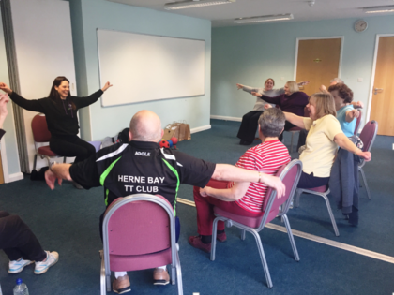
For Northern Ireland

Northern Ireland Assembly returns – what next?

After a three year absence, the Northern Ireland Assembly and Executive are back in business.
The return of a devolved Assembly, Minister, committees and political decision-makers provides additional avenues for the MS Society and people with MS to get issues of importance to the MS community on the agenda and to lobby for progress and change.
We want to continue to fight for required changes to policy, practice and service provision which will improve outcomes for people living with MS and their families. Those issues might include the neurology recall and ongoing inquiries, the current review of neurology services, access to Sativex and medicinal cannabis or problems with the PIP system.
During the Assembly’s absence, and since its return, we have been briefing Members of the Legislative Assembly and political parties on key issues. We are also currently working alongside them to reinstate the All-Party Group on MS and have requested a meeting with the new Health Minister.
Contact: Stewart Finn, Press, Policy and Campaigns Manager stewart.finn@mssociety.org.uk

Fundraising Events
Join Team Stop MS
We have two fantastic running events coming up:
- The Belfast City Marathon takes place on Sunday 3 May offering a full and half marathon, team relay, walk and fun run.
Register at belfastcitymarathon.com/.

- Our Run for Research Half Marathon and 10K event takes place on Sunday 7 June at Belfast Harbour Estate. We had over 500 participants in 2018 and hope for even more this year.
Register at runforresearch.eventbrite.co.uk.
Why not get together with family members and friends, or recruit a team from your workplace, and run for MS?
Roaring 20s Stop MS Ball – Save the date
You and your group are invited – so get the glad rags sorted and join us at the Stormont Hotel on Saturday 14 November.
Given the popularity of our 2019 Ball we expect demand to be high, and are giving our groups an opportunity to reserve tickets or a table now.

Contact: Tom or Eve, Fundraising Team
tom.mallon@mssociety.org.uk or eve.shearer@mssociety.org.uk
Stop MS Champions
We are still recruiting Stop MS Champions to promote the Stop MS Appeal by talking to individuals, local groups, organisations, companies and schools. To date, we have six Champions, who will be getting out and about sharing information about the appeal over the coming weeks and months. Let us know if you would like to get involved.

CONTACT: Tom Mallon, Fundraising Manager
tom.mallon@mssociety.org.uk

Mind My MS recruitment
Last summer, we received £155,973 from the Big Lottery’s People and Community Fund to deliver the Mind My MS Project in Mid and East Antrim. This is a project we are really excited about. It was co-designed with people living with MS and our partner organisations, Aware NI and New Life Counselling.
Launching in March, Mind My MS aims to improve emotional wellbeing through counselling, create social connections through our ‘Connect Cafes’, and teach helpful techniques through mindfulness programmes. The project will be delivered over the next two years.
For more information, visit mssociety.org.uk/care-and-support/local-support/mind-my-ms.
Volunteer with us

Can you spare a couple of hours to host one of our monthly ‘Connect Cafes’, to welcome people with MS and introduce them to others? We have a number of locations and times available. Or could you promote the project as an Influencer? If you can help, please get in touch.
Contact: Mind My MS Team
mindmyms@mssociety.org.uk or 028 9080 2802
For Scotland
First treatment for people living with progressive MS in Scotland

Earlier this year, we were delighted to see ocrelizumab (Ocrevus) become the first drug to be made available on the NHS in Scotland for people living with primary progressive MS.

The Scottish Medicines Consortium (SMC) have approved ocrelizumab for treating primary progressive MS where the condition is still early in terms of duration and disability and there is evidence of inflammation.

More than 11,000 people in Scotland have MS and around 65 each year are diagnosed with the primary progressive form. Ocrelizumab is the first and only treatment that can slow disability progression in this type of MS, where symptoms gradually worsen over time.

Karine Mather was diagnosed with primary progressive MS six years ago and reflected on what this decision will mean for people in a similar situation in the future:

“This is great news for the MS community as people diagnosed with early primary progressive MS in Scotland will now be able to access a treatment for the first time.

Primary progressive MS has had a massive impact on my life and on the lives of my wife and family. In the space of five years I went from walking with a slight limp and working full-time to using a power chair, being unable to work and needing round-the-clock care from my wife, who gave up her full-time job.

This medication will slow the progression of MS, offering people newly diagnosed a treatment, enabling them to continue working and living a full life."

You can find more information about MS and ocrelizumab here - mssociety.org.uk/about-ms/treatments-and-therapies/disease-modifying-therapies/ocrelizumab.

Contact: MS Helpline
helpline@mssociety.org.uk or 0808 800 8000

Join us at our Parliamentary Reception for MS Awareness Week

This MS Awareness Week (20-26 April), we’re thrilled to be holding a Parliamentary Reception at the Scottish Parliament to raise awareness of MS and highlight the importance of MS research.

Hosted by George Adam MSP, the event will be taking place from 6-8pm on 21 April, and will be an excellent opportunity for you and your local group to meet MSPs, connect with others affected by MS, and hear first-hand the latest developments in MS research. Guests will be welcomed with a drinks reception and speeches will start from 6pm.

You’ll hear updates on our ambitious Stop MS Appeal and our campaign to raise £100 million in ten years for MS research into treatments to slow or stop disability progression.

We would love it if you could join us! To reserve your place at the reception, please visit our Eventbrite page here: tinyurl.com/uf7t32o. Before attending, please let us know if you have any specific access requirements or any general questions.

Contact: Scotland Campaigns Team
scotlandcampaigns@msscociety.org.uk

Help shape our manifesto

It may seem a while away, but we’re starting to gear up for the 2021 Scottish Parliamentary elections on Thursday 6 May. We want to ensure the voice of the MS community is heard loud and clear by the political parties and candidates.
We’ll shortly begin working on our election manifesto and want to hear your views. If you’d like to help, it would be great if you could take part in a co-production group to help us develop the manifesto. The group will meet monthly, for an hour, over a four to six month period as we develop our campaign priorities. The meetings will be done virtually over Zoom, so you can join from the comfort of your own home. We will do the drafting, editing and production. What we want are your experiences, your knowledge and your insights to help influence the next parliament.
Contact: Keith Robson, Policy, Public Affairs and Campaigns Manager keith.robson@mssociety.org.uk

Take the leap and join our Daredevil Skydive!

Conquer a 10,000ft drop and take on our Daredevil Skydive in 2020 to help us stop MS. You’ll enjoy the rush of flying through the air at speeds up to 120mph in this unforgettable challenge, which takes place on 1 August at Skydive St Andrews.

Our fantastic MS Superstar, Daniel, has braved our Daredevil Skydive for the last two years and loved it so much he’s ready to do it again this year!

Daniel said:

"This is something I’ve always wanted to do but I thought with my MS it would no longer be possible. I really enjoyed the skydive because in that moment when you are free falling I’ve never felt so alive.

I like to raise as much money as I can for the MS Society because when I have needed help or information they have been there for me so I want to give something back.”

We’d love to have you and your group on the MS Superstars team! For more information, visit mssociety.org.uk/get-involved/fundraise/adrenaline/skydiving/daredevil-skydive.

Contact: Fundraising Team
msfundraising@mssociety.org.uk

Lanarkshire Group secure funding to continue counselling service

We’re delighted that the Lanarkshire Group has secured £6,600 of funding from the Agnes Hunter Trust to continue Talking Therapy, a project providing counselling support to people affected by MS in Lanarkshire. It had previously been funded by the group through local fundraising, but funding had not been secured beyond March 2020.

Talking Therapy provides a free, fully-inclusive, person-centric counselling service with an experienced and trained counsellor. After an initial assessment, people affected by MS are able to access five one-hour counselling sessions free of charge in a community venue in Lanarkshire, or by telephone or Skype.

Talking Therapy has supported more than 63 people affected by MS since the pilot for the service started in 2018. Thanks to the Agnes Hunter Trust, the service will be able to continue for the rest of 2020, and 30 more people are set to benefit from it.

A huge well done to the Lanarkshire Group for all of your hard work in running such a fantastic service for people affected by MS!

For Wales

Stop MS Appeal in Wales

We are all Stop MS Champions!

Two new supporters attended a Newly Diagnosed Day in South Wales, where they met our My MS My Rights My Choices Project Manager, Adele.

The couple were impressed by the information and support they received and wanted to know more about raising funds for MS.

Adele put them in touch with our Fundraising Manager, Sian, and the couple went on to arrange a football tournament in aid of the Stop MS Appeal, raising almost £3,500!

This incredible result highlights how we can all play a part in the success of the Appeal, through whatever we do.

Our groups have been pivotal to the Appeal so far; doing their own fundraising, reaching out to local companies, donating reserves towards research, and recruiting Stop MS Champions.

Please keep spreading the word far and wide; it really makes such a huge difference. Together we’ll raise £100m to fund the vital research that will help stop MS; a goal that we’re all so passionate about achieving!

Future events:

- 11 July – Concert for Stop MS in St Asaph Cathedral - featuring, among others, our very own aMaSing choir from North Wales!

- 27 November - Opera for Stop MS in Cardiff (tbc)

Contact: Sian Dorward, Fundraising Manager
sian.dorward@mssociety.org.uk

Campaigning update

Compared to the rest of the UK, Wales still has the lowest number of people with access to Disease Modifying Treatments (DMTs), and people living with MS are less likely to access specialist help when they need to.

The fight to change this continues and of course people living with MS have been at the forefront!

With your help, we’ve submitted evidence to an inquiry into the Welsh Government’s Neurological Conditions Delivery Plan. We’ve recommended to all politicians in Wales that:

- The infrastructure in the NHS must be improved to cope with existing treatments as well as new treatments.

- MS standards and guidelines on MS should be implemented consistently across Wales.

Thank you to everyone who has contributed to our campaigning so far. It may not seem like it at times but we are making a difference! People living with MS have already helped to secure better MS services in Swansea and Powys – but our aim is to raise the bar of MS services so that every person living with the condition is able to access the right treatment, care and support and at the right time, wherever they live in Wales.

Contact: Fiona McDonald, Policy, Press and Campaigns Manager
fiona.mcdonald@mssociety.org.uk

Digital communities in Wales

11% of adults in Wales are not online and could be missing out on opportunities to save money, find work, learn skills and access important services. Loneliness, poverty and unemployment are some of the issues that many in the MS community face and these are being made worse by not being online.

Our MS groups on Facebook are a lifeline to many but we know only too well that not everyone can access them.

Digital Communities Wales is funded by the Welsh Government and aims to promote digital confidence by offering free support to digitally excluded people.

We’ll be linking in with them to offer our groups across Wales a chance to become more confident online and (should they wish to) to learn about reaching more people in our community through the power of social media.

Contact: Sian Tucker and Brian Watson, Local Networks Officers sian.tucker@mssociety.org.uk or brian.watson@mssociety.org.uk

Group Contributions

Thanks for all your contributions, which are gratefully received.

Table breakdown of each group donation since the last issue of Teamspirit.

Group contributions 10 Dec 2019 to 12 Feb 2020
Group | Where you wanted your donation to go | Amount
Alnwick & District | Stop MS Appeal | £450
Brent | Stop MS Appeal | £5,000
Cambridge & District | Cambridge Myelin Repair Centre | £1,500
Castlederg | Research | £2,500
Croydon | Stop MS Appeal | £5,000
Dundee | Stop MS Appeal | £10,000
East Cumbria | Research | £1,041
Falkirk | Research | £2,000
Grimsby & District | Research | £2,500
Mendip | Research | £5,000
Merton | Research | £2,000
MSS Don't MS with Us! Fundraising | Cambridge Myelin Repair Centre | £1,000
North Hertfordshire | Cambridge Myelin Repair Centre | £10,000
North Tyneside | Research | £1,100
Oldham & District | Research | £3,000
Orkney | Research | £5,000
Preston | Stop MS Appeal | £200
Salisbury & District | Research | £500
South East Cheshire | Research | £5,000
South Tyneside | Research | £100
Spelthorne (Staines & District) | Research | £5,000
Surrey | Research | £4,500
West Central London | Research | £20,000
West Hertfordshire | Research | £4,000
West Hertfordshire | Cambridge Myelin Repair Centre | £4,000
West Oxfordshire | Research | £5,000
Westmorland South Lakes | Research | £2,000
Worksop & District | Stem Cell Therapy | £2,000

Classifieds

Accessible holiday accommodation

- Share chalets (County Fermanagh)

The team in Northern Ireland have two fully accessible chalets for hire at the Share village in Lisknaskea on the tranquil shores of Upper Lough Erne in beautiful County Fermanagh.

Share is an outdoor activity centre open to everyone and with plenty of entertainment options for the whole family. Share works for the inclusion of disabled and non-disabled people by providing opportunities for all to participate in a wide range of recreational and creative activities.

We’re able to offer our chalets at a much reduced rate to people with MS and their families. Our chalets sleep eight and come with access to the onsite fitness centre.

Contact: NI Reception
nireception@mssociety.org.uk or 028 90 802 802

- Rotherwood (Skegness)

Rotherwood is an accessible bungalow close to the centre and beaches of Skegness. It has six beds (including one adjustable bed, with a ceiling hoist), two wet rooms and a garden. Well-behaved pets are welcome, and it is available all year round.

Rotherwood was formerly run by the MS Society Barnsley Group, who have now established a new charity to manage it independently of the Society.

For more information, visit https://en-gb.facebook.com/pg/Rotherwood-MS-Holidays-481562032027554/.

Contact: Trish
rotherwoodmsholidays@gmail.com or 01226 381524

- Badger Lodge (Great Yarmouth)

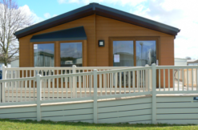

Badger Lodge is an accessible timber lodge (two bedrooms, plus sofa bed) which includes an adjustable bed with an overhead hoist running to the wet room. There is adjacent parking, and free use of a mobility scooter.

It sits within the Cherry Tree Holiday Park, which has two swimming pools and offers a range of activities and kids’ clubs. The park is three miles from the Great Yarmouth coast and sixteen miles from the historic city of Norwich.

For more details, pricing and booking information, visit the Badger Lodge website at https://www.badgerlodge.co.uk/.

Badger Lodge was formerly run by the MS Society North Norfolk Group, who have now established a new charity to manage it independently of the Society.

Contact: David
dandm4sc@btinternet.com or 07793 414874

