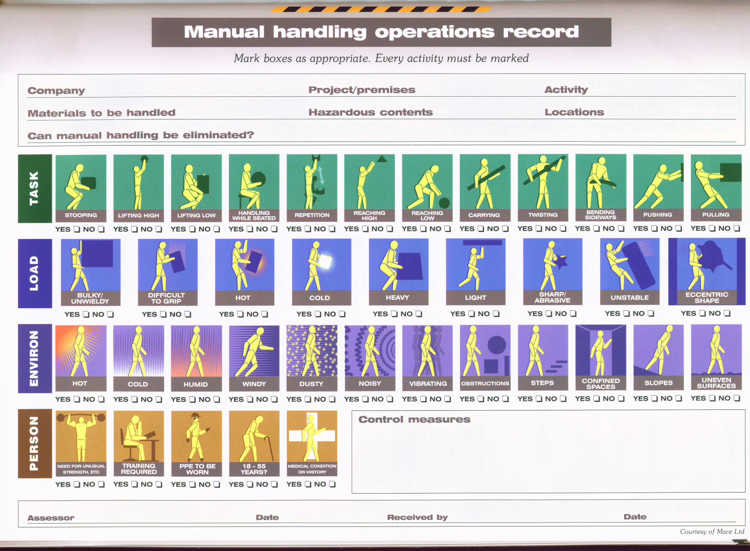

MANUAL HANDLING RISK ASSESSMENT

To be completed by a group representative responsible for or based at the property
Group: |  | Type of property:
Address:
Groups are requested to scan the document and either upload to the service bank/portal or email to the health and safety auditor on completion
Risk highlighted by the assessment | Action needed |  | Responsible person | Completion date | Sign when complete

