Health and Safety Policy
  - Statement of intention
The Multiple Sclerosis Society (the MS Society) is committed to the continual improvement of the health, safety and wellbeing of all volunteers and employees who work with us, those using our services and anyone else affected by what we do. We all have responsibilities to take reasonable steps to ensure our own health and safety, and that of others.

Health and safety considerations are taken into account in all our decisions. As Chief Executive I will ensure the Board of Trustees is kept informed of key health and safety matters. To implement our legal responsibilities we will recruit appropriate staff and liaise with suitable outside expertise.

We will implement all relevant legislation to provide a safe work environment. This will be achieved if everyone plays their part.

We are committed to promoting co-operation between trustees, management, employees and volunteers to create the safe environment that we all deserve.

The MS Society’s policy will be reviewed and updated annually and in response to changes within the MS Society or developments in legislation and best practice.

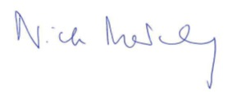

Nick Moberly
Chief Executive

October 2023

